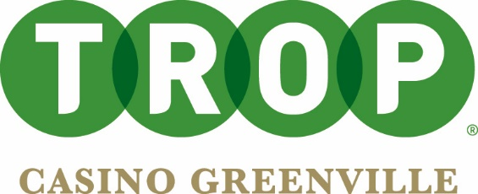

Trop Casino Greenville Fact Sheet

LOCATION: 199 North Lakefront, Greenville, MS 38701

WEBSITE: https://www.caesars.com/tropicana-greenville

HISTORY: In 1996, the first phase of the casino was built and opened as the Lighthouse Casino. The property was then bought by Tropicana and rebranded to Trop Greenville in 2012. The casino took on new life in 2014 when El Dorado Resorts acquired the property in a merger building phase 2 which added more gaming space along with a new bar and restaurant Max & Erma’s. The restaurant was rebranded as Big Water’s Café in 2018. The casino became a part of the largest and most rewarding casino loyalty clubs as a Caesars property in 2020. Since becoming a Caesars property, Trop Greenville has experienced many new and exciting changes including the creation of a new Caesars Sportsbook.

OVERVIEW: Located in the Downtown Historic District, we are Greenville’s premier casino packed with all the excitement the Queen City of the Delta has to offer. With hundreds of slot machines, newly renovated bar, e-table games and Big Waters Café serving up Delta favorites, we are the spot to be! Our newly opened sportsbook hosts 24 betting kiosks and 12 comfortable chair to catch all the action on 12 big screen TVs. Big Water’s café serves up the Delta’s finest with southern favorites made with love! Our newly renovated bar is the perfect spot to relax and unwind with friendly service and cold drinks. We have favorite classic slots like Buffalo and Dragon Links combined with over 40 brand new games! The gaming experience here can’t be beat! We are the only casino in Greenville that rewards you for both slot play and sports betting!

CASINO FLOOR: With over 450 slot machines, 7 e-table games and 24 sports betting kiosks, you can’t miss out on 100% excitement!

SPORTSBOOK: Our newly opened sportsbook hosts 12 large TV screens perfect for catching all the action with 16 comfy seats. We host 24 betting kiosks and the option to order some delicious Delta favorites from Big Water’s Café while you enjoy the game!

ENTERTAINMENT: For special holidays and events, we bring in special talent including local DJ’s and live bands!

DINING: Hungry for picture-perfect views and classic American and Southern food? Then our Big Water’s Café is the spot for you. From cheeseburgers and fries to hand-breaded catfish strips, we’ve got all your favorites. Make sure to try our delicious chicken wings. Plus, our waterfront location offers great views of Lake Ferguson!

###