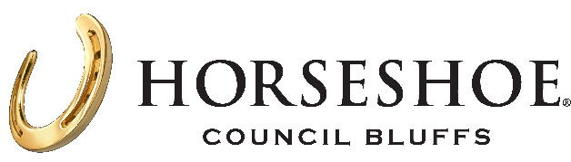
Horseshoe Council Buffs Fact Sheet
LOCATION: 2701 23rd Ave, Council Bluffs, IA 51501
WEBSITE: https://www.caesars.com/horseshoe-council-bluffs
Horseshoe Casino (@HorseshoeIowa) · Twitter
Horseshoe Council Bluffs (@horseshoeiowa)
Horseshoe Casino Council Bluffs- facebook

HISTORY: Bluffs Run Greyhound Park opened in 1986. In March 1995, slot machines were added, and the property became Bluffs Run Casino.
OVERVIEW: Discover the legendary name in gaming just five miles from Omaha. Horseshoe Council Bluffs is a true gambler's paradise, featuring an expansive round-the-clock casino floor with over 1,300 slot machines and over 50 table games including our Golden Treasures Asian pit, a full-service Caesars Sportsbook, and one-of-a-kind gaming areas. When it's time to refuel, explore a range of casual and upscale dining options that are sure to satisfy.
ROOMS: 153 rooms (all non-smoking)
CASINO FLOOR: With 59,397 square feet of casino space, Horseshoe Council Bluffs offers a variety of gaming action, 1,300 slots, including a high-end slot area, with 50+ table games, and our Poker Room offering games daily.
SPORTSBOOK: Located on the casino floor, this space features 32 tv’s dozens of self-betting kiosks and betting windows, and a full-service bar.
MEETING SPACE: Over 5,500 sq. ft. of flexible meeting and event space, including a 3,200 sq. ft. ballroom Dedicated Sales Professionals help plan every detail of your event.
DINING:

Jack Binion's Steak House at Horseshoe Council Bluffs serves up a fine dining experience sure to satisfy. Featuring the finest cuts of aged USDA prime steaks and succulent, fresh seafood, enjoy artful presentation paired with impeccable attention to detail—all complemented by an extensive wine list.

Dig into delicious pub grub and raise a glass to good times at Whiskey Roadhouse. Don’t miss a minute of epic sports ac􀆟on with our 15-foot screens and 60+ HDTVs. It’s a little bit country, a little bit rock n’ roll, and a whole lot of fun.

###

