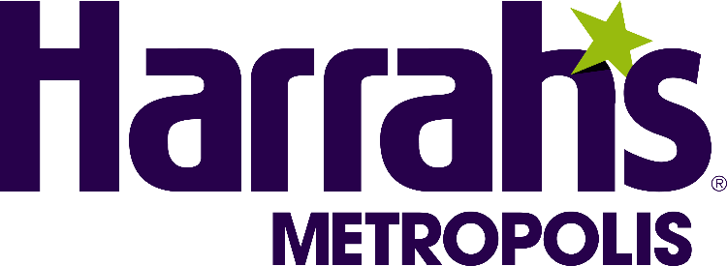

**HARRAH’S METROPOLIS FACT SHEET**

**OVERVIEW**

Harrah’s Metropolis Hotel and Casino is a full-service casino entertainment establishment with amenities including two bars, a world-class restaurant, Bridges Dining Company, Riverfront Grill, and a single-level casino that features slot machines, table games, and video poker. Harrah’s is located at Exit 37 just off Interstate-24 on the Ohio River, west of Paducah, KY.

**LOCATION**

100 East Front Street

Metropolis, IL 62960

**TELEPHONE**

618-524-2628

**WEBSITE**

[www.harrahsmetropolis.com](http://www.harrahsmetropolis.com)

**QUICK CASINO FACTS**

**Casino opened:** 1993

**Table Games:** 17 gaming tables including Roulette, Blackjack with Trilux Bonus and Super 3,

Craps with Firebet and Diceology, Three-Card Poker, High Card Flush,

Mississippi Stud, Ultimate Texas Hold’em and Mini Baccarat with Dragon Bonus.

**Slot Machines:** Over 600

**Casino Floor Square Footage:** 24,270

**HOTEL QUICK FACTS**

**Hotel opened:** 2006

**Hotel Rooms:**  215 rooms

**GENERAL MANAGER**

Sherry Wessel, Senior Vice President and General Manager

**DINING**

**Riverfront Grill:** With ease and convenience in mind, the Riverfront Grill features something for everyone. Looking to grab a quick bite with friends? This is the place to be. Dig into pizza, nachos, burgers, wings and more, or take select items to go and get right back to the casino action.

Hours of Operation:

Monday – Wednesday: 11AM – 10PM

Friday: 4PM – 1AM

Saturday: 12PM – 1AM

Sunday: 12PM – 10PM

**Bridges Dining Company:** Serving brunch, lunch, and dinner, Bridges Dining Company puts a spin on classic favorites, along with several options from land and sea. Savor steaks seared to perfection, tempting sandwiches and burgers, fresh salads, and so much more. Call for reservations: 618-524-6111.

Hours of Operation  
Thursday – Friday: 10AM – 11PM

Saturday – Sunday: 8AM – 11PM