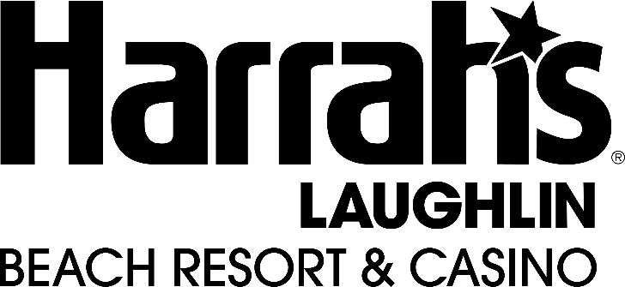

Harrah’s Laughlin Fact Sheet

LOCATION: 2900 S Casino Dr, Laughlin, NV 89029

WEBSITE: https://www.caesars.com/harrahs-laughlin

HISTORY: Any details about the history of the property. When it opened, if it has been through a rebrand or renovation etc.

OVERVIEW: Harrah's Laughlin is a 1,506 rooms hotel and 50,000 sq. ft. casino located on the Colorado River in Laughlin, Nevada. The property features spectacular outdoor amenities including a private soft sand beach with jet ski rentals, and two pools that overlook the Colorado River. Restaurant selections range from casual dining in Guy Fieri’s El Burro Borracho to fine dining in The Range Steakhouse, and favorite brands such as Starbucks, Smashburger and Cinnabon. Other amenities include a live Poker Room, Race & Sports Book, 5,000 seat outdoor amphitheater, 425 seat indoor showroom, health club, shopping, and an arcade.

ROOMS: Classic, Deluxe, River View, Premium, Riverfront, Pet Stay

CASINO FLOOR: 750+ Slot Machines, 22 Table Games, WSOP & Keno

SPORTSBOOK: 20 HD Tv’s & Big Screen Projector.. open 24 hours a day with one kiosk.. 5 windows

MEETING SPACE: Meeting/Event rooms for events 20-500

ENTERTAINMENT: Shows year-round at Rio Vista Outdoor Amphitheatre & Fiesta Showroom

NIGHTLIFE: N/A

DINING: Guy Fierie’ El Burro Borracho

Traditional tastes meet Guy Fieri’s creativity. Dig into El Burro Borracho’s over-the-top tacos, enchiladas, fajitas and more. Don’t miss out on the epic Trash Can Nachos and signature margaritas. Just be sure to save room for some fried ice cream.

The Range Steakhouse

An elevated steakhouse experience. Enjoy a fine dining take on the classics in a tranquil setting at The Range Steakhouse.

Beach Café

You’ve found the right place for breakfast, lunch, dinner, or a mouth watering dessert. With so many hearty options, you’re sure to leave satisfied.

Smashburger

The better burger brand known for its fresh, never frozen, 100% Certified Angus Beef burgers, real milkshakes, and more.

Starbucks

Starbucks is more than just coffee and tea. Select your favorite from our wide range of drinks and snacks.

Cinnabon

Treat yourself with world-famous cinnamon rolls from Cinnabon. Try fresh baked goods and specialty coffee drinks.

Red Mango

Red Mango serves your favorite frozen yogurt fortified with probiotics, all-natural juices, and fresh fruit smoothies.

POOL: 1 Family Pool, 1 21+ Pool, Private beach w// Jetski Rentals – Canaba & Daybed Rentals available