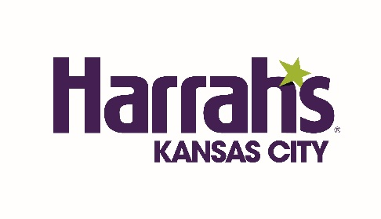

**HARRAH’S KANSAS CITY FACT SHEET**

LOCATION: 1 Riverboat Dr, North Kansas City, MO 64116

WEBSITE: <https://www.caesars.com/harrahs-kansas-city>

HISTORY: Harrah's Kansas City has undergone several remodels and renovations since it first opened in 1994. In 2014, the hotel completed a major $50 million renovation project, which included updates to the casino floor, restaurants, hotel rooms, and public areas. In addition, Harrah's Kansas City has continued to make updates and improvements to its facilities over the years to provide guests with the best possible experience.

OVERVIEW: Located along the scenic Missouri River, Harrah's Kansas City offers a thrilling and unforgettable stay, complete with non-stop excitement, big flavors, and fantastic hotel amenities. Harrah’s Kansas City boasts a 60,000-square-foot casino floor with table games and slots, over 390 luxurious rooms, gourmet dining experiences, and the area's hottest gaming and entertainment.

#### ROOMS: PREMIUM KING NON-SMOKING- KC TOWER- Located within the Kansas City Tower, the Premium King Non-Smoking room comes with one king bed. It also includes TV with on-demand movies, coffee maker, hair dryer, alarm clock radio, and private voice mail.

#### PREMIUM KING NON SMOKING - LV TOWER-Located in the resort's Las Vegas Tower, the spacious 390-square-foot Premium King Non-Smoking room features modern décor, one king bed, TV with on-demand movies, coffee maker, hair dryer, alarm clock radio and private voice mail. Bathroom includes a tub/shower combination.

#### PREMIUM KING SMOKING - LV TOWER- Located in the resort's Las Vegas Tower, the spacious 390-square-foot Premium King Smoking room features modern décor, one king bed, TV with on-demand movies, coffee maker, hair dryer, alarm clock radio and private voice mail. Bathroom includes a tub/shower combination.

#### PREMIUM TWO DOUBLE NON-SMOKING - LV TOWER- Located in the resort's Las Vegas Tower, the spacious and modern 390-square-foot Premium Two Double Non-Smoking room features modern décor, two beds, TV with on-demand movies, coffee maker, hair dryer, alarm clock radio and private voice mail. Bathroom includes a tub/shower combination.

#### PREMIUM TWO DOUBLE SMOKING - LV TOWER - Located in the resort's Las Vegas Tower, the spacious and modern 390-square-foot Premium Two Double Smoking room features modern décor, two beds, TV with on-demand movies, coffee maker, hair dryer, alarm clock radio and private voice mail. Bathroom includes a tub/shower combination.

#### PREMIUM TWO DOUBLE NON-SMOKING- KC TOWER- Located in the Kansas City Tower, the 314-square-foot Premium Two Double Non-Smoking room at Harrah's Kansas City features two double beds, TV with on-demand movies, coffee maker, hair dryer, alarm clock radio and private voice mail. Bathroom includes a shower/tub combination.

#### PETSTAY DELUXE KING NON-SMOKING - KC TOWER- Located on the first floor of Kansas City tower, the PetStay Deluxe King Non-Smoking room offers the same features as Premium rooms. This floor has its own entrance, making the outdoor pet area accessible. Guests will need to sign a waiver form accepting responsibility for any damage and/or cleaning charges. A $125 credit authorization on a valid card is also required as an initial deposit if damages or cleaning charges occur. Up to 2 dogs per room are permitted and each dog must weigh less than 50 pounds.

CASINO FLOOR: 45 Table Games, 1,000+ Slots, 60,000 SQ. FT Gaming Floor

MEETING SPACE: 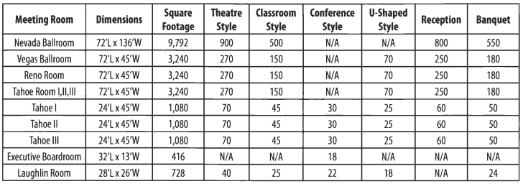

ENTERTAINMENT: VooDoo Lounge offers diverse programming, see <https://www.caesars.com/harrahs-kansas-city/shows> for the latest shows.

DINING: **GORDON RAMSAY STEAK:** Staying true to his British roots, Chef Ramsay’s stunning menu combines choice cuts of beef with fresh seafood offerings.

**WINNING STREAKS:** Sports fans and foodies alike have a place to call home at the largest sports bar in North Kansas City.

**ROYAL NOODLE BAR:** Enjoy authentic Asian cuisine featuring various noodle dishes, rice dishes, pho, and dim sum right on the casino floor.

**BITE & BEAN:** Bite & Bean is Harrah's quick stop for coffee, breakfast, lunch and dinner. Sit down in the café or grab a bite to go.

###