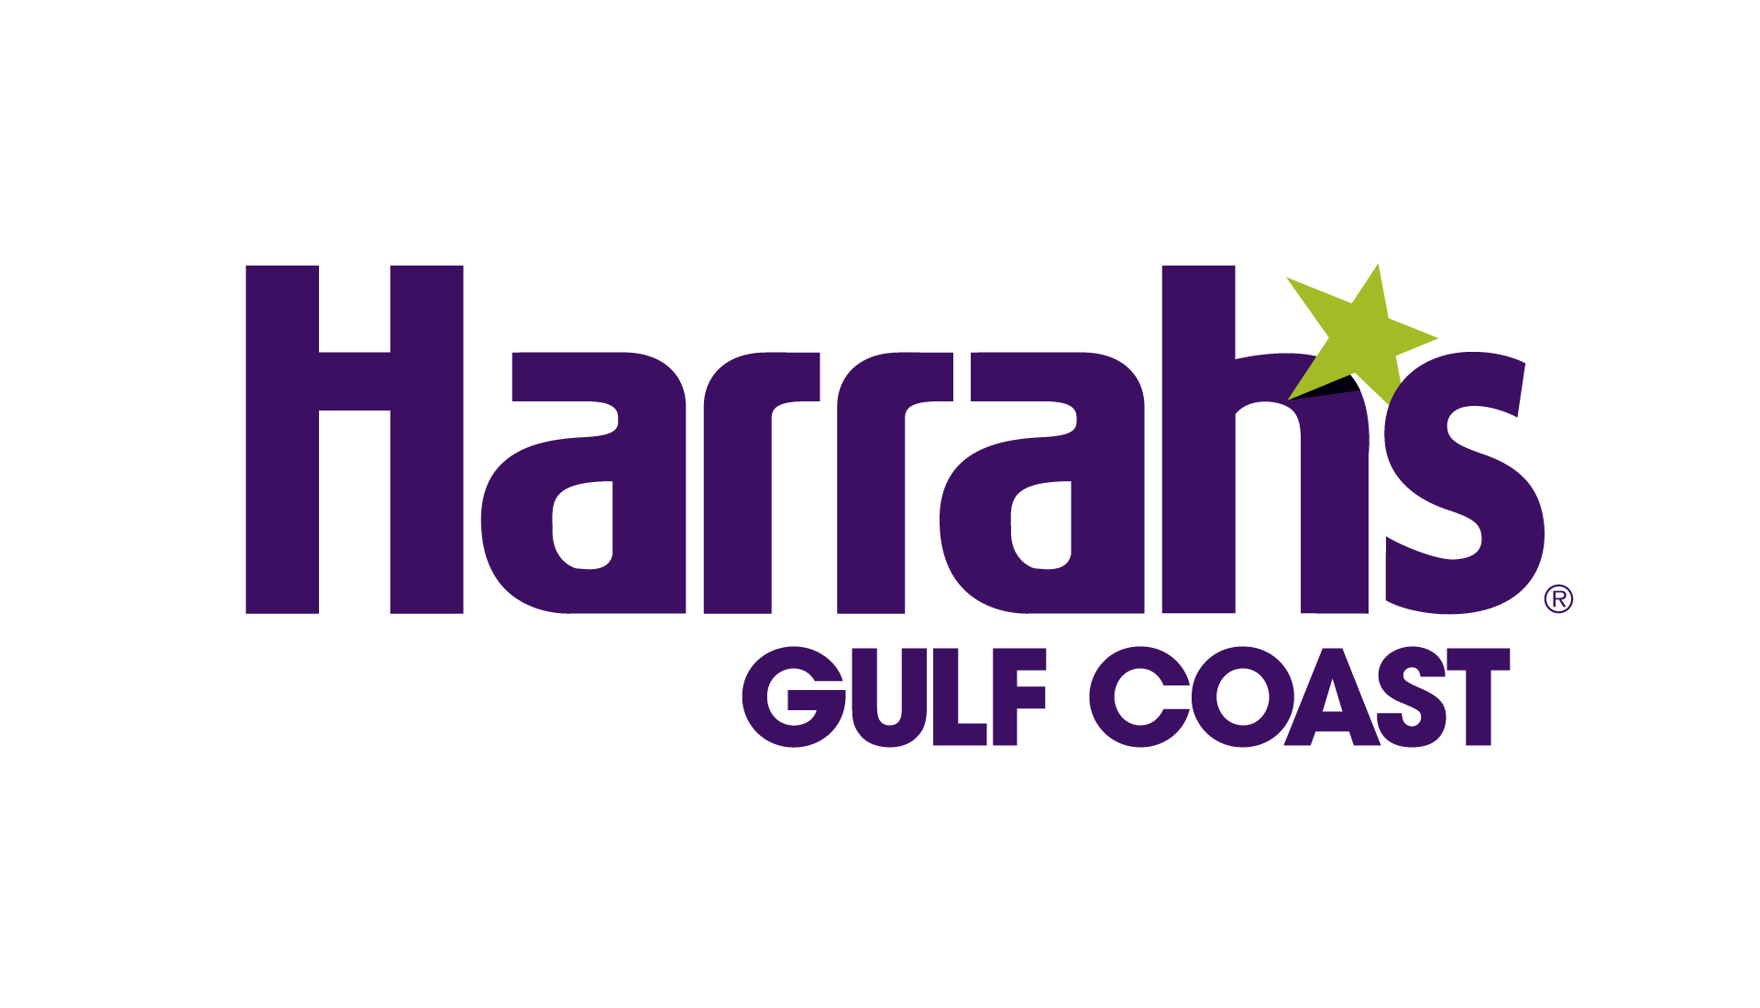

**HARRAH’S GULF COAST FACT SHEET**

**LOCATION** 280 Beach Blvd.

Biloxi, MS 39530

228-436-2946 or (800) 946-2946

<https://www.caesars.com/harrahs-gulf-coast>

<https://www.facebook.com/HarrahsGulfCoast>

<https://twitter.com/HarrahsGC>

<https://www.instagram.com/harrahsgc>

**OVERVIEW** Harrah’s Gulf Coast is a Caesars Entertainment property. Located on the beaches of Biloxi, Mississippi, the resort and casino features a 35,000-square-foot casino that includes a sports and entertainment venue, 406 Club, and a sports wagering venue, Caesars Sportsbook, along with five dining amenities and a daiquiri bar: Magnolia House, a fine-dining restaurant, the American Classic, Steak ‘n Shake, Chef Thomas Genin’s The Blind Tiger – Biloxi Beach, a bar and lounge, Mix & Mingle, Starbucks coffeehouse, located in the hotel lobby and Purple Zebra Daiquiri Bar that connects to an outdoor pool oasis.

The restaurants complement Harrah’s Gulf Coast’s other award-winning amenities, including Grand Bear – a Jack Nicklaus Signature Golf Course – Bellissimo Salon & Spa, complete with a fitness center and The Great Lawn, a 10.5 acre event venue that overlooks the Gulf of Mexico. Featuring Caesars Rewards ®, the most inclusive loyalty program in the country, guests have access to exclusive benefits across the country with the ability to redeem offers and reward credits at any of the 55 destinations within the network. Must be 21 or older to gamble. Know When To Stop Before You Start.® Gambling Problem? Call 1-800-522-4700. For more information, please visit www.HarrahsGulfCoast.com.

**GUEST ROOMS** 499 total guest rooms, including 38 suites

Surrounded by white-sand beaches, Harrah’s Gulf Coast offers genuine Southern hospitality in the heart of Biloxi, Mississippi. Stay in one of our 499 luxe rooms and suites, chase thrills on the casino floor, make time for rejuvenation at our spa and salon, or kick back by the resort-style pool.

**Deluxe Room:**Take your vacation to the next level with style and sophistication in a Deluxe room. Enchanting from the moment you enter the foyer, our spacious California King beds or two queens feature a plush pillow-topper, and in-room amenities, including a 49” wall-mounted high-definition TV, custom illuminated headboard, safety deposit box, complimentary refrigerator, telephone and desk, will provide luxury and comfort during your escape to the Coast. Showcasing gorgeous views of the Gulf of Mexico and Biloxi sunsets, our modern hotel accommodations will make your at stay Harrah’s Gulf Coast unforgettable.

**Resort Studio Suite:** Our charming Studio Suite will take play to a whole new level with its premier tech accessories, two 49” high-definition TV and artwork that celebrates the beautiful Gulf Coast. From the custom illuminated headboard, down to the roomy California King bed featuring a plush pillow-topper, not a detail has been overlooked. Start your vacation early and check in to check out this Studio Suite.

**Resort Parlor Suite:** Luxury and sophistication meet in our spacious, 700 sq. ft. Parlor Suites. This elegant retreat will elevate your stay with its modern furnishings, separate seating area and wet bar. The impressive marble master bathroom features a Jacuzzi and oversized shower, perfect for getting ready for a night out or relaxing after a fun-filled day. And when it’s time to get some shut-eye, sink into our plush California King beds, featuring a soft pillow-topper and custom headboard with ambient illumination. Boasting unparalleled views of the Gulf of Mexico, and in-room amenities, including state of the art tech accessories, a 49” high-definition TV, safety deposit box and complimentary refrigerator, our Parlor Suite will make you never want to leave. So book a date in our Parlor Suite during your next stay and experience the lifestyle of a high roller.

**CASINO** With nearly 35,000 square feet of casino space, Harrah’s Gulf Coast offers a variety of gaming action, including a high-end slot area and table games area.

**Table Games**: Harrah’s Gulf Coast offers 28 live table games. The selection of games includes blackjack (21); mini-baccarat; roulette; craps; Pai Gow poker, Mississippi Stud, Ultimate Texas Hold’Em, and Three Card Poker.

**Slot Machines**: The Harrah’s Gulf Coast casino floor features more than 645 slots, video poker machines and electronic table games.

**Caesars Sportsbook Ticket Counter:** Located just off the casino floor, Caesars Sportsbook offers quick access to a full-service bar that features 5 betting windows, 19 Kiosks, 10 high-definition televisions, and 12 giant screens. That means more than 78 feet of HD sports action. Kick back in style in one of our plush seating areas, order a drink, and cheer your team to victory.

**World Series of Poker Hall of Fame® Poker Room:** Opening Summer 2023, Harrah’s Gulf Coast will get the first WSOP Poker Room in the Mississippi Gulf Coast!

**RESTAURANTS** **Magnolia House**

At Magnolia House, we invite you to come home and indulge. Because that’s what we’re about: quality, comfort, and great food. Magnolia House will raise your expectations of what comfortable, fine dining should be. Steak dinner.

**Mix & Mingle**

A social setting serving up southern flair and hospitality, Mix & Mingle delivers breakfast and dinner seven days a week. Enjoy easy access to the pool, classic American fare, and creative cocktails. Dive into fresh American fare and let our friendly bartenders shake, stir, and pour up something special.

**The Blind Tiger**

Stunning Gulf views and fresh Southern-style seafood await at this open-air restaurant across the boardwalk from Harrah’s Gulf Coast. Our fresh, never frozen food philosophy and “come as you are” mentality, combine to create an unforgettable waterfront dining experience.

**Steak ‘n’ Shake**

Steak ‘n Shake has been creating memories for 80 years by making the best hand-dipped milkshakes in the country and the juiciest Steakburgers you can get your hands on. In addition to their iconic milkshakes and Steakburgers, Steak ‘n Shake offers an array of menu items that everyone will enjoy.

**Starbucks**

With more than 15,000 stores in 50 countries, Starbucks is the premier roaster and retailer of specialty coffee in the world. Fresh, fast, and convenient, Starbucks offers everything from sweet treats to healthy snacks – all made with quality ingredients.

**Purple Zebra**

Located just off the hotel lobby, stop in and indulge your adventurous side at Purple Zebra — the destination for delicious frozen cocktails. Named after a passage in F. Scott Fitzgerald's This Side of Paradise, this eccentric bar offers ice-cold treats served in a novelty yard cup.

**SPA** **Bellissimo Spa and Salon**

Prepare to reset and recharge at Bellissimo Spa & Salon. Our beauty professionals are dedicated to revitalizing your mind, body, and spirit through a range of restorative services. Take a break from the hustle and bustle of daily life and spoil yourself with a well-deserved spa retreat.

**FITNESS CENTER** **Grand Bear Golf Course**

Considered one of the most spectacular courses in the South, Grand Bear features a sprawling Jack Nicklaus-designed layout. Beautiful and challenging, this championship course winds through 650 acres of natural cypress wetlands with packed pine needle roughs, deep bunkers, and well-manicured greens.

**GOLF** **Fitness Center**

At Harrah's, it's easy to begin or end your day with a workout. The fitness center at Bellissimo Spa & Salon is a 24-hour facility complimentary to all hotel guests over 18. Enjoy top-of-the-line fitness equipment brands, including Nautilus and Precor, as you stay on top of your wellness routine.

**SHOPPING Lucky Duck Snacks and Essentials**

Looking to treat yourself or that special someone? Discover a collection of brand-name watches, elegant fragrances, the latest fashions, Grand Bear Golf Course merchandise, and more.

**POOL COMPLEX** Discover year-round fun in the sun at Harrah's. Our resort-style pool deck is open seven days a week featuring flowing fountains, seasonal cabanas, and stunning views of Deer Island. Plus, enjoy direct access to Mix & Mingle and Purple Zebra Daiquiri Bar for delicious refreshments.

###