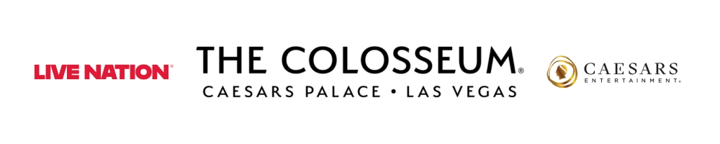
LISA ADDS TWO NEW DATES TO HER SOLD-OUT LAS VEGAS RESIDENCY DUE TO OVERWHELMING DEMAND
VIVA LA LISA
AT THE COLOSSEUM AT CAESARS PALACE
NOV 12, 13, 14, 27, 28 & 29 2026

MAKES HISTORY AS THE FIRST K-POP ARTIST WITH A VEGAS RESIDENCY

General on sale begins September 30th

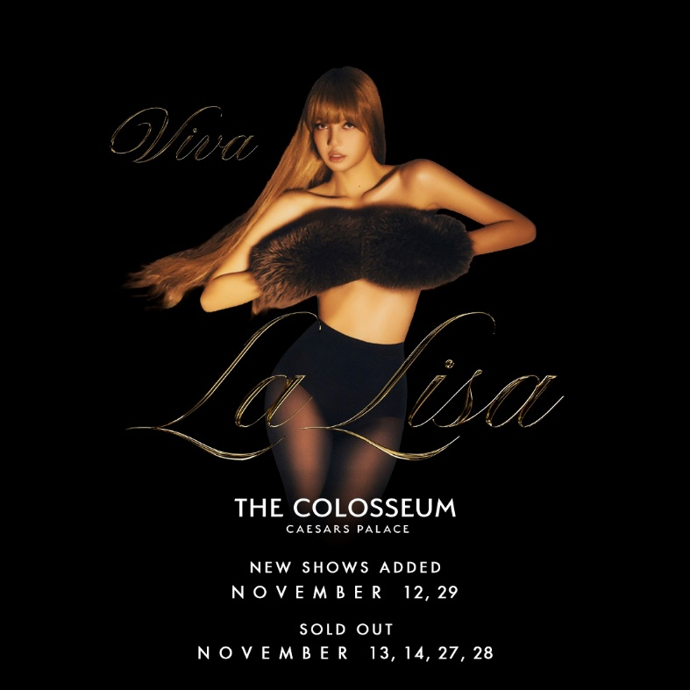

Hi-Res Download HERE

LAS VEGAS, NV (September 29, 2026) – Today, world renowned rapper, singer, dancer, and style icon, LISA announces two additional dates of her first ever Las Vegas residency, VIVA LA LISA, coming to The Colosseum at Caesars Palace in November 2026.

Due to incredible fan demand, LISA initially sold out the first four dates in under 10 minutes. The newly added shows will take place on Thursday, November 12th and Sunday, November 29th expanding the previously announced weekends for a total of six shows. This is a historic run for LISA as the first K-pop artist to have a Vegas residency.

General on-sale begins tomorrow, Wednesday, September 30th. Tickets are available at ticketmaster.com.

The announcement comes off the heels of LISA’s newest single “SaWaDiKa” - Listen HERE/Watch HERE. The music video, shot in her native Bangkok, Thailand garnered 70.8 million views in under the first 24 hours of release. “SaWaDiKa” is the first release from LISA’s forthcoming EP, PRESS PLAY, releasing on October 23rd. LISA debuted the first televised performance of “SaWaDiKa” at the 2026 MTV Video Music Awards. She also took home the award for Best Pop for “Dream feat. Kenatro Sakaguchi” making history as the first K-pop artist to win the category.

Aside from music, LISA’s feature documentary Always Lalisa directed by Sue Kim recently premiered at the Toronto Film Festival and will release in cinemas worldwide on October 12th. For more information and to purchase tickets, please visit www.AlwaysLaLisa.com.

VIVA LA LISA DATES:
Thursday, November 12 - The Colosseum at Caesars Palace*
Friday, November 13 - The Colosseum at Caesars Palace
Saturday, November 14- The Colosseum at Caesars Palace
Friday, November 27- The Colosseum at Caesars Palace
Saturday, November 28 - The Colosseum at Caesars Palace
Sunday, November 29 - The Colosseum at Caesars Palace*
*Indicates New Dates

FOLLOW LISA: INSTAGRAM
About LISA
LISA is a singer, dancer, rapper and actor best known as a member of the globally renowned K-pop girl group BLACKPINK. Beyond her success with BLACKPINK, LISA has made a name for herself as a solo artist. In 2024, LISA launched her own management company, LLOUD CO., to create a platform that showcases her overall vision in music and entertainment that pushes boundaries. In partnership with LLOUD Co. and RCA Records, LISA released her solo debut album, Alter Ego, in February 2025, which included breakout tracks “Rockstar,” “New Woman” with ROSALÍA, “Born Again” with Doja Cat and Raye, and more. As a solo performer, LISA has taken the stage at some of the world’s biggest events, including the Global Citizen Festival, Victoria’s Secret Fashion Show, MTV VMAs, The Academy Awards, and Coachella, where she made her solo debut in 2025 to one of the largest crowds the Sahara tent has ever seen. Most recently, she performed at the opening of the 2026 FIFA World Cup in Los Angeles alongside Anitta and Rema, debuting their song “Goals” from the Official FIFA World Cup 2026 Album. Outside of music, LISA made her acting debut as “Mook” in the Emmy-nominated third season of HBO’s hit series The White Lotus and is currently embarking on her first major film role in TYGO, a new chapter of the Extraction universe. This month, she will premiere her documentary, Always Lalisa, at the Toronto International Film Festival. Up next, LISA will release more new solo music with her single “SaWaDiKa” and upcoming PRESS PLAY EP, out October 23, before continuing the fall with four sold-out nights this November as she makes history as the first K-pop act to announce a Las Vegas residency with her show, VIVA LA LISA, at the Colosseum at Caesars Palace.

About Caesars Palace
Caesars Palace, the iconic Las Vegas Strip resort where every guest is treated like a Caesar, features 3,980 hotel guest rooms and suites, including the redesigned 182-room Nobu Hotel Caesars Palace, the renovated Colosseum Tower and THE VILLAS Caesars Palace, which has earned the prestigious AAA Five Diamond rating. Both Caesars Palace and Nobu Hotel Caesars Palace have also received AAA Four Diamond designations. The 85-acre resort offers diverse dining options from the award-winning Bacchanal Buffet to celebrity chef-branded restaurants, including Gordon Ramsay HELL’S KITCHEN, Pronto by Giada, Amalfi by Bobby Flay, Vanderpump Cocktail Garden by restaurateur and television star Lisa Vanderpump, one of Nobu Matsuhisa’s largest Nobu restaurants, Restaurant Guy Savoy, award-winning pastry chef Dominique Ansel’s first Las Vegas bakery, Stanton Social Italian – a dining concept in partnership with Tao Group Hospitality, legendary New York Steak House Peter Luger and Brasserie B Parisian Steakhouse by Bobby Flay. The Celebrity Food Hall features Guy Fieri’s Chicken Guy!, Bobby’s Burgers by Bobby Flay, Tortazo by Rick Bayless, Buddy V’s Pizzeria and Mokbar by Esther Choi. For the best in cocktails, destination lounges include Montecristo Cigar Bar, VISTA Cocktail Lounge, Stadia Bar and Caspian’s – a cocktail and caviar bar with Clique Hospitality. The resort also features nearly 130,000 square feet of casino space, the Caesars Race & Sportsbook at Caesars Palace with a 143-foot HD LED screen and state-of-the-art sound, a five-acre Garden of the Gods Pool Oasis, the luxurious Qua Baths & Spa, Hairdreams by Michael Boychuck, five wedding chapels and gardens, the 75,000-square-foot OMNIA Nightclub and OMNIA Dayclub & Skybar on Las Vegas Boulevard. The 4,300-seat Colosseum is the most celebrated venue in Las Vegas with an impressive legacy of superstar talent featured in an intimate, once-in-a-lifetime setting. The Colosseum currently spotlights world-class entertainers, including LISA, Josh Groban, Tim McGraw, Nikki Glaser and David Spade and Rod Stewart. Also, the Green Fairy Garden in front of Caesars Palace hosts ABSINTHE by Spiegelworld, an adults-only circus variety show featuring a cocktail of wild and outlandish acts. The Forum Shops at Caesars Palace showcases more than 160 boutiques and restaurants. Caesars Palace is operated by a subsidiary of Caesars Entertainment, Inc. (NASDAQ: CZR). For more information, please visit caesarspalace.com or the Caesars Entertainment media room. Find Caesars Palace on Facebook and follow on X and Instagram. Know When To Stop Before You Start.® If you or someone you know has a gambling problem, crisis counseling and referral services can be accessed by calling or texting 1-800- 522-4700, Caesars License Company, LLC.

About Live Nation Las Vegas
Live Nation Entertainment (NYSE: LYV) is the world’s leading live entertainment company comprised of global market leaders: Ticketmaster, Live Nation Concerts, and Live Nation Sponsorship. Live Nation Las Vegas produces residency shows from Tim McGraw, Josh Groban, Kelly Clarkson and Rod Stewart at The Colosseum at Caesars Palace; Mary J. Blige, Sammy Hagar, New Kids On The Block and Bruno Mars at Dolby Live at Park MGM; The B-52s, Earth, Wind & Fire, FOREIGNER, STYX and Chicago at The Venetian Theatre at The Venetian Resort Las Vegas; Scorpions at PH Live at Planet Hollywood Resort & Casino; and Santana at House of Blues. Live Nation Las Vegas also brings other world-famous artists to many of the city’s other premier concert venues including Allegiant Stadium, T-Mobile Arena, MGM Grand Garden Arena, Michelob ULTRA Arena, the Pearl at Palms Casino Resort and more. For additional information, visit www.livenationentertainment.com. Find Live Nation Las Vegas on Facebook and Instagram.

For more information on LISA, please contact The LEDE Company:
Kristin Somin | kristin.somin@ledecompany.com
Alex Labrie | alex.labrie@ledecompany.com
Emily Leonard | emily.leonard@ledecompany.com

For Caesars Entertainment:
Robert Jarrett
RJarrett@caesars.com

For Live Nation Las Vegas:
Kelly Frey
Kelly@KFPublicity.com

