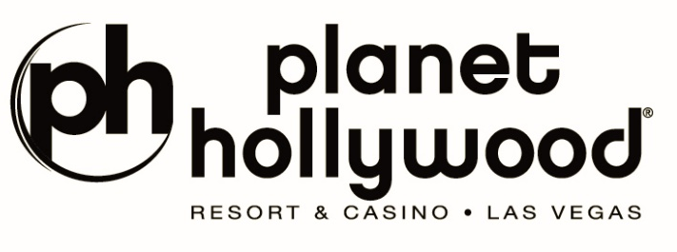
TWO NIGHTS. TWO WORLDS. ONE UNFORGETTABLE LAS VEGAS WEEKEND.
“VŨ TRỤ SAY HI” & HIEUTHUHAI LIVE CONCERT “MẮT NHẮM MẮT MỞ”
Two special concert experiences created for U.S. audiences at PH Live, Planet Hollywood Resort & Casino

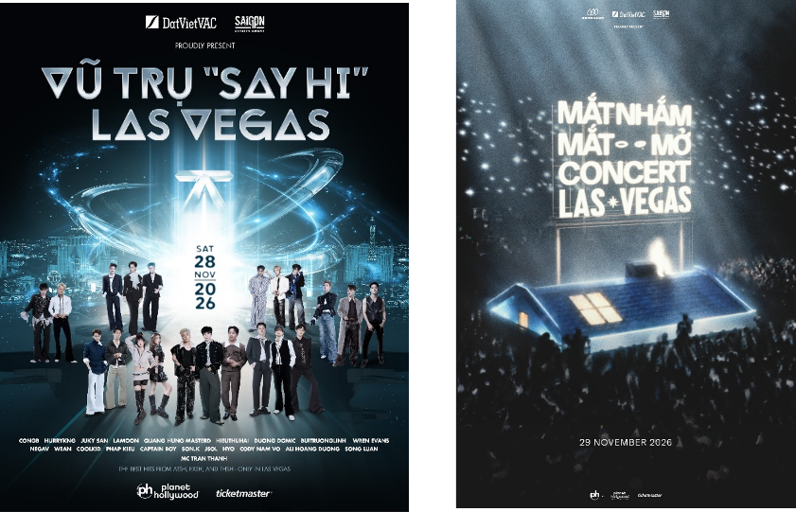
NOVEMBER 28, 2026 — VŨ TRỤ SAY HI
NOVEMBER 29, 2026 — HIEUTHUHAI LIVE CONCERT “MẮT NHẮM MẮT MỞ”
Co-organized by Casino Entertainment Corp. • Saigon Entertainment • VieON
For Vietnamese translation, click HERE
LAS VEGAS, NV (Sept. 28, 2026) — Some concerts are remembered for the music. Some are remembered because we finally got to see an artist we love. And then there are nights that stay with us long after the lights go dark. Hearing one song years later can bring back exactly where we were, who stood beside us and how we felt.
This Thanksgiving weekend, Casino Entertainment Corp., Saigon Entertainment and VieON will bring two distinct Vietnamese music experiences to PH Live at Planet Hollywood Resort & Casino: “Vũ Trụ Say Hi” on Saturday, November 28 and HIEUTHUHAI Live Concert “Mắt Nhắm Mắt Mở” on Sunday, November 29.
Two nights. Two musical worlds. One extraordinary weekend. These special experiences are created for U.S. audiences — fans who have loved and supported Vietnamese music from thousands of miles away. Sometimes the distance between America and Vietnam is only one song away.
NOVEMBER 28, 2026 — VŨ TRỤ SAY HI
AN ENTIRE UNIVERSE CREATED FOR U.S. AUDIENCES
On November 28, PH Live will become a meeting place for music, youth, emotion and community. “Vũ Trụ Say Hi” invites audiences to do more than watch artists perform: it invites them to become part of the experience.
Imagine an entire theater singing the same lyrics, the roar when a favorite artist steps onstage, and thousands of phone lights illuminating the room. Friends will travel from California, Texas, New York, Washington, Canada and beyond for one shared weekend in Las Vegas.
It may be a mother attending with her child, a Vietnamese American raised in the United States who knows every lyric, or someone who has lived far from Vietnam for decades and suddenly feels close to home through a familiar melody. For a few unforgettable hours, PH Live will become a little piece of Vietnam in the heart of America.
NOVEMBER 29, 2026 — HIEUTHUHAI LIVE CONCERT “MẮT NHẮM MẮT MỞ”
SOME THINGS WE SEE. OTHERS WE FEEL WHEN WE CLOSE OUR EYES.
If November 28 is the energy of an entire musical universe, November 29 invites audiences into HIEUTHUHAI’s own world: closer, more personal and more emotional. “Mắt Nhắm Mắt Mở” comes to Las Vegas as a special concert experience for U.S. audiences.
With our eyes open, we see the lights, the stage, the artist and the people around us. When we close our eyes, we may find a memory, someone we once loved, a chapter of our youth or a song that stayed with us through our happiest days or loneliest nights.
Some will come for HIEUTHUHAI; some for a particular song. Some will arrive with someone they love; others may come alone to reconnect with a part of themselves. When the first notes begin, they become part of a shared story that can only happen once — on November 29 in Las Vegas.
TWO NIGHTS TO EXPERIENCE TOGETHER
November 28 is “Vũ Trụ Say Hi” — youthful, colorful and full of the energy of a community coming together. November 29 is HIEUTHUHAI’s “Mắt Nhắm Mắt Mở” — a more personal world where music and emotion take center stage. One night to Say Hi to an entire Universe. One night to close your eyes and feel the music.
THREE ORGANIZATIONS. ONE SHARED VISION.
Casino Entertainment Corp., Saigon Entertainment and VieON share a vision of bringing Vietnamese entertainment to international audiences with cultural identity, ambition and emotion. Together, they aim to create stages where Vietnamese music can be experienced with the production and pride it deserves.
Michael Nguyen, CEO/Producer of Casino Entertainment Corp. & Saigon Entertainment, said:
“Together with VieON, we want to create more than a repeat of a show audiences have already seen in Vietnam. U.S. audiences have waited a long time and deserve experiences made especially for them. “Vũ Trụ Say Hi” and HIEUTHUHAI Live Concert “Mắt Nhắm Mắt Mở” are different worlds with one shared purpose: a beautiful memory for the audience. Years from now, we may forget our seat numbers, the ticket price or how many videos we recorded. We will remember how the night made us feel. We want people to walk out of PH Live saying, “I will remember that night for a very long time.””
SATURDAY, NOVEMBER 28, 2026: Vũ Trụ Say Hi
SUNDAY, NOVEMBER 29, 2026: HIEUTHUHAI Live Concert “Mắt Nhắm Mắt Mở”
PH Live at Planet Hollywood Resort & Casino • Las Vegas, Nevada
Tickets will go on sale to the public Tuesday, Oct. 6 at 10 a.m. PT at ticketmaster.com.
About Planet Hollywood Resort & Casino
Planet Hollywood Resort & Casino is the centerpiece of the famed Las Vegas Strip, with 2,500 beautifully redesigned guest rooms and suites showcasing some of the best views in town, along with endless options of unparalleled shopping, distinguished dining, popular entertainment and a bustling nightlife. A bright, bold addition to the resort’s portfolio, the Ultra Hip Rooms feature contemporary elegance and luxury bedding. Known as the place to play for its roster of A-list celebrity guests, Planet Hollywood’s 231 restyled suites feature stunning views of the glittering skyline and daring décor elements such as suspended sofas, lounge-style living spaces and oversized modern artwork. The resort encompasses more than 100,000 square feet of gaming, Caesars Sportsbook at Planet Hollywood, The Scene Pool Deck, several lounges, an intimate wedding chapel and Reflections the Spa at Planet Hollywood. Impressive restaurants include Gordon Ramsay Burger, Strip House, Caramella – an Italian restaurant and lounge in partnership with Tao Group Hospitality – and more. PH Live is one of the largest and most celebrated theaters on The Strip and showcases a variety of resident headliners, tour stops and limited engagements from music’s top artists. Magician Criss Angel performs an over-the-top visual spectacular with “Criss Angel MINDFREAK®” in the Criss Angel Theater. The property is encircled by Miracle Mile Shops with more than 150 specialty stores and restaurants. Planet Hollywood Resort & Casino is operated by a subsidiary of Caesars Entertainment, Inc. (NASDAQ: CZR). For more information, please visit planethollywoodresort.com or the Caesars Entertainment media room. Find Planet Hollywood Resort & Casino on Facebook and follow on X and Instagram. Must be 21 or older to gamble. Know When To Stop Before You Start.® If you or someone you know has a gambling problem, crisis counseling and referral services can be accessed by calling or texting 1-800-GAMBLER, Caesars License Company, LLC.
Media Contact:
For Caesars Entertainment:
Robert Jarrett
RJarrett@caesars.com

