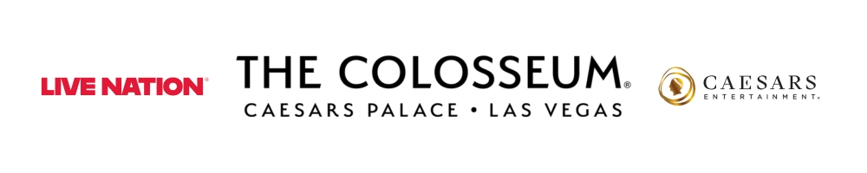
NIKKI GLASER AND DAVID SPADE
ANNOUNCE 2027 DATES FOR LAS VEGAS RESIDENCY AT
THE COLOSSEUM AT CAESARS PALACE

Presales begin Tuesday, Sept. 29
Public on sale begins Friday, Oct. 2

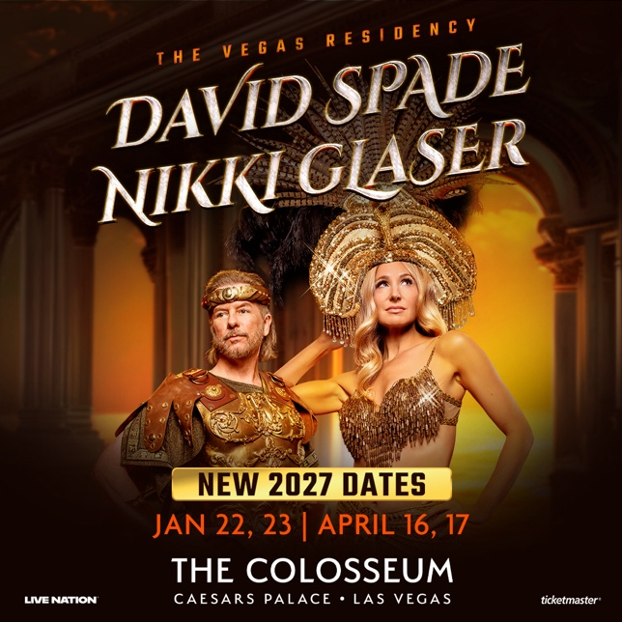

Click HERE for admat and photo
LAS VEGAS, NV (Sept. 28, 2026) – Comedy favorites Nikki Glaser and David Spade have announced 2027 dates for their Las Vegas residency, returning to The Colosseum at Caesars Palace on January 22 & 23 and April 16 & 17, 2027.

Citi is the official card of Nikki Glaser and David Spade at The Colosseum at Caesars Palace. Citi cardmembers will have access to presale tickets beginning Tuesday, Sept. 29 at 10 a.m. PT until Thursday, Oct. 1 at 10 p.m. PT through the Citi Entertainment program. For complete presale details visit www.citientertainment.com.

Artist fans will have access to a presale beginning Tuesday, Sept. 29 at 10 a.m. PT. Caesars Rewards members, Caesars Entertainment’s loyalty program, as well as Live Nation customers, will have access to a presale beginning Wednesday, Sept. 30 at 10 a.m. PT. All presales will end Thursday, Oct. 1 at 10 p.m. PT.

Tickets will go on sale to the public Friday, Oct. 2 at 10 a.m. PT at ticketmaster.com, with all shows scheduled to begin at 8 p.m.

About Nikki Glaser
For nearly two decades at sold-out tours, and as the host of three hit podcasts, Emmy®, Grammy® and Golden Globe®-nominated Nikki Glaser has honed her shockingly honest, no-holds barred style, solidifying herself as one of the funniest voices in comedy today.

On January 5, 2025, Glaser made history as the first woman to host the Golden Globe® Awards solo. She received praise from audiences worldwide and rave reviews from critics alike hailing her memorable performance as “victorious.” She returned as host of the 83rd Golden Globe® Awards on January 11, 2026, to equally unanimous praise, earning a 2026 Primetime Emmy® Award nomination for Outstanding Variety Special (Live), as well as a WGA Award nomination. She is set to reprise her role as host for a third time at the 84th Golden Globe® Awards on January 10, 2027.

Last October, in front of a sold-out crowd at the Fabulous Fox Theatre in her hometown of St. Louis, Missouri, Nikki taped her newest hour-long comedy special for Hulu, NIKKI GLASER: GOOD GIRL, that premiered on April 24, 2026. The special earned three 2026 Primetime Emmy® Award nominations, including Outstanding Variety Special (Pre-Recorded), Outstanding Writing for a Variety Special, and Outstanding Picture Editing for Variety Programming. A few weeks later on November 8 she made her SATURDAY NIGHT LIVE hosting debut with musical guest Sombr.

2024 was a career defining year for Glaser, culminating with being named “Comedian of the Year” by The New York Times and one of the TIME100: The Most Influential People of 2025. One year later, Glaser graced the cover of the TIME100: The Most Influential People of 2026.

In film, Nikki has a slate of highly anticipated projects on the horizon. She will star, alongside Kim Kardashian, in Eva Longoria’s Netflix comedy THE FIFTH WHEEL written by Paula Pell and Janine Brito. This November, also for Netflix, she lends her voice to the animated film STEPS which reimagines the story of Cinderella (Amanda Seyfried) and features the voices of Ali Wong, Stephanie Hsu and Bette Midler. She will also co-write, produce and star in an original comedy inspired by the classic game MASH for Paramount Pictures. This SLIDING DOORS-style comedy follows a woman whose childhood MASH game magically becomes reality, and she discovers that the perfect life isn’t the one she imagined. Additionally, she will star in, co-write and produce a new romantic comedy for Universal Pictures with Judd Apatow producing.

Following the success of her Critics Choice Award-nominated HBO standup special, GOOD CLEAN FILTH in 2022, Glaser’s highly anticipated second HBO comedy special, SOMEDAY YOU’LL DIE premiered in May 2024 to a record-breaking audience. It set the record for both the best premiere night for an HBO comedy special in more than two years and for the #1 largest streaming audience for a Comedy Special in HBO Max history. Glaser was nominated for an Emmy® Award for “Outstanding Variety Special (Pre-Recorded),” a Grammy® Award for “Best Comedy Album,” a Golden Globe® Award for "Best Performance in a Stand-Up Comedy on Television," a Critics Choice Award for “Best Comedy Special” and a WGA Award for “Comedy/Variety Special,” which she won. Glaser also wrote and performed “Someday You’ll Die” the special’s theme song that is available on all streaming platforms. The single was recorded in Glaser’s hometown of St. Louis with producers Dan Monahan and Tim Convy. Released by Bailey Blues in partnership with Redbird Records, the track shows a different side of Glaser, but fans of her comedy will recognize her trademark wit and authenticity throughout the lyrics.
Glaser was also the undeniable standout on Netflix’s Emmy®-nominated THE GREATEST ROAST OF ALL TIME: TOM BRADY which earned her viral attention and reinstated her title as “the best roaster on the planet” according to Indiewire. The roast aired live and unedited on Netflix from the Kia Forum in Los Angeles on May 5, 2024.

After wrapping her global THE GOOD GIRL tour in 2024 and her ALIVE AND UNWELL tour across the US, Canada and Australia in 2025, Nikki is now on her all-new THE STUNNING tour across Europe and North America.

From March 2021 to March 2025, Glaser hosted THE NIKKI GLASER PODCAST for iHeartMedia and Will Ferrell’s Big Money Players Network, where she provided a fun and brutally honest look into pop-culture and her personal life in weekly episodes. THE NIKKI GLASER PODCAST was nominated for “Best Comedy” by the 2025 iHeart Podcast Awards.

Nikki hosts and executive produces LOVERS AND LIARS (formerly FGIRL ISLAND), which premiered on the CW on April 11, 2024. LOVERS AND LIARS is the female spinoff of the hit HBO Max reality dating series FBOY ISLAND, which Nikki hosted and executive produced for three seasons. The Washington Post hailed FBOY ISLAND as “deliciously twisty” and TIME called it a “compelling and clever masterpiece” with “smart execution” noting that, “An advisor to the women and a gentle antagonist to the FBoys, Glaser, a comedian, brings just the right level of self-aware humor.” Season one of FBOY ISLAND had the biggest premiere weekend for an HBO Max Original reality series since the platform’s launch.

Nikki took her love of reality TV to the next level by starring in, and executive producing, the E! half-hour reality sitcom WELCOME HOME NIKKI GLASER? Uprooted from her fast-paced Hollywood lifestyle, Nikki returns to her hometown of St. Louis where she embarks on a hilarious and often uncomfortable journey of self-discovery. Unfiltered, relatable, and unapologetically herself, Nikki navigates friends, family, and romance as a homegrown local celebrity.

Previously, Nikki flexed her over-sharing muscle as the host of Comedy Central’s first live daily morning show, YOU UP WITH NIKKI GLASER for SiriusXM, which ran from February 2018 to October 2020. Nikki’s most recent Netflix comedy special, BANGIN’, was released in October 2019. BANGIN’ was the most watched special on Netflix when it premiered. Nikki hosted, co-created and executive produced the critically acclaimed and daring comedic show, NOT SAFE WITH NIKKI GLASER, for Comedy Central and NIKKI & SARA LIVE for MTV.

Nikki was a standout on three Comedy Central Roasts, including those of Bruce Willis and Rob Lowe, which led to her guest-hosting JIMMY KIMMEL LIVE! and hosting the inaugural edition of the 2021 MTV MOVIE & TV AWARDS: UNSCRIPTED, which earned her stellar reviews. She also had memorable film and television roles in Judd Apatow’s TRAINWRECK, NBC’s AP BIO and INSIDE AMY SCHUMER, amongst others. In November 2022 Nikki was a triumph coming in third place on the ninth season of the hit FOX series THE MASKED SINGER.

Nikki has multiple stand-up specials and late-night tv appearances in which she jokes about her most humiliating moments as a woman in the modern world. Nikki’s past and current struggles with anorexia, depression, and anxiety are fair game in both her stand-up, and in-depth interviews with THE HOWARD STERN SHOW, WTF with MARC MARON, CONAN O ́BRIEN NEEDS A FRIEND and THE JOE ROGAN EXPERIENCE. She has become a complete open book on mic for the laughs and as the empowering voice for women that she yearned for as a confused adolescent.

About David Spade
David Spade became a household favorite during his tenure as a cast member on NBC’s “Saturday Night Live” For his memorable role as Dennis Finch, the wise-cracking, power-hungry assistant on “Just Shoot Me,” Spade received nominations for a 1999 Emmy Award, Golden Globe, and American Comedy Award. Recently, Spade also completed a nationwide stand-up tour. His more recent projects include his comedy special “Dandelion” that premiered in May 2025 on Amazon Prime Video, and his role in the Apple TV film OUTCOME. In April 2026, Spade co-wrote, produced, and starred in the film Busboys alongside comedian and podcaster Theo Von.

Currently, Spade is in production on the long-awaited GROWN UPS 3, which is slated for release on Netflix in summer 2027. He previously starred in Sony Pictures’ GROWN UPS 2 alongside Adam Sandler, Chris Rock, and Kevin James, reprising the ensemble comedy franchise that began with the 2010 hit about a group of childhood friends reuniting years later.

He can also be heard co-hosting the top ranked podcast “Fly on the Wall,” alongside fellow SNL alumni Dana Carvey. They interview cast members, hosts, writers, and musical guests, as they share never-before told stories about their careers and SNL's cultural history. The podcast debuted at #1 in the Comedy category and is frequently ranked among Apple’s top podcast charts. It went on to earn a nomination for Podcast of the Year at the 2023 iHeartRadio Podcast Awards and won Best Comedy Podcast at the 2025 iHeartRadio Podcast Awards. Now on its second season, the podcast has featured interviews with Sir Paul McCartney, Lorne Michaels, Jimmy Fallon, Martin Short, Tina Fey, Maya Rudolph, Molly Shannon, Tom Hanks, and many more. New episodes are released every Monday and Thursday, everywhere podcasts are available.

Spade also starred in the 2020 Netflix original comedy, THE WRONG MISSY. At the time of release, the film was the # 1 movie on Netflix and the eighth most-watched Netflix original movie in the company’s history. That same year, Spade also hosted his own late-night series “Lights Out with David Spade” on Comedy Central.

In July 2018, Spade released “A Polaroid Guy in a Snapchat World” exclusively on Audible. The audio book was a New York Times best-seller and was well received by critics and fans. Spade was also seen in the Netflix original comedy, FATHER OF THE YEAR which was one of the highest streamed films globally on Netflix. Prior to that, Spade starred in the Netflix original comedy THE DO-OVER, opposite Adam Sandler and Paula Patton, which is one of Netflix’s biggest original film releases.

In 2015, Spade reprised his role as the hilarious and endearing “white trash” misfit, Joe Dirt, in the sequel to the cult classic, JOE DIRT 2: BEAUTIFUL LOSER, directed by Fred Wolf, with whom he also co-wrote the script. The film has been streamed over two million times, making it Crackle’s most watched original movie to date. Later that same year, Spade also released his memoir, Almost Interesting, through Dey Street Books, which went on to become a New York Times Bestseller.

In 2012, Spade was heard as the voice of Griffin the Invisible Man in the animated feature, HOTEL TRANSYLVANIA alongside Adam Sandler, Selena Gomez, Steve Buscemi, Kevin James, and Andy Samberg, among others. He reprised his role in the film’s sequel, HOTEL TRANSYLVANIA 2, and returned for the third installment HOTEL TRANSYLVANIA 3: SUMMER VACATION. He reprised his role in HOTEL TRANSYLVANIA 4: TRANSFORMANIA, which was released on Amazon Prime in 2022.

Other popular film credits include Sony Pictures’ BENCHWARMERS and Paramount Pictures’ DICKIE ROBERTS: FORMER CHILD STAR, the latter which he co-wrote with Fred Wolf. Both opened # 1 at the box office and enjoyed critical and commercial success. Spade also co-starred with SNL alumnus Chris Farley in the films TOMMY BOY and BLACKSHEEP, the former for which the pair won a 1996 MTV Movie Award for "Best On-Screen Duo." He has also appeared in REALITY BITES, LIGHT SLEEPER, CONEHEADS, and LOST & FOUND (which he also co-wrote the screenplay).

On the small screen, Spade starred in the CBS comedy “Rules of Engagement.” The show was produced by Sony’s Happy Madison Productions and centered around three men in different stages of their relationships: married, engaged, and single. The series enjoyed excellent ratings and critical success throughout all of its seven seasons. He also appeared in “The Showbiz Show” for Comedy Central, which aired from 2005-2007. Spade created, executive produced, hosted and wrote the show along with pal and former SNL writer Hugh Fink. He also had a memorable guest starring role on the critically acclaimed “The Larry Sanders Show” and appeared in HBO’s “13thAnnual Young Comedians Special”. Spade has also had several well-received standup comedy specials, including Comedy Central’s “David Spade: My Fake Problems” in 2014.

Born in Birmingham, Michigan, and raised in Scottsdale, Arizona, Spade began his career by performing stand-up comedy in clubs, theaters and colleges across the country. He made his television debut on SNL and was soon named the “Hot Stand-Up Comedian of the Year” by Rolling Stone Magazine. As a writer and a performer on SNL for five years, he is best known for his memorable characters including the sarcastic “Hollywood Minute” reporter on “Weekend Update” and catch phrases like “And you are…?” and “Buh-Bye!.”

About Caesars Palace
Caesars Palace, the iconic Las Vegas Strip resort where every guest is treated like a Caesar, features 3,980 hotel guest rooms and suites, including the redesigned 182-room Nobu Hotel Caesars Palace, the renovated Colosseum Tower and THE VILLAS Caesars Palace, which has earned the prestigious AAA Five Diamond rating. Both Caesars Palace and Nobu Hotel Caesars Palace have also received AAA Four Diamond designations. The 85-acre resort offers diverse dining options from the award-winning Bacchanal Buffet to celebrity chef-branded restaurants, including Gordon Ramsay HELL’S KITCHEN, Pronto by Giada, Amalfi by Bobby Flay, Vanderpump Cocktail Garden by restaurateur and television star Lisa Vanderpump, one of Nobu Matsuhisa’s largest Nobu restaurants, MICHELIN-starred Restaurant Guy Savoy, award-winning pastry chef Dominique Ansel’s first Las Vegas bakery, Stanton Social Italian – a dining concept in partnership with Tao Group Hospitality, legendary New York Steak House Peter Luger and Brasserie B Parisian Steakhouse by Bobby Flay. The Celebrity Food Hall features Guy Fieri’s Chicken Guy!, Bobby’s Burgers by Bobby Flay, Tortazo by Rick Bayless, Buddy V’s Pizzeria and Mokbar by Esther Choi. For the best in cocktails, destination lounges include Montecristo Cigar Bar, VISTA Cocktail Lounge, Stadia Bar and Caspian’s – a cocktail and caviar bar with Clique Hospitality. The resort also features nearly 130,000 square feet of casino space, the Caesars Race & Sportsbook at Caesars Palace with a 143-foot HD LED screen and state-of-the-art sound, a five-acre Garden of the Gods Pool Oasis, the luxurious Qua Baths & Spa, Hairdreams by Michael Boychuck, five wedding chapels and gardens, the 75,000-square-foot OMNIA Nightclub and OMNIA Dayclub & Skybar on Las Vegas Boulevard. The 4,300-seat Colosseum is the most celebrated venue in Las Vegas with an impressive legacy of superstar talent featured in an intimate, once-in-a-lifetime setting. The Colosseum currently spotlights world-class entertainers, including LISA, Nikki Glaser and David Spade, Josh Groban and Tim McGraw. Also, the Green Fairy Garden in front of Caesars Palace hosts ABSINTHE by Spiegelworld, an adults-only circus variety show featuring a cocktail of wild and outlandish acts. The Forum Shops at Caesars Palace showcases more than 160 boutiques and restaurants. Caesars Palace is operated by a subsidiary of Caesars Entertainment, Inc. (NASDAQ: CZR). For more information, please visit caesarspalace.com or the Caesars Entertainment media room. Find Caesars Palace on Facebook and follow on X and Instagram. Know When To Stop Before You Start.® If you or someone you know has a gambling problem, crisis counseling and referral services can be accessed by calling or texting 1-800- 522-4700, Caesars License Company, LLC.

About Live Nation Las Vegas
Live Nation Entertainment (NYSE: LYV) is the world’s leading live entertainment company comprised of global market leaders: Ticketmaster, Live Nation Concerts, and Live Nation Sponsorship. Live Nation Las Vegas produces residency shows from Tim McGraw, Josh Groban, Kelly Clarkson and Rod Stewart at The Colosseum at Caesars Palace; Mary J. Blige, Sammy Hagar, New Kids On The Block and Bruno Mars at Dolby Live at Park MGM; The B-52s, Earth, Wind & Fire, FOREIGNER, STYX and Chicago at The Venetian Theatre at The Venetian Resort Las Vegas; Scorpions at PH Live at Planet Hollywood Resort & Casino; and Santana at House of Blues. Live Nation Las Vegas also brings other world-famous artists to many of the city’s other premier concert venues including Allegiant Stadium, T-Mobile Arena, MGM Grand Garden Arena, Michelob ULTRA Arena, the Pearl at Palms Casino Resort and more. For additional information, visit www.livenationentertainment.com. Find Live Nation Las Vegas on Facebook and Instagram.

###

MEDIA CONTACTS:
For Caesars Entertainment:
Robert Jarrett
RJarrett@caesars.com

For Live Nation Las Vegas:
Kelly Frey
Kelly@KFPublicity.com

