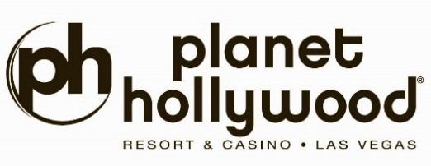

ALICE COOPER & CRISS ANGEL
ANNOUNCE ADDITIONAL DATES FOR
“WELCOME TO OUR NIGHTMARE”
AT PLANET HOLLYWOOD RESORT & CASINO

DUE TO OVERWHELMING DEMAND, TWO MORE SHOWS
HAVE BEEN ADDED! NOVEMBER 29 AND DECEMBER 6

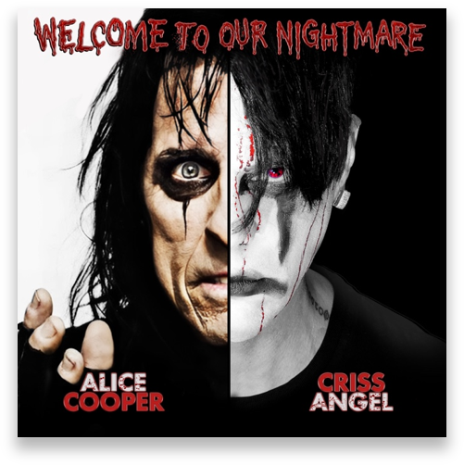

For photos, click here

LAS VEGAS (Sept. 25, 2026) – After nine sell-outs and selling-out existing shows, Alice Cooper and Criss Angel are excited to announce an additional two show dates. Shows have been added on November 29 and December 6, 2026.

Music icon Alice Cooper and magic GOAT Criss Angel unite to create the Shock Rock Magic experience of a lifetime, WELCOME TO OUR NIGHTMARE!, with all the smash hits in a theatrical visual feast that will destroy your MIND! Immerse your senses; run for your lives. History will be made again in The Criss Angel Theater at Planet Hollywood Resort & Casino with this exclusive limited engagement partnership. Welcome To OUR Nightmare! Are You Ready?

Alice and Angel bring the smash hits to life: “Poison,” “I’m 18,” “School’s Out,” “You and Me” and more in an unprecedented 90-minute revolutionary concert spectacle of magic, music and mayhem.

Additionally, fans can take advantage of exclusive ticket add-ons, including a limited number of Ultimate VIP Nightmare Experiences with an up close and personal backstage meet & greet with Alice and Criss, and a Nightmare Collectible Package.

Welcome To Our Nightmare will play in the Criss Angel Theater at Planet Hollywood Resort & Casino on November 27, 29, 29, and December 4, 5, 6, 2026, at 7 p.m. Tickets are on sale now and can be purchased via Ticketmaster.com/crissangel, or by calling (855) 234-7469. For more information on Nightmare VIP experiences and packages, visit Ticketmaster.com/crissangel.

###

About Planet Hollywood Resort & Casino
Planet Hollywood Resort & Casino is the centerpiece of the famed Las Vegas Strip, with 2,500 beautifully redesigned guest rooms and suites showcasing some of the best views in town, along with endless options of unparalleled shopping, distinguished dining, popular entertainment and a bustling nightlife. A bright, bold addition to the resort’s portfolio, the Ultra Hip Rooms feature contemporary elegance and luxury bedding. Known as the place to play for its roster of A-list celebrity guests, Planet Hollywood’s 231 restyled suites feature stunning views of the glittering skyline and daring décor elements such as suspended sofas, lounge-style living spaces and oversized modern artwork. The resort encompasses more than 100,000 square feet of gaming, Caesars Sportsbook at Planet Hollywood, The Scene Pool Deck, several lounges, an intimate wedding chapel and Reflections the Spa at Planet Hollywood. Impressive restaurants include Gordon Ramsay Burger, Strip House, Caramella – a new Italian restaurant and lounge in partnership with Tao Group Hospitality – and more. PH Live is one of the largest and most celebrated theaters on The Strip and showcases a variety of resident headliners, tour stops and limited engagements from music’s top artists. Magician Criss Angel performs an over-the-top visual spectacular with “Criss Angel MINDFREAK®” in the Criss Angel Theater. The world-famous male revue Chippendales bring high-energy performances, irresistible charm, live music and dazzling dance moves to the Chippendales Theater. The property is encircled by Miracle Mile Shops with more than 150 specialty stores and restaurants. Planet Hollywood Resort & Casino is operated by a subsidiary of Caesars Entertainment, Inc. (NASDAQ: CZR). For more information, please visit planethollywoodresort.com or the Caesars Entertainment media room. Find Planet Hollywood Resort & Casino on Facebook and follow on X and Instagram. Must be 21 or older to gamble. Know When To Stop Before You Start.® If you or someone you know has a gambling problem, crisis counseling and referral services can be accessed by calling or texting 1- 522-4700, Caesars License Company, LLC.

Media Contacts:
Robert Jarrett / Brooke Kaplan
RJarrett@caesars.com / BKaplan@caesars.com

