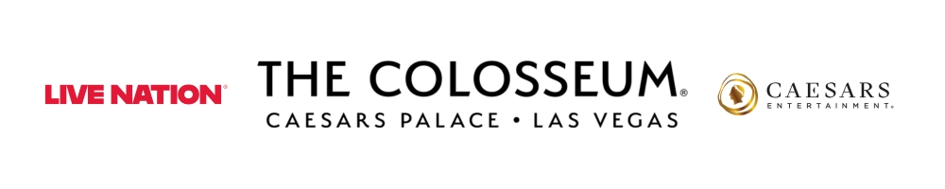
STING RETURNS TO THE COLOSSEUM AT CAESARS PALACE
WITH NEW LAS VEGAS RESIDENCY “STING 3.0”

TICKETS GO ON SALE SATURDAY, OCT. 17 AT 10 A.M. PT
SHOWS BEGIN MARCH 4, 2027

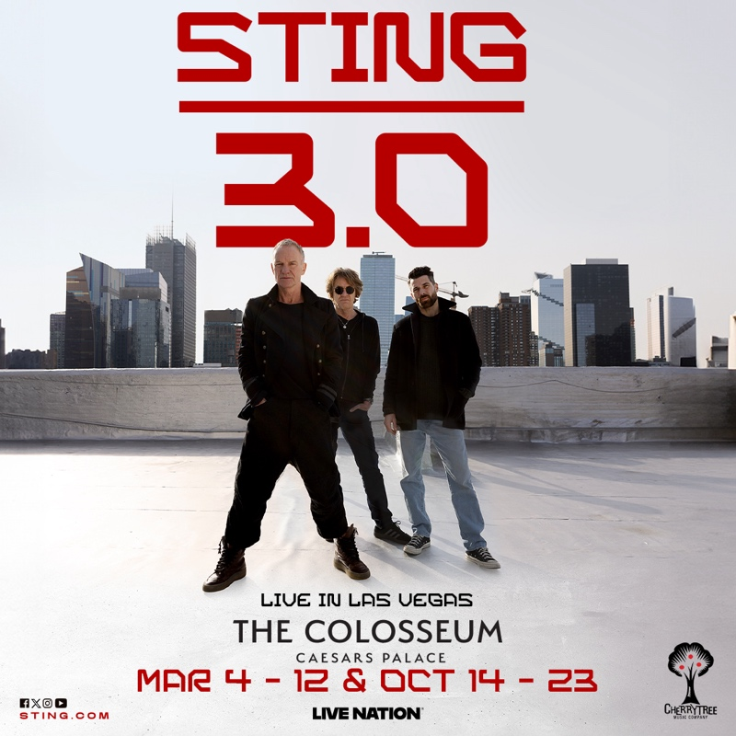

Click HERE for photo and admat
Photo credit: Carter B. Smith

LAS VEGAS (Oct. 13, 2026) – The Cherrytree Music Company, Live Nation and Caesars Entertainment announce that 17-time GRAMMY Award-winning musician Sting will return to The Colosseum at Caesars Palace with a new Las Vegas residency, “STING 3.0.” Launching Thursday, March 4, 2027, the engagement follows his universally celebrated “STING 3.0” World Tour and marks his return to The Colosseum after his critically acclaimed “My Songs” residency, which featured 22 sold-out performances from 2021 through 2023.

Accompanied by longtime guitarist Dominic Miller and dynamic drummer Chris Maas (Mumford & Sons, Maggie Rogers), “STING 3.0” reinvents Sting’s most beloved hits performed by a lean, explosive three-piece harnessing the full power of his voice and songwriting.

A groundbreaking artist both as a solo performer and as the frontman/bassist and principal songwriter for The Police, Sting continues to redefine and expand his musical horizons. Under the management of Martin Kierszenbaum/Cherrytree Music Company, his innovative spirit remains central to the “STING 3.0” Tour, which spotlights new creative interpretations of his timeless catalog and inspired his latest live album, STING 3.0 LIVE, now available digitally, on CD and on 180g vinyl. Recorded on the “STING 3.0” Tour, STING 3.0 LIVE is a collection of his greatest hits, including “Be Still My Beating Heart,” which has never-before been released as a live version. The 10-song digital album also features a live recording of “Fragile,” Sting’s 1987 single, which was covered by a children’s choir in an episode of the Netflix miniseries Adolescence.
Tickets for the “STING 3.0” Las Vegas residency go on sale to the public Saturday, Oct. 17 at 10 a.m. PT. Sting.com fan club members will have first access to a presale beginning Wednesday, Oct. 14 at 10 a.m. PT through Friday, Oct. 16 at 10 p.m. PT. (For more information, please visit https://www.sting.com/subscribe.)
In addition, Caesars Rewards members, Caesars Entertainment’s loyalty program, as well as Live Nation customers will have access to a presale running Thursday, Oct. 15 at 10 a.m. PT through Friday, Oct. 16 at 10 p.m. PT.

A limited number of VIP meet & greet packages are available for each show. All tickets and packages can be purchased online at Ticketmaster.com or in-person at The Colosseum box office. All shows begin at 8 p.m.

The 11 performances going on sale are:
March 2027: 4, 6, 7, 10, 12
October 2027: 14, 16, 17, 20, 22, 23

# # #

ABOUT STING: In Sting’s distinguished career, the Rock and Roll Hall of Famer has received 17 GRAMMY Awards® and sold 100 million albums worldwide from his combined work as one of the most distinctive solo artists in the world and former front man/bassist of The Police. A composer, singer-songwriter, actor, author and activist, Sting also has received a Golden Globe, four Oscar nominations, a Tony nomination, Billboard Magazine’s Century Award and Kennedy Center Honors. This year, he is also starring in his TONY-nominated musical, The Last Ship, on a limited international tour and recently released a new album, The Night Watch: Live at the Rijksmuseum – a special, intimate performance, featuring his most celebrated hits and songs from the show, captured at one of Europe’s most iconic museums. Sting’s support for human rights organizations such as the Rainforest Fund, Amnesty International, and Live Aid mirrors his art in its universal outreach. Along with wife Trudie Styler, Sting founded the Rainforest Fund in 1989 to protect both the world’s rainforests and the indigenous people living there. Official Website

About the Cherrytree Music Company: Founded in 2005 by multi-platinum, Grammy-nominated songwriter/producer Martin Kierszenbaum, the Cherrytree Music Company provides management, record label and publishing services to a boutique roster of artists, producers and mixers who push the creative envelope in popular music. In the 19 years since its inception and launch of its first-ever release, Feist’s “Let It Die” album, Cherrytree has had an indelible impact on the music landscape from managing celebrated musician and cultural icon Sting to launching Lady Gaga’s first two albums. The Cherrytree Music Company has also released culturally ground-breaking records and commercial successes by Ellie Goulding, LaRoux, Far East Movement and Robyn whose 2010 Cherrytree release “Body Talk” was named Album of the Decade by Rolling Stone. The Cherrytree Music Company, responsible for over 40-million-unit sales to-date, remains a vital source for popular music and catalyst for artist collaboration and innovation. For more information on the Cherrytree Music Company, click here and here for logo.

About Live Nation Las Vegas
Live Nation Entertainment (NYSE: LYV) is the world’s leading live entertainment company comprised of global market leaders: Ticketmaster, Live Nation Concerts, and Live Nation Sponsorship. Live Nation Las Vegas produces residency shows from Sting, LISA, Tim McGraw and Rod Stewart at The Colosseum at Caesars Palace; Mary J. Blige and Bruno Mars at Dolby Live at Park MGM; The B-52s, Earth, Wind & Fire, FOREIGNER, STYX and Chicago at The Venetian Theatre at The Venetian Resort Las Vegas; Scorpions at PH Live at Planet Hollywood Resort & Casino; and Santana at House of Blues. Live Nation Las Vegas also brings other world-famous artists to many of the city’s other premier concert venues including Allegiant Stadium, T-Mobile Arena, MGM Grand Garden Arena, Michelob ULTRA Arena, the Pearl at Palms Casino Resort and more. For additional information, visit www.livenationentertainment.com. Find Live Nation Las Vegas on Facebook and Instagram.

About Caesars Palace
Caesars Palace, the iconic Las Vegas Strip resort where every guest is treated like a Caesar, features 3,980 hotel guest rooms and suites, including the redesigned 182-room Nobu Hotel Caesars Palace, the renovated Colosseum Tower and THE VILLAS Caesars Palace, which has earned the prestigious AAA Five Diamond rating. Both Caesars Palace and Nobu Hotel Caesars Palace have also received AAA Four Diamond designations. The 85-acre resort offers diverse dining options from the award-winning Bacchanal Buffet to celebrity chef-branded restaurants, including Gordon Ramsay HELL’S KITCHEN, Pronto by Giada, Amalfi by Bobby Flay, Vanderpump Cocktail Garden by restaurateur and television star Lisa Vanderpump, one of Nobu Matsuhisa’s largest Nobu restaurants, MICHELIN-starred Restaurant Guy Savoy, award-winning pastry chef Dominique Ansel’s first Las Vegas bakery, Stanton Social Italian – a dining concept in partnership with Tao Group Hospitality, legendary New York Steak House Peter Luger and Brasserie B Parisian Steakhouse by Bobby Flay. The Celebrity Food Hall features Guy Fieri’s Chicken Guy!, Bobby’s Burgers by Bobby Flay, Tortazo by Rick Bayless, Buddy V’s Pizzeria and Mokbar by Esther Choi. For the best in cocktails, destination lounges include Montecristo Cigar Bar, VISTA Cocktail Lounge, Stadia Bar and Caspian’s – a cocktail and caviar bar with Clique Hospitality. The resort also features nearly 130,000 square feet of casino space, the Caesars Race & Sportsbook at Caesars Palace with a 143-foot HD LED screen and state-of-the-art sound, a five-acre Garden of the Gods Pool Oasis, the luxurious Qua Baths & Spa, Hairdreams by Michael Boychuck, five wedding chapels and gardens, the 75,000-square-foot OMNIA Nightclub and OMNIA Dayclub & Skybar on Las Vegas Boulevard. The 4,300-seat Colosseum is the most celebrated venue in Las Vegas with an impressive legacy of superstar talent featured in an intimate, once-in-a-lifetime setting. The Colosseum currently spotlights world-class entertainers, including LISA, Nikki Glaser and David Spade, Sting and Tim McGraw. Also, the Green Fairy Garden in front of Caesars Palace hosts ABSINTHE by Spiegelworld, an adults-only circus variety show featuring a cocktail of wild and outlandish acts. The Forum Shops at Caesars Palace showcases more than 160 boutiques and restaurants. Caesars Palace is operated by a subsidiary of Caesars Entertainment, Inc. (NASDAQ: CZR). For more information, please visit caesarspalace.com or the Caesars Entertainment media room. Find Caesars Palace on Facebook and follow on X and Instagram. Know When To Stop Before You Start.® If you or someone you know has a gambling problem, crisis counseling and referral services can be accessed by calling or texting 1-800-522-4700, Caesars License Company, LLC.

###

Media Contacts:
Live Nation Las Vegas
Kelly Frey
Kelly@kfpublicity.com
Caesars Entertainment
Robert Jarrett
RJarrett@caesars.com

Sting
Tracy Bufferd
tracy@tracybufferd.com

