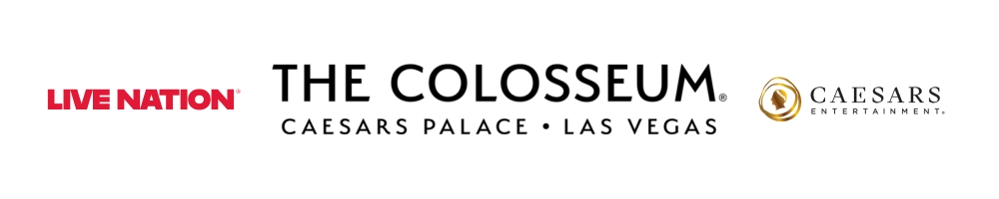
MATCHBOX TWENTY CELEBRATE
30TH ANNIVERSARY WITH MAJOR
NORTH AMERICAN TOUR

THE COLOSSEUM AT CAESARS PALACE
JUNE 11, 2027

General On Sale Begins Friday, Oct. 23 at 10 a.m. PT

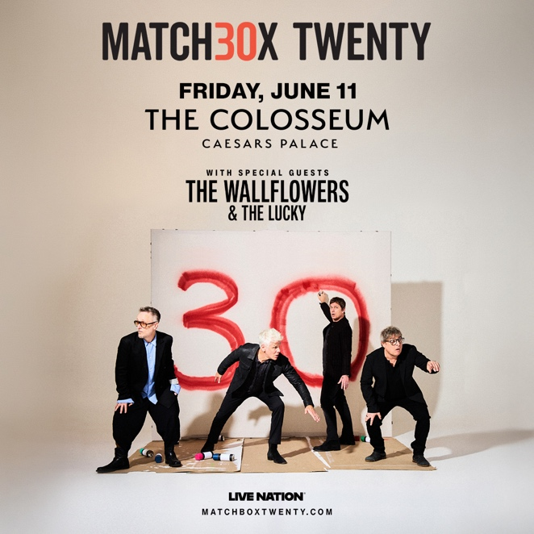

Click HERE for admat and photo
LAS VEGAS, NV (Oct. 13, 2026) – Matchbox Twenty announced their 30th Anniversary Tour, an extensive North American run celebrating three decades of music and milestones throughout the band’s three-decades-long career. Promoted by Live Nation, the 52-date tour will make a Las Vegas stop at The Colosseum at Caesars Palace on Friday, June 11, 2027, with special guests The Wallflowers and The Lucky.

The tour is the centerpiece of a yearlong anniversary celebration that began last night with an intimate, one-night-only performance at the Fonda Theatre in Los Angeles, where the band played songs from their landmark debut Yourself or Someone Like You, alongside other fan favorites. The celebration continues tomorrow when Matchbox Twenty perform on Jimmy Kimmel Live!. Just ahead of the tour, Matchbox Twenty will perform at Stagecoach Festival in Indio, CA on Sunday, April 25.

Matchbox Twenty’s Artist Presale starts Tuesday, Oct. 20 at 5 p.m. PT. All fans can sign up for access presale tickets on their tour dates page HERE.

Tickets will also be available starting with the Reserved by Spotify presale on Tuesday, Oct. 20 at 10 a.m. PT for eligible Spotify Premium top fans purchasing tickets in Ticketmaster venues. Additional presales will run throughout the week ahead of the general on sale beginning Friday, Oct. 23 at 10 a.m. PT at ticketmaster.com.

Released in 1996, Yourself or Someone Like You introduced Matchbox Twenty (Rob Thomas, Brian Yale, Paul Doucette and Kyle Cook) to the world and launched a career that has now spanned three decades. Featuring smash hit singles “3AM,” “Push,” “Real World,” “Back 2 Good,” “Long Day” and more, the diamond-certified, 12x-platinum album became one of the defining rock records of the era and established the band as a fixture of pop culture.

In the 30 years since, Matchbox Twenty have built a catalog of hits including “Bent,” “If You’re Gone,” “Unwell,” “How Far We’ve Come,” “She’s So Mean” and more. The band have sold more than 40 million records worldwide, topped charts, garnered multiple GRAMMY® Award nominations, and played to millions of fans across arenas, amphitheaters and stadiums on multiple continents.

About Live Nation Las Vegas
Live Nation Entertainment (NYSE: LYV) is the world’s leading live entertainment company comprised of global market leaders: Ticketmaster, Live Nation Concerts, and Live Nation Sponsorship. Live Nation Las Vegas produces residency shows from Sting, LISA, Tim McGraw and Rod Stewart at The Colosseum at Caesars Palace; Mary J. Blige and New Kids On The Block at Dolby Live at Park MGM; The B-52s, Earth, Wind & Fire, FOREIGNER, STYX and Chicago at The Venetian Theatre at The Venetian Resort Las Vegas; Scorpions and John Fogerty at PH Live at Planet Hollywood Resort & Casino; and Santana at House of Blues. Live Nation Las Vegas also brings other world-famous artists to many of the city’s other premier concert venues including Allegiant Stadium, T-Mobile Arena, MGM Grand Garden Arena, Michelob ULTRA Arena, the Pearl at Palms Casino Resort and more. For additional information, visit www.livenationentertainment.com. Find Live Nation Las Vegas on Facebook and Instagram.

About Caesars Palace
Caesars Palace, the iconic Las Vegas Strip resort where every guest is treated like a Caesar, features 3,980 hotel guest rooms and suites, including the redesigned 182-room Nobu Hotel Caesars Palace, the renovated Colosseum Tower and THE VILLAS Caesars Palace, which has earned the prestigious AAA Five Diamond rating. Both Caesars Palace and Nobu Hotel Caesars Palace have also received AAA Four Diamond designations. The 85-acre resort offers diverse dining options from the award-winning Bacchanal Buffet to celebrity chef-branded restaurants, including Gordon Ramsay HELL’S KITCHEN, Pronto by Giada, Amalfi by Bobby Flay, Vanderpump Cocktail Garden by restaurateur and television star Lisa Vanderpump, one of Nobu Matsuhisa’s largest Nobu restaurants, MICHELIN-starred Restaurant Guy Savoy, award-winning pastry chef Dominique Ansel’s first Las Vegas bakery, Stanton Social Italian – a dining concept in partnership with Tao Group Hospitality, legendary New York Steak House Peter Luger and Brasserie B Parisian Steakhouse by Bobby Flay. The Celebrity Food Hall features Guy Fieri’s Chicken Guy!, Bobby’s Burgers by Bobby Flay, Tortazo by Rick Bayless, Buddy V’s Pizzeria and Mokbar by Esther Choi. For the best in cocktails, destination lounges include Montecristo Cigar Bar, VISTA Cocktail Lounge, Stadia Bar and Caspian’s – a cocktail and caviar bar with Clique Hospitality. The resort also features nearly 130,000 square feet of casino space, the Caesars Race & Sportsbook at Caesars Palace with a 143-foot HD LED screen and state-of-the-art sound, a five-acre Garden of the Gods Pool Oasis, the luxurious Qua Baths & Spa, Hairdreams by Michael Boychuck, five wedding chapels and gardens, the 75,000-square-foot OMNIA Nightclub and OMNIA Dayclub & Skybar on Las Vegas Boulevard. The 4,300-seat Colosseum is the most celebrated venue in Las Vegas with an impressive legacy of superstar talent featured in an intimate, once-in-a-lifetime setting. The Colosseum currently spotlights world-class entertainers, including LISA, Nikki Glaser and David Spade, Sting and Tim McGraw. Also, the Green Fairy Garden in front of Caesars Palace hosts ABSINTHE by Spiegelworld, an adults-only circus variety show featuring a cocktail of wild and outlandish acts. The Forum Shops at Caesars Palace showcases more than 160 boutiques and restaurants. Caesars Palace is operated by a subsidiary of Caesars Entertainment, Inc. (NASDAQ: CZR). For more information, please visit caesarspalace.com or the Caesars Entertainment media room. Find Caesars Palace on Facebook and follow on X and Instagram. Know When To Stop Before You Start.® If you or someone you know has a gambling problem, crisis counseling and referral services can be accessed by calling or texting 1-800-522-4700, Caesars License Company, LLC.

###

MEDIA CONTACTS:
For Caesars Entertainment:
Robert Jarrett
RJarrett@caesars.com

For Live Nation Las Vegas:
Kelly Frey
Kelly@KFPublicity.com

