FOR IMMEDIATE RELEASE
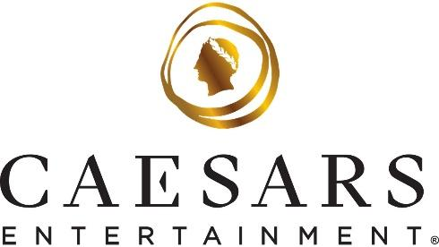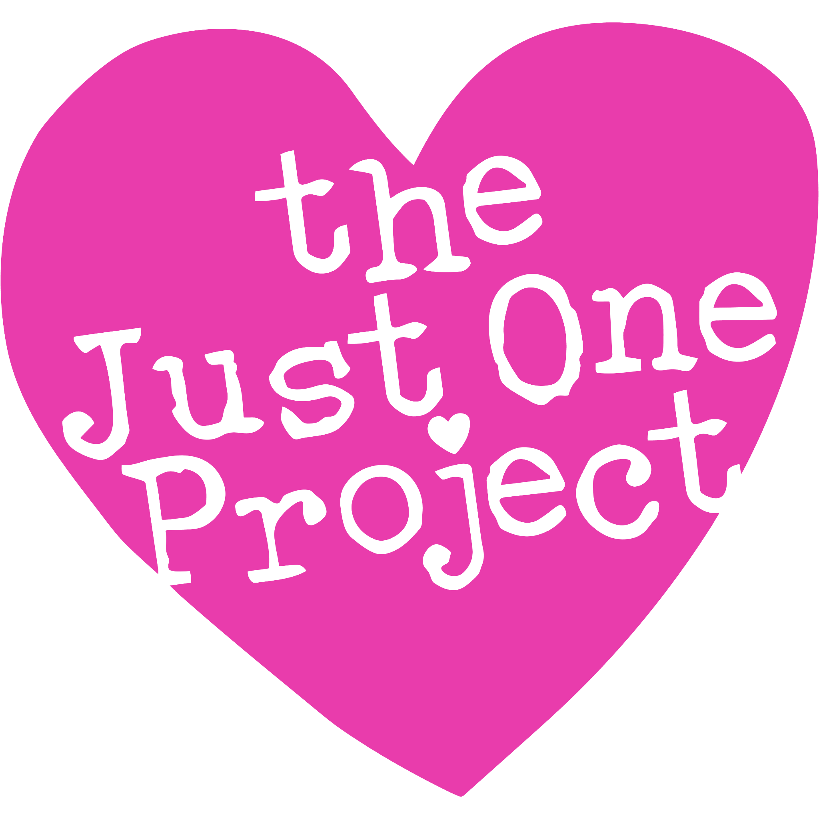

Caesars Entertainment Partners with The Just One Project to Expand Food Rescue Efforts in Las Vegas
Partnership kicks off with more than 3,700 meals donated to individuals and families in need
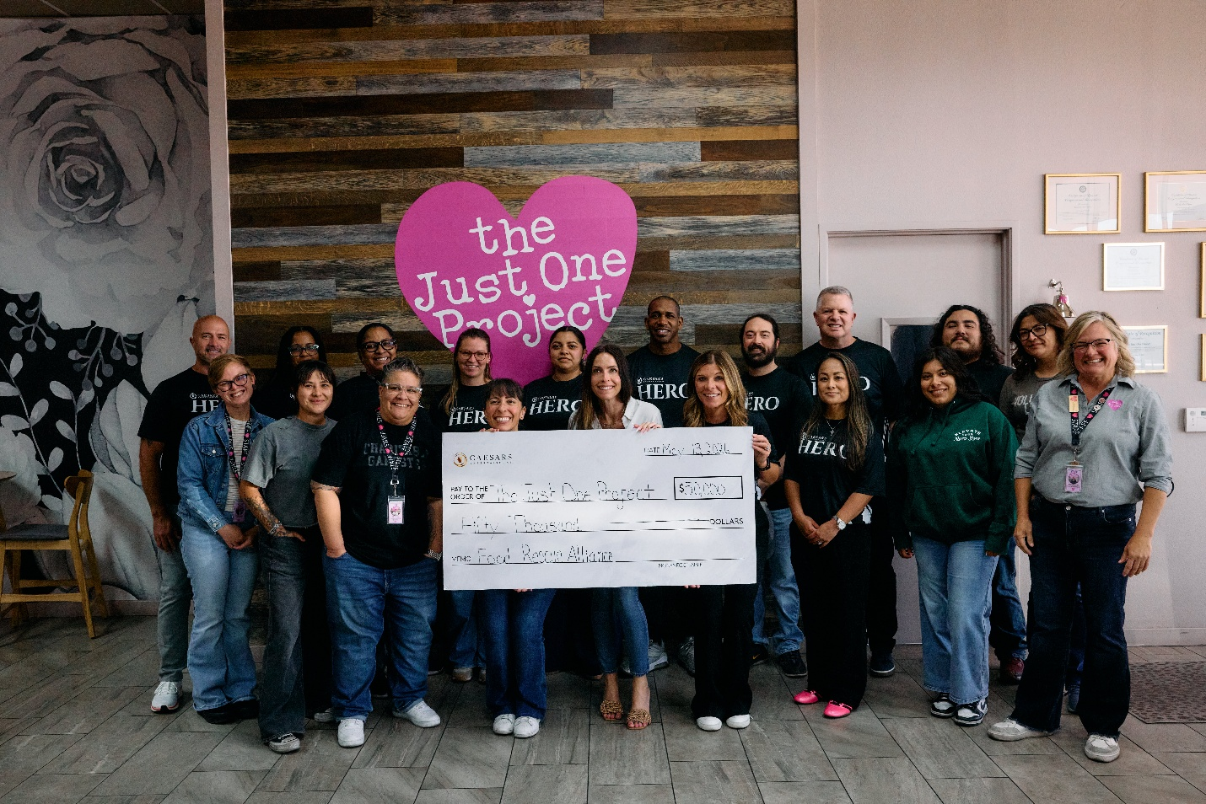
For photos and b-roll of the donation event, please click here
LAS VEGAS (May 19, 2026) — Caesars Entertainment (Caesars) today announced a new partnership with The Just One Project, one of Southern Nevada's leading food access nonprofits, to significantly expand food rescue efforts tied to Las Vegas meetings, conventions and large-scale events through the organization’s Food Rescue Alliance program. The collaboration builds on Caesars' longstanding commitment to reducing food waste while increasing access to nutritious meals for individuals and families across the community.
“At Caesars, we’ve always believed that if we can make a difference, we should,” said Kiersten Flint, SVP of Corporate Social Responsibility and Internal Communications for Caesars Entertainment. “For years, our teams have worked behind the scenes to make sure good food doesn’t go to waste. Partnering with The Just One Project allows us to do that more consistently and at a much larger scale — especially through the meetings and conventions that bring so many people to Las Vegas.”
The partnership kicked off with a donation event on May 13, led by Caesars Entertainment VP of Meetings Operations, Chis Skelding, Caesars Entertainment Executive Director of Culinary Operations for Las Vegas Banquets, Eric Vaughn, Caesars Entertainment SVP of Corporate Social Responsibility and Internal Communications, Kiersten Flint, volunteers from Caesars Entertainment’s HERO network, The Just One Project CEO, Brooke Neubauer and staff from The Just One Project. The food collected over the course of a recent four-day conference, including the volunteer event on May 13, totaled nearly 4,500 lbs. of surplus food, providing 3,749 meals to individuals and families in need throughout the Las Vegas area. Caesars also donated an additional $50,000 to The Just One Project that afternoon.
Through the partnership, excess food from select meetings and events at Caesars Entertainment resorts in Las Vegas will be regularly recovered by The Just One Project, safely packaged and redistributed through The Just One Project’s Food Rescue Alliance, which works with a network of nonprofit partners serving food-insecure individuals and families across Southern Nevada.
“What makes this partnership so powerful is how naturally it fits,” said Brooke Neubauer, CEO and founder of The Just One Project. “Caesars has the scale, and we have the ability to safely recover and distribute food quickly. Together, we’re making sure high-quality meals reach people who need them.”
By leveraging the nonprofit’s established infrastructure — including trained staff, vehicles, food safety protocols and reporting metrics — Caesars can reduce food waste from large-scale events and provide nutritious meals for people in need in a way that’s reliable, responsible and sustainable. All while supporting nonprofits already doing vital work in the Las Vegas community.
Additionally, the partnership creates hands-on opportunities for Caesars Team Members through the company’s HERO volunteer network, which connects them with nonprofit organizations in their communities. HERO volunteers will be able to support food rescue efforts by assisting in donation collection, packing and distributing meals and supporting other TJOP programs through direct and in-person service.
“Our HERO volunteers care deeply about this community, and this partnership gives them another meaningful way to show up,” added Flint. “At the end of the day, it’s about taking care of our neighbors, and doing it together.”
For more information, please visit www.thejustoneproject.org.
Frequently Asked Questions (FAQs)
What is the partnership between Caesars Entertainment and The Just One Project?
Caesars Entertainment has partnered with The Just One Project (TJOP) to expand food rescue efforts connected to meetings and conventions in Las Vegas, ensuring surplus, high-quality prepared food is safely redirected to people in need across Southern Nevada.
Why did Caesars choose to partner with The Just One Project?
The Just One Project is one of Southern Nevada’s leading food access nonprofits and operates the Food Rescue Alliance, which specializes in recovering surplus food from large-scale events and redistributing it through trusted nonprofit partners.
How does the food rescue process work?
Excess food from Caesars Entertainment’s meetings and events in Las Vegas is recovered by TJOP, safely packaged in accordance with food safety protocols and distributed to community organizations serving food-insecure individuals and families.
What impact does the partnership have on the community?
The partnership helps reduce food waste while supporting nonprofits already embedded in the community, providing immediate access to meals for individuals and families facing food insecurity.
How are Caesars Team Members involved?
Caesars HERO volunteers support food rescue and other TJOP programs through hands-on service, reinforcing a shared commitment to helping address food insecurity in Southern Nevada.
###
About Caesars Entertainment, Inc.
Caesars Entertainment, Inc. (NASDAQ: CZR) is the largest casino entertainment company in the U.S. and one of the world's most diversified casino entertainment providers. Since its beginning in Reno, NV, in 1937, Caesars Entertainment, Inc. has grown through the development of new resorts, expansions and acquisitions. Caesars Entertainment, Inc.'s resorts operate primarily under the Caesars®, Harrah's®, Horseshoe® and Eldorado® brand names. Caesars Entertainment, Inc. offers diversified gaming, entertainment and hospitality amenities, one-of-a-kind destinations, and a full suite of mobile and online gaming and sports betting experiences. All tied to its industry-leading Caesars Rewards® loyalty program, the company focuses on building value with its guests through a unique combination of impeccable service, operational excellence and technology leadership. Caesars is committed to its Team Members, suppliers, communities and the environment through its PEOPLE PLANET PLAY framework. Know When To Stop Before You Start.® Gambling Problem? Call 1-800-GAMBLER. For more information, please visit www.caesars.com/corporate.

About The Just One Project
The Just One Project is a Southern Nevada nonprofit committed to creating lasting change through a holistic approach to community support. What began as a grocery assistance initiative has grown into a comprehensive resource hub operating under two pillars: Food for All and Community Connect. Food for All spans eight programs ranging from our No-Cost Community Market and Meals on Wheels to our Food is Medicine Farmers Market and emergency food assistance, ensuring neighbors of all backgrounds and circumstances have access to nutritious food. Community Connect extends that support through housing assistance, workforce development, and youth programs, helping clients build long-term stability and self-sufficiency. Guided by the mission to increase access to food, resources, and supportive services, The Just One Project serves as a one-stop resource hub for Southern Nevada families. Learn more at thejustoneproject.org.

Media Contact:
Dayna Calkins
Caesars Entertainment
dcalkins@caesars.com

Deja Williams
The Just One Project
deja@thejustoneproject.org

