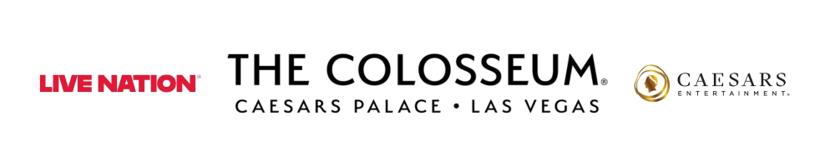
BY POPULAR DEMAND
SIR ROD STEWART
ANNOUNCES SIX ADDITIONAL PERFORMANCES AT THE COLOSSEUM AT CAESARS PALACE

THE ENCORE SHOWS
AUGUST 18 – 29, 2026

Presales begin Tuesday, March 17
Public on sale begins Friday, March 20

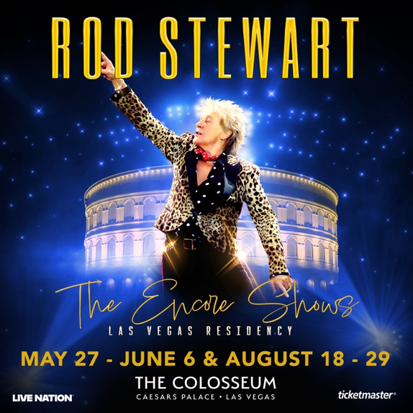

Click HERE for admat and photos
Photo Credit: Denise Truscello
LAS VEGAS (March 16, 2026) – Two-time Rock & Roll Hall of Fame inducted singer, songwriter and performer Rod Stewart has announced six additional performances of “The Encore Shows” at The Colosseum at Caesars Palace, taking place from August 18 – 29, 2026.

Rod Stewart launched his Las Vegas residency, Rod Stewart: The Hits., at The Colosseum at Caesars Palace in 2011. Over 13 years and 200 performances later, the residency became one of the venue’s longest-running and most acclaimed shows. While the milestone run concluded in 2024, Stewart returned by popular demand with “The Encore Shows” in 2025. Presented in partnership by Caesars Entertainment and Live Nation Las Vegas, “The Encore Shows” feature his biggest hits, plus surprises, deep cuts, and stunning new production elements.

Citi is the official card of “The Encore Shows” at The Colosseum at Caesars Palace. Citi cardmembers will have access to presale tickets beginning Tuesday, March 17 at 10 a.m. PT until Thursday, March 19 at 10 p.m. PT through the Citi Entertainment program. For complete presale details visit www.citientertainment.com.

Fan club presale tickets will be available starting Wednesday, March 18 at 10 a.m. PT. In addition, Caesars Rewards members, Caesars Entertainment’s loyalty program, as well as Live Nation and Ticketmaster customers, will have access to a presale running Thursday, March 19 from 10 a.m. to 10 p.m. PT.

Tickets go on sale starting Friday, March 20 at 10 a.m. PT. Tickets may be purchased online at ticketmaster.com/rodstewartvegas. Shows are scheduled for 7:30 p.m.

The six new concerts going on sale are:

August 2026: 18, 20, 22, 25, 27, 29

A limited number of tickets are available for the following previously-announced performances:

May 2026: 27, 29, 30
June 2026: 2, 4, 6

About Rod Stewart
Sir Rod Stewart is one of the best-selling artists in the history of recorded music, with more than 250 million records and singles sold worldwide. His signature voice, style, and songwriting have transcended all genres of popular music, including rock, folk, soul, R&B, the Great American Songbook, and swing—making him one of the few stars to enjoy chart-topping albums throughout every decade of his career. Drawing from his illustrious 50+ year catalog of hit songs, Rod personally creates a unique setlist for each show, taking audiences on an unprecedented ride through every era of his career with chart-toppers like, “Have I Told You Lately,” “Maggie May,” “You Wear it Well,” “Hot Legs,” “Broken Arrow,” “Infatuation,” “You’re in My Heart,” “Do You Think I’m Sexy,” “Some Guys Have All the Luck,” “Rhythm of My Heart,” “Young Turks,” “Sailing,” “Tonight’s The Night,” and “Forever Young,” as well as a few surprises and legendary covers in the mix. Fans will experience an extraordinary night of entertainment with a dynamic stage production and his award-winning 12-piece band and backup vocalists.
A two-time inductee into the Rock & Roll Hall of Fame, Stewart’s extraordinary catalog includes ten No. 1 albums and 31 Top 10 singles in the U.K., six of which reached No. 1, plus 17 Top 10 albums, with four reaching No. 1, and 16 Top 10 singles in the US. He's written several songs that are now modern standards and earned countless of the industry’s highest awards, among them, the ASCAP Founders Award for songwriting, New York Times bestselling author, Grammy™ Living Legend, and in 2016 he officially became “Sir Rod Stewart” after being knighted at Buckingham Palace for his services to music and charity. In 2023, his first foray outside of music, Wolfie's Whisky, was another critical hit and has quickly been embraced worldwide. In 2024, he tackled yet another music genre with the release of Swing Fever, his 33rd studio album. The album, a collaboration with Jools Holland and his Rhythm & Blues Orchestra, a 13-track sparkling salute to the timeless songs of the big band years, garnered him his 11th No. 1 album in the U.K.—a feat he shares with David Bowie, Taylor Swift, and U2 on the all-time list of acts with the most No. 1 albums in the U.K. He continues to tour the world with “One Last Time,” a box office smash, which grossed among The Top 20 Global Concert Tours of 2024 and just completed legs in North America and Europe and will continue with concerts scheduled in South America, Europe and beyond. In 2024, Rod also wrapped his record-setting 13-year Las Vegas residency, “Rod Stewart: The Hits,” and after much fan demand, he’s returned to The Colosseum at Caesars Palace with “The Encore Shows. For more information, visit RodStewart.com and follow him on Facebook, Instagram, YouTube, and TikTok.
About Live Nation Las Vegas
Live Nation Entertainment (NYSE: LYV) is the world’s leading live entertainment company comprised of global market leaders: Ticketmaster, Live Nation Concerts, and Live Nation Sponsorship. Live Nation Las Vegas produces residency shows from Josh Groban, Cyndi Lauper, Blake Shelton, Dolly Parton, Jennifer Lopez, Kelly Clarkson and Rod Stewart at The Colosseum at Caesars Palace; Mary J. Blige, Sammy Hagar, New Kids On The Block and Bruno Mars at Dolby Live at Park MGM; The B-52s, Earth, Wind & Fire, FOREIGNER, STYX and Chicago at The Venetian Theatre at The Venetian Resort Las Vegas; Scorpions and John Fogerty at PH Live at Planet Hollywood Resort & Casino; and Santana at House of Blues. Live Nation Las Vegas also brings other world-famous artists to many of the city’s other premier concert venues including Allegiant Stadium, T-Mobile Arena, MGM Grand Garden Arena, Michelob ULTRA Arena, the Pearl at Palms Casino Resort and more. For additional information, visit www.livenationentertainment.com. Find Live Nation Las Vegas on Facebook and Instagram.

About Caesars Palace
Caesars Palace, the iconic Las Vegas Strip resort where every guest is treated like a Caesar, features 3,980 hotel guest rooms and suites, including the redesigned 182-room Nobu Hotel Caesars Palace, the renovated Colosseum Tower and THE VILLAS Caesars Palace, which has earned the prestigious AAA Five Diamond rating. Both Caesars Palace and Nobu Hotel Caesars Palace have also received AAA Four Diamond designations. The 85-acre resort offers diverse dining options from the award-winning Bacchanal Buffet to celebrity chef-branded restaurants, including Gordon Ramsay HELL’S KITCHEN, Pronto by Giada, Amalfi by Bobby Flay, Vanderpump Cocktail Garden by restaurateur and television star Lisa Vanderpump, one of Nobu Matsuhisa’s largest Nobu restaurants, Restaurant Guy Savoy, award-winning pastry chef Dominique Ansel’s first Las Vegas bakery, Stanton Social Italian – a dining concept in partnership with Tao Group Hospitality, legendary New York Steak House Peter Luger and Brasserie B Parisian Steakhouse by Bobby Flay. The Celebrity Food Hall features Guy Fieri’s Chicken Guy!, Bobby’s Burgers by Bobby Flay, Tortazo by Rick Bayless, Buddy V’s Pizzeria and Mokbar by Esther Choi. For the best in cocktails, destination lounges include Montecristo Cigar Bar, VISTA Cocktail Lounge, Stadia Bar and Caspian’s – a cocktail and caviar bar with Clique Hospitality. The resort also features nearly 130,000 square feet of casino space, the Caesars Race & Sportsbook at Caesars Palace with a 143-foot HD LED screen and state-of-the-art sound, a five-acre Garden of the Gods Pool Oasis, the luxurious Qua Baths & Spa, Hairdreams by Michael Boychuck, five wedding chapels and gardens, the 75,000-square-foot OMNIA Nightclub and OMNIA Dayclub on Las Vegas Boulevard (coming summer 2026). The 4,300-seat Colosseum is the most celebrated venue in Las Vegas with an impressive legacy of superstar talent featured in an intimate, once-in-a-lifetime setting. The Colosseum currently spotlights world-class entertainers, including Kelly Clarkson, Jennifer Lopez, Dolly Parton, Josh Groban, Blake Shelton, Nikki Glaser and David Spade, Def Leppard, Cyndi Lauper, Jerry Seinfeld and Rod Stewart. Also, the Green Fairy Garden in front of Caesars Palace hosts ABSINTHE by Spiegelworld, an adults-only circus variety show featuring a cocktail of wild and outlandish acts. The Forum Shops at Caesars Palace showcases more than 160 boutiques and restaurants. Caesars Palace is operated by a subsidiary of Caesars Entertainment, Inc. (NASDAQ: CZR). For more information, please visit caesarspalace.com or the Caesars Entertainment media room. Find Caesars Palace on Facebook and follow on X and Instagram. Know When To Stop Before You Start.® If you or someone you know has a gambling problem, crisis counseling and referral services can be accessed by calling or texting 1-800- 522-4700, Caesars License Company, LLC.

# # #

MEDIA CONTACTS:

For Live Nation Las Vegas:
Kelly Frey
Kelly@KFPublicity.com

For Caesars Entertainment:
Robert Jarrett
RJarrett@caesars.com

For Rod Stewart:
Hannah Kampf, Kampaign PR
hannah@kampaignpr.com

