FOR IMMEDIATE RELEASE

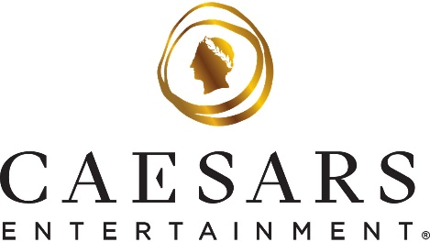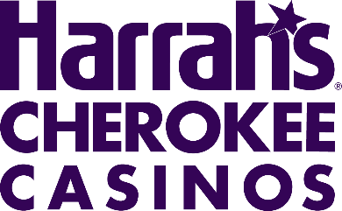

Caesars Entertainment and Harrah’s Cherokee Casinos Present $1M Donation to Eastern Band of Cherokee Indians to Support New Intellectual and Developmental Disabilities Center

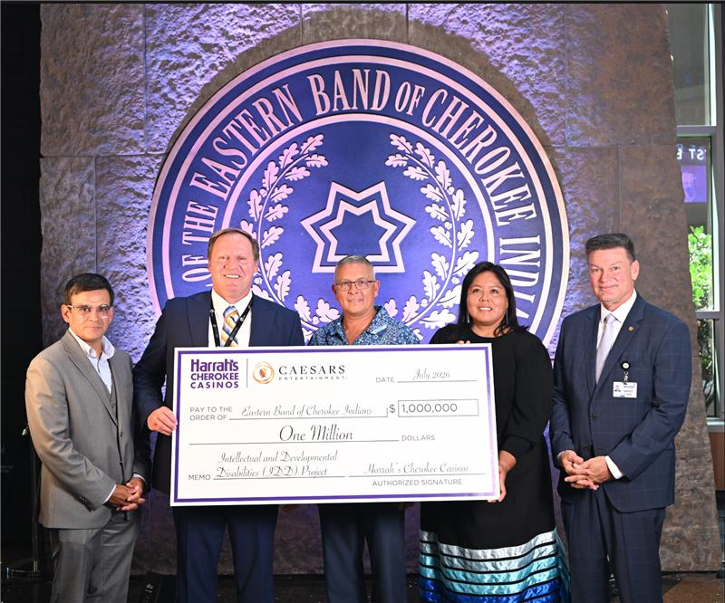

CHEROKEE, N.C. (Thursday, July 30, 2026) – Caesars Entertainment and Harrah’s Cherokee Casinos presented a $1 million donation to the Eastern Band of Cherokee Indians last Wednesday, July 29 to support the development of a new Intellectual and Developmental Disabilities Center serving Cherokee individuals and families.

The donation will help advance facility improvements and related support for a dedicated center designed to expand access to services, resources and care for individuals with intellectual and developmental disabilities, including autism spectrum disorder. The Center is expected to provide culturally responsive services rooted in Cherokee values, with space for therapy, education, sensory support, family consultation and resource navigation.

“Caesars Entertainment is proud to stand with the Eastern Band of Cherokee Indians in support of this important investment in health, wellness and inclusion,” said Barron Fuller, Regional President of Caesars Entertainment. “This donation reflects our deep respect for the Tribe, our long-standing partnership through Harrah’s Cherokee Casinos and our shared commitment to strengthening access to care for families across the community.”

The new Center is being developed by the Eastern Band of Cherokee Indians to address critical gaps in services, promote person-centered care and create inclusive opportunities for neurodiverse community members. Planned improvements include accessible therapy rooms, classrooms, sensory spaces and family support areas, along with programming intended to increase access to early screening, intervention, education and long-term support.

“We are grateful for the continued partnership of Caesars Entertainment and Harrah’s Cherokee Casinos as we work to build a stronger, more inclusive future for Cherokee families,” said Michell Hicks, Principal Chief of the Eastern Band of Cherokee Indians. “This support helps move forward a vision for a culturally grounded center where individuals with intellectual and developmental disabilities can access the resources, care and community they deserve.”

The donation presentation precedes the Center’s groundbreaking ceremony, scheduled for August 26 at 1 p.m. in Cherokee, North Carolina.

“Harrah’s Cherokee Casinos have always been more than entertainment destinations — we are part of this community,” said Brian Marsh, SVP and Regional General Manager of Harrah’s Cherokee Casinos. “We are honored to help celebrate this milestone and support a project that will have a lasting impact for individuals, caregivers and families throughout the region.”

Through its PEOPLE PLANET PLAY framework, Caesars Entertainment is committed to supporting the communities where its Team Members live and work. The contribution to the Eastern Band of Cherokee Indians reflects that commitment and reinforces the shared values of inclusion, access and community well-being.

###

About Harrah's Cherokee Casinos - An Enterprise of the Eastern Band of Cherokee Indians

Harrah's Cherokee Casino Resort, located in Cherokee, North Carolina, is a premier entertainment destination offering world-class gaming, dining, and accommodations. The Resort features 9 unique dining experiences, 1,800 hotel rooms, a full-service spa, live entertainment, and event spaces, making it a top destination for visitors from around the world.

Harrah's Cherokee Valley River Casino & Hotel, situated near Murphy, North Carolina, boasts an impressive 75,000 square foot gaming floor featuring an array of over 1,300 gaming options. The property also includes a luxurious 500 plus-room full-service hotel offering sweeping views of North Carolina’s largest natural forest, a premier WSOP ™ Poker Room, renowned Caesars Sportsbook, celebrity-owned restaurant, Ramsay’s Kitchen and Valley River Spa by Mandara. Additionally, guests can enjoy the UltraStar Multi-tainment Center, featuring 16 bowling lanes, an engaging arcade, and a thrilling bar experience.

About Caesars Entertainment, Inc.
Caesars Entertainment, Inc. (NASDAQ: CZR) is the largest casino entertainment company in the U.S. and one of the world's most diversified casino entertainment providers. Since its beginning in Reno, NV, in 1937, Caesars Entertainment, Inc. has grown through the development of new resorts, expansions and acquisitions. Caesars Entertainment, Inc.'s resorts operate primarily under the Caesars®, Harrah's®, Horseshoe® and Eldorado® brand names. Caesars Entertainment, Inc. offers diversified gaming, entertainment and hospitality amenities, one-of-a-kind destinations, and a full suite of mobile and online gaming and sports betting experiences. All tied to its industry-leading Caesars Rewards® loyalty program, the company focuses on building value with its guests through a unique combination of impeccable service, operational excellence and technology leadership. Caesars is committed to its Team Members, suppliers, communities and the environment through its PEOPLE PLANET PLAY framework. Know When To Stop Before You Start.® Gambling Problem? Call 1-800-GAMBLER. For more information, please visit www.caesars.com/corporate.

Media Contact:
Michael Fisher
Harrah’s Cherokee Casinos
mifisher@harrahs.com

