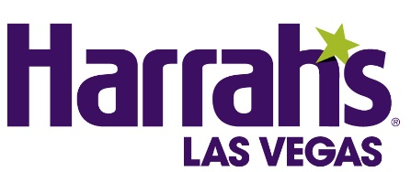

Donny Osmond Extends Residency at Harrah’s Las Vegas

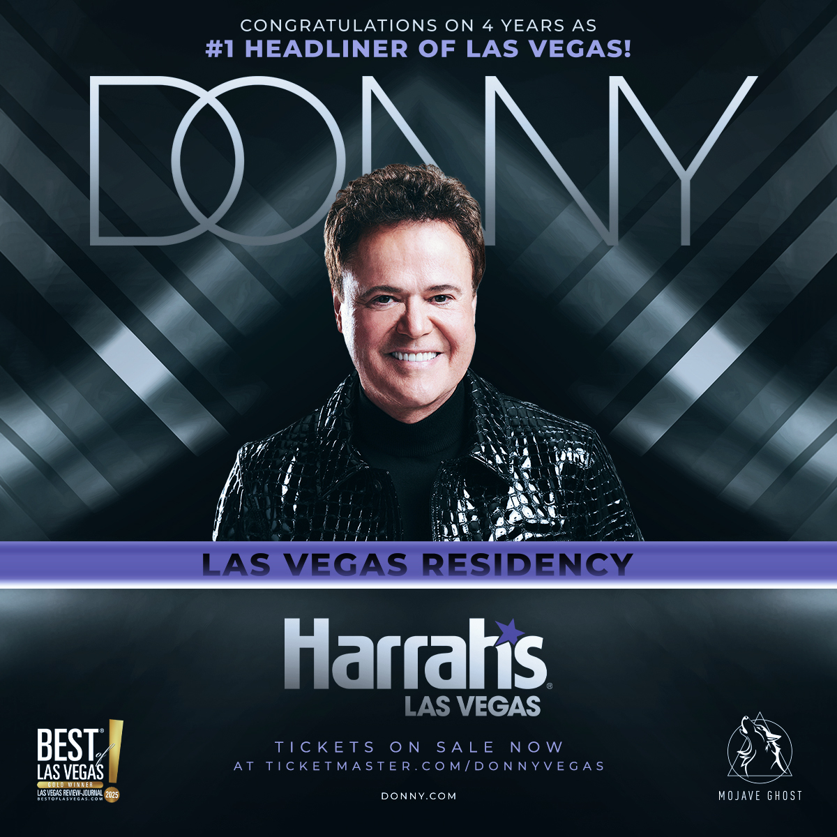

New dates set for September - December 2026, tickets on sale Jan. 26

For show assets, click here

LAS VEGAS (Jan. 23, 2026) – Legendary entertainer and music icon Donny Osmond has once again extended his award-winning residency inside Harrah’s Showroom at Harrah’s Las Vegas, adding new dates from September through December 2026.
Guests also have the chance to book two special meet-and-greet experiences with Donny. On Saturday, Sept. 5, fans can celebrate Donny’s Fifth Anniversary at Harrah’s Las Vegas with a special dinner at Ramsay’s Kitchen by Chef Gordon Ramsay. The dinner includes a three-course Prix Fixe menu, special gift, photo opportunity and an intimate moment with Donny. Additionally, Donny will host a one-night-only country-themed pre-show on Saturday, Dec. 5, in honor of the National Finals Rodeo.
Presale tickets will be available to Donny Osmond App users from Friday, Jan. 23, at 10 a.m. through Monday, Jan. 26, at 9:59 a.m. Tickets for the general public will go on sale Monday, Jan. 26 at 10 a.m.
Performances run nightly Tuesday through Saturday, with all shows starting at 7:30 p.m. A limited number of tickets for Donny’s Pre-Show VIP Experience — which includes a meet-and-greet, personal storytelling, a Q&A session and a special musical moment — are also available.
For more information, scheduling and to purchase tickets, please visit www.ticketmaster.com/donny. Guests looking to save by bundling show tickets with a hotel stay can visit the dedicated booking page linked here.
Osmond’s show has earned Best Resident Performer/Headliner and Best Production Show in the Las Vegas Review‑Journal’s Best of Las Vegas Awards every year since its 2021 debut and continues to dazzle audiences with its high-energy journey through his unparalleled six-decade career. Featuring the fan‑favorite “Auto‑rap‑ography,” along with milestone photos and videos, the production showcases Osmond’s hit songs, an interactive audience request segment covering his entire catalog, and a full Broadway-style performance of his Disney classic “I’ll Make a Man Out of You.”

The most recent addition to the show allows Osmond to lean into a growing technological trend by harnessing control of his Artificial Intelligence (AI) likeness to create a magical and memorable concert going experience for fans. Using state-of-the-art technology, original multi-track audio recordings from over 50 years ago and original footage from the 1970s, the worldwide song sensation "Puppy Love" is reimagined with AI to recreate and celebrate the 1972 hit. Audiences uniquely experience a special performance of Osmond in duet and a 3-D AI version of his 14-year-old self, live on stage.
Osmond’s residency is directed by Raj Kapoor who has produced The GRAMMYs, Latin GRAMMYs, The Academy Awards, Academy of Country Music Awards and Emmy Awards. Kapoor has also directed and produced hit Las Vegas residencies for Shania Twain, Mariah Carey and the Backstreet Boys. The show is choreographed by Emmy Award-winning duo, NAPPYTABS. DONNY is produced by Mojave Ghost. Greg Young of Mojave Ghost has produced Tony and Drama Desk Award-winning productions on Broadway, as well as more than 2,500 concerts, 40 Broadway shows, national tours and IP exhibitions throughout the domestic U.S. Mojave Ghost has also produced Donny’s tours for the past decade.

About Harrah’s Las Vegas
A hidden gem in the heart of The Strip, Harrah’s Las Vegas features 2,542 redesigned guest rooms, a remodeled casino floor and direct access to CAESARS FORUM Conference Center. The renovated hotel rooms and suites feature bold purple and blue hues that complement the cream-colored décor, dark wood accents and contemporary fixtures. The resort offers 87,000 square feet of casino space, the new Lounge, the Caesars Race & Sportsbook at Harrah's Las Vegas, The Spa at Harrah’s Las Vegas and more than 25,000 square feet of meeting and convention space. Dining options encompass everything from Ramsay’s Kitchen from Chef Gordon Ramsay and PizzaCake by Buddy Valastro, to the chef-driven Fulton Street Food Hall featuring Bobby’s Burgers by acclaimed Chef Bobby Flay and Guy Fieri’s Chicken Guy!, to the upscale setting of Ruth’s Chris Steak House, a romantic venue with breathtaking views of The Strip. Harrah’s outdoor bar, Carnaval Court, brings high energy to the Las Vegas Strip with live music and some of the world’s top flair bartenders who juggle and pour to perfection. A wide variety of entertainment options include the first-ever solo residency from Donny Osmond, as well as Menopause The Musical, X Country, Colin Cloud: Mastermind and MJ LIVE. Harrah’s Las Vegas is operated by a subsidiary of Caesars Entertainment, Inc. (NASDAQ: CZR). For more information, please visit harrahslasvegas.com or the Caesars Entertainment media room. Find Harrah’s Las Vegas on Facebook and follow on X and Instagram. Must be 21 or older to gamble. Know When To Stop Before You Start.® If you or someone you know has a gambling problem, crisis counseling and referral services can be accessed by calling or texting 1-800-GAMBLER, Caesars License Company, LLC.

###
Media Contacts:
Harrah’s Las Vegas
Robert Jarrett / Maicyn Udani
RJarrett@caesars.com / mudani@caesars.com

Donny Osmond
Susan Madore
susan@guttmanpr.com

