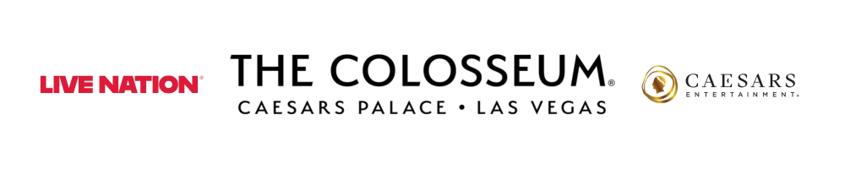
Jennifer Lopez
Welcomes 2026 With Debut of New Las Vegas Residency
at The Colosseum at Caesars Palace

Tickets for performances of Jennifer Lopez: Up All Night Live in Las Vegas through March 2026 are on sale now

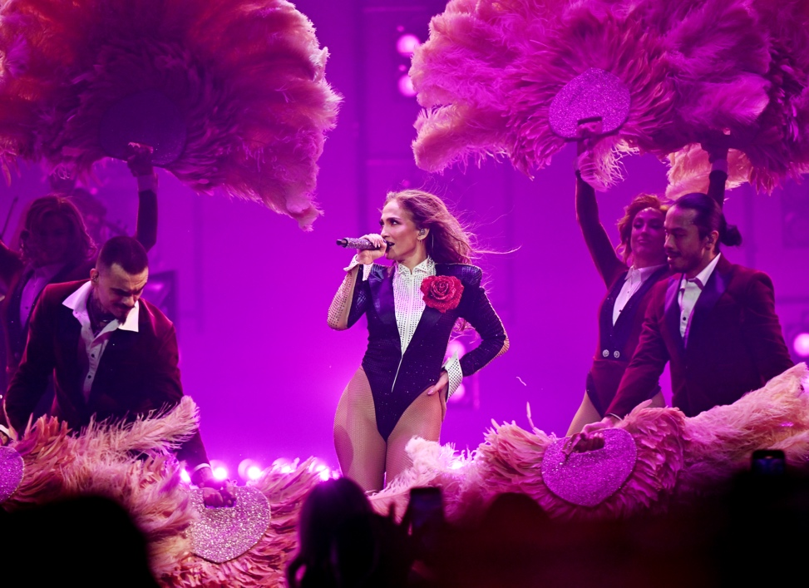

Click HERE for production photos and b-roll
LAS VEGAS, NV (Jan. 1, 2026) – Global icon Jennifer Lopez rang in the New Year with a triumphant return to the Las Vegas Strip, launching her brand-new residency, Jennifer Lopez: Up All Night Live in Las Vegas, at The Colosseum at Caesars Palace. Lopez kicked off the residency with two electrifying performances on December 30 and 31, followed by two additional shows this weekend on January 2 and 3.

The two-hour spectacular takes audiences on an exhilarating journey from the Bronx to Broadway and beyond, culminating in a full-scale Las Vegas production. Directed by acclaimed husband-and-wife duo Nappytabs—Napoleon and Tabitha Dumo—the show unfolds across four dynamic acts and features more than two dozen numbers. Fans are treated to a powerful mix of Lopez’s chart-topping hits, including “On The Floor,” “Jenny From the Block,” “Get Right” and “Love Don’t Cost a Thing,” alongside Broadway classics that have influenced her artistry from the start of her career through today. Backed by a 17-piece band—highlighted by an all-female string section—the production also showcases high-energy choreography, show-stopping costumes and cutting-edge lighting, video and special effects. The opening nights were made even more memorable by a surprise appearance from Ja Rule, who joined Lopez on stage to perform their iconic duets “I’m Real” and “Ain’t It Funny.”

Tickets for performances through March 28, 2026 are on sale now at ticketmaster.com/JLoVegas. All shows are scheduled for 8 p.m.

About Jennifer Lopez
Jennifer Lopez is an award-winning actress, producer, singer, entertainer, and businesswoman who has helped build billion-dollar brands and established herself in film, music, television and business as one of the most influential artists in history.

The only female artist to ever have a number one album and number one film simultaneously, she has a cumulative worldwide box-office gross of over $3 billion. Additionally, Lopez has sold over 80 million records, had 15 billion global streams and more than 18 billion views of her music videos.

Jennifer Lopez’s record-breaking success shows no signs of slowing down in 2025. Her highly anticipated film Unstoppable premiered on Prime Video on January 16th, climbing to the #1 spot globally. Ten days later, Kiss of the Spider Woman, based on Manuel Puig’s novel, debuted at the Sundance Film Festival on January 26th, earning critical acclaim and generating significant industry buzz.

Further solidifying her reign as a top streaming star, Unstoppable became Lopez’s fifth #1 streaming film in just two years. In 2024, ATLAS dominated Netflix, holding the #1 position for two weeks with over 60 million global views. The previous year, The Mother was Netflix’s most-watched film worldwide, amassing over 239 million hours streamed. She also had two additional #1 films on Prime Video, underscoring her unparalleled streaming dominance.

Starring in over 35 movies to date, her box office success is just as impressive, in 2019, the movie Hustlers was Lopez’s highest opening weekend of her career, topping $32 million and grossing over $100 million worldwide.

Her television success on and off the screen is just as impressive. Appearing on five seasons of American Idol (ABC), and three seasons of Shades Of Blue (NBC), she was also an executive producer for four seasons of World Of Dance (NBC) and five seasons of Good Trouble (Freeform).

Grammy and Golden Globe nominated, she is the recipient of prestigious industry awards including the 2500th star on the Hollywood Walk Of Fame, the first female recipient of the Billboard Icon Award, and the Telemundo Star Award (2017). She was also awarded the Michael Jackson Video Vanguard Award (2018) and the MTV Generation Award (2022). Lopez is the first and only person in history to receive both of these awards for her accomplishments in music, film and television.

As a fashion icon, entrepreneur, and a philanthropist, Jennifer Lopez has been named on the TIME 100 list, Forbes' "Most Powerful Celebrity,” and was the first to grace People Magazine’s cover for "Most Beautiful Woman in the World.” In 2023, she was the recipient of Elle’s Women In Hollywood Icon Award and April 2024 saw her awarded the Premio Orgullo Award which celebrates bringing pride to the community at the annual Hispanic Federation Gala chaired by Lin-Manuel Miranda.

In addition to receiving accolades across film, music and her philanthropic efforts, Lopez has also made waves within business as a Founder, Owner and Investor. She has co-owned Nuyorican Productions for two-decades and produced acclaimed film and tv projects. Most recently Lopez, announced a multi-year and multi-platform first-look production deal with Netflix in addition to a partnership with Skydance and Concord to develop original projects based on Concord's catalog of musicals.
Philanthropy and giving back are dear to Lopez’s heart and while she prefers to keep these efforts out of the public eye, she is passionate about helping children and supports the Children’s Hospital Los Angeles and Gloria Wise Boys and Girls Club. She was also a global advocate for girls and women at the United Nations Foundation. In 2022, Jennifer partnered with Grameen America, the nation’s fastest-growing microfinance organization, alongside her latest philanthropic project, Limitless Labs, to support Latina-owned small businesses and to empower 600,000 Latina entrepreneurs across 50 U.S. cities with $14 billion in life-changing business capital and 6 million hours of financial education and training by 2030.
With a career spanning over two decades at the top of every field, Jennifer Lopez is cemented in history as a global icon and the ultimate multihyphenate.

About Live Nation Las Vegas
Live Nation Entertainment (NYSE: LYV) is the world’s leading live entertainment company comprised of global market leaders: Ticketmaster, Live Nation Concerts, and Live Nation Sponsorship. Live Nation Las Vegas produces residency shows from Cyndi Lauper, Blake Shelton, Def Leppard, Dolly Parton, Jennifer Lopez, Alanis Morissette, Kelly Clarkson and Rod Stewart at The Colosseum at Caesars Palace; ZAYN, Mariah Carey, Sammy Hagar, New Kids On The Block and Bruno Mars at Dolby Live at Park MGM; The B-52s, Earth, Wind & Fire, FOREIGNER, STYX and Chicago at The Venetian Theatre at The Venetian Resort Las Vegas; John Fogerty at PH Live at Planet Hollywood Resort & Casino; and Santana at House of Blues. Live Nation Las Vegas also brings other world-famous artists to many of the city’s other premier concert venues including Allegiant Stadium, T-Mobile Arena, MGM Grand Garden Arena, Michelob ULTRA Arena, the Pearl at Palms Casino Resort, Downtown Las Vegas Events Center and more. For additional information, visit www.livenationentertainment.com. Find Live Nation Las Vegas on Facebook and Instagram.

About Caesars Palace
Caesars Palace, the iconic Las Vegas Strip resort where every guest is treated like a Caesar, features 3,980 hotel guest rooms and suites, including the redesigned 182-room Nobu Hotel Caesars Palace, the renovated Colosseum Tower and THE VILLAS Caesars Palace, which has earned the prestigious AAA Five Diamond rating. Both Caesars Palace and Nobu Hotel Caesars Palace have also received AAA Four Diamond designations. The 85-acre resort offers diverse dining options from the award-winning Bacchanal Buffet to celebrity chef-branded restaurants, including Gordon Ramsay HELL’S KITCHEN, Pronto by Giada, Amalfi by Bobby Flay, Vanderpump Cocktail Garden by restaurateur and television star Lisa Vanderpump, one of Nobu Matsuhisa’s largest Nobu restaurants, Restaurant Guy Savoy, award-winning pastry chef Dominique Ansel’s first Las Vegas bakery, Stanton Social Italian – a dining concept in partnership with Tao Group Hospitality, legendary New York Steak House Peter Luger and Brasserie B Parisian Steakhouse by Bobby Flay. The Celebrity Food Hall features Guy Fieri’s Chicken Guy!, Bobby’s Burgers by Bobby Flay, Tortazo by Rick Bayless, Buddy V’s Pizzeria and Mokbar by Esther Choi. For the best in cocktails, destination lounges include Montecristo Cigar Bar, VISTA Cocktail Lounge, Stadia Bar and Caspian’s – a cocktail and caviar bar with Clique Hospitality The resort also features nearly 130,000 square feet of casino space, the Caesars Race & Sportsbook at Caesars Palace with a 143-foot HD LED screen and state-of-the-art sound, a five-acre Garden of the Gods Pool Oasis, the luxurious Qua Baths & Spa, Hairdreams by Michael Boychuck, five wedding chapels and gardens, the 75,000-square-foot OMNIA Nightclub and OMNIA Dayclub on Las Vegas Boulevard (coming summer 2026). The 4,300-seat Colosseum is the most celebrated venue in Las Vegas with an impressive legacy of superstar talent featured in an intimate, once-in-a-lifetime setting. The Colosseum currently spotlights world-class entertainers, including Kelly Clarkson, Jennifer Lopez, Dolly Parton, Blake Shelton, Nikki Glaser and David Spade, Def Leppard, Cyndi Lauper, Jerry Seinfeld and Rod Stewart. Also, the Green Fairy Garden in front of Caesars Palace hosts ABSINTHE by Spiegelworld, an adults-only circus variety show featuring a cocktail of wild and outlandish acts. The Forum Shops at Caesars Palace showcases more than 160 boutiques and restaurants. Caesars Palace is operated by a subsidiary of Caesars Entertainment, Inc. (NASDAQ: CZR). For more information, please visit caesarspalace.com or the Caesars Entertainment media room. Find Caesars Palace on Facebook and follow on X and Instagram. Know When To Stop Before You Start.® If you or someone you know has a gambling problem, crisis counseling and referral services can be accessed by calling or texting 1-800- 522-4700, Caesars License Company, LLC.

# # #

MEDIA CONTACTS:

For Live Nation Las Vegas:
Kelly Frey
Kelly@KFPublicity.com

For Caesars Entertainment:
Robert Jarrett
RJarrett@caesars.com

For Jennifer Lopez:
Christy Welder
cwelder@fullpic.com

Nicola Phillips
nphillips@fullpic.com

