Warmer days are back, and it’s officially time for guests to break out their swimsuits as Caesars Entertainment dives into pool season. Several Las Vegas pools are now open and will continue to open throughout the season, offering everything from DJ-driven parties to poolside relaxation.
For current pricing and availability across all venues, please visit www.caesars.com/pools. All pool openings are weather-permitting and subject to change.
Click here for high-res images.
Garden of the Gods Pool Oasis at Caesars Palace – Now Open
This 10,000-square-foot oasis features seven pools, 48 cabanas, 65 daybeds and numerous chaise lounges available for full- or half-day rentals. Guests can also enjoy five swim-up blackjack tables and cool off with signature Tiki drinks served in a pineapple or 64-ounce pitchers.

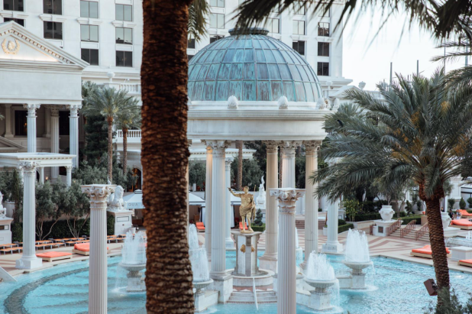
Garden of the Gods Pool Oasis at Caesars Palace, Caesars Entertainment
Go Pool & Family Pool at Flamingo Las Vegas – Now Open
The all-new $20M Go Pool is a 21+ pool-party playground spread across 1.5 acres, featuring a swim-up bar, daily DJs and an all-around high-energy vibe. Debuting last year, it’s Caesars Entertainment’s newest pool experience. For guests seeking family-friendly fun, the nearby Family Pool offers a waterslide, waterfalls and crowd-pleasing favorites like sliders, nachos and the Street Taco Trio.

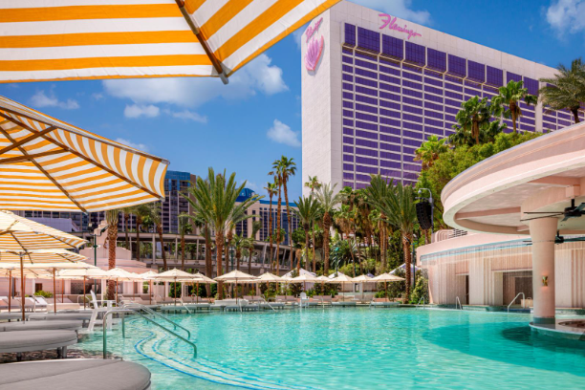
Go Pool at Flamingo Las Vegas, Caesars Entertainment
The Scene Pool Deck at Planet Hollywood Resort & Casino – Now Open
The Scene Pool Deck not only offers two rooftop pools with sweeping Strip views, but it is also home to the FlowRider — the only free-standing wave riding experience on The Strip. Guests can book cabanas or daybeds and enjoy seasonal favorites like the Hollywood Sunset cocktail.

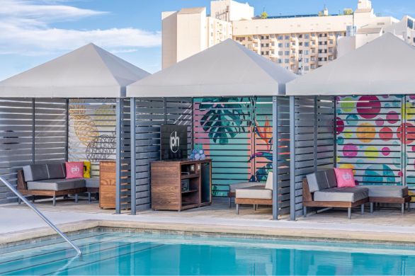
Cabanas at The Scene Pool Deck at Planet Hollywood Resort & Casino, Caesars Entertainment

Influence, The POOL at The LINQ – Now Open
This 21+ pool brings the energy with live DJs, life-sized games and beer pong. Cabanas and daybeds are available for half- or full-day rentals in a lively, social atmosphere.
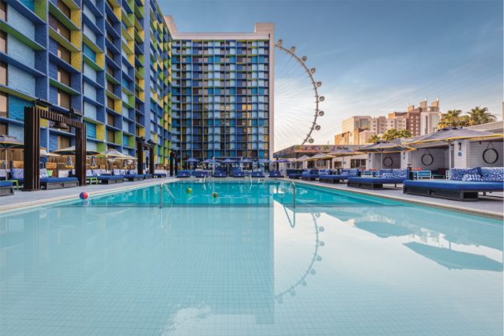
Influence, The POOL at The LINQ, Caesars Entertainment
Pool à Paris at Paris Las Vegas – Now Open
Sometimes, a pool day requires a serene retreat under the Eiffel Tower replica. Pool à Paris offers lounge chairs, daybeds, cabanas and villas for full- or half-day use. This pool is an ideal option for guests seeking a quieter, more relaxing experience.

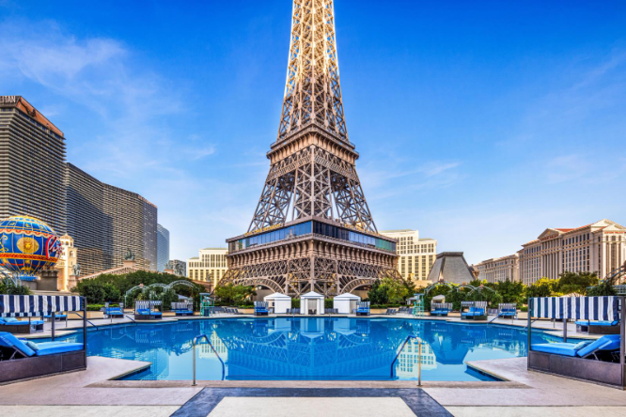
Pool à Paris at Paris Las Vegas, Caesars Entertainment
The Pool at Harrah’s Las Vegas – Opening Friday, March 13
Harrah’s features an Olympic-sized pool paired with games and cabana rentals available for the full or half day. Guests can enjoy beer pong or elevate their day with bottle service.
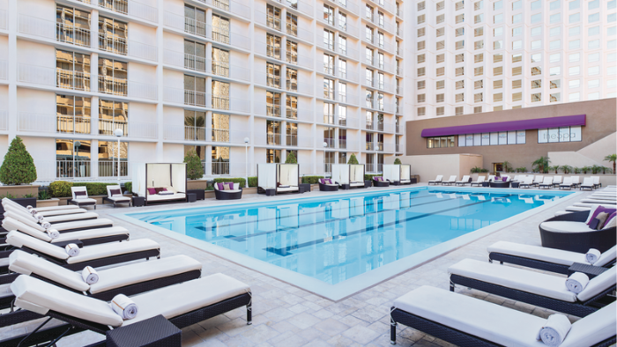
The Pool at Harrah’s Las Vegas, Caesars Entertainment
Blu Pool at Horseshoe Las Vegas – Opening Wednesday, April 1
Blu Pool’s 12-foot-deep main pool makes for a refreshing splash, with cabanas and daybeds for some extra relaxation. Guests can amp up the fun with a game of cornhole or foosball in the activity-filled deck.
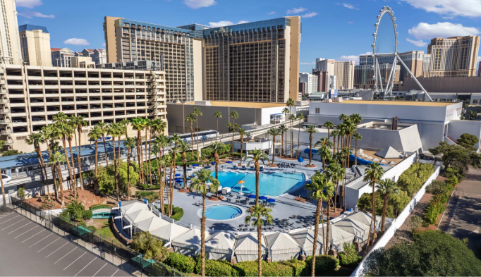
Blu Pool at Horseshoe Las Vegas, Caesars Entertainment
*NEW* OMNIA Dayclub & Skybar at Caesars Palace – Opening Pool Season 2026
Guests ready to party for the summer can look forward to Tao Group Hospitality’s OMNIA Dayclub & Skybar, which will command 46,000 square feet, featuring two expansive pools and performances from top global DJs.
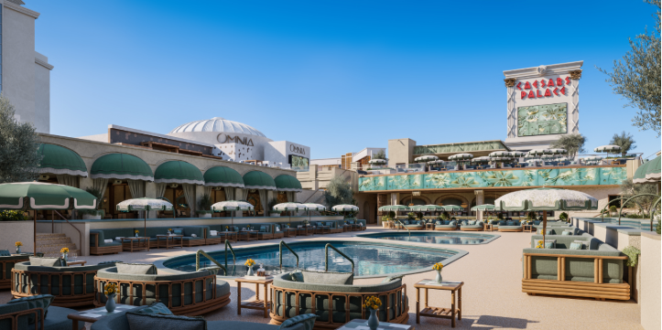
OMNIA Dayclub & Skybar at Caesars Palace, Tao Group Hospitality

