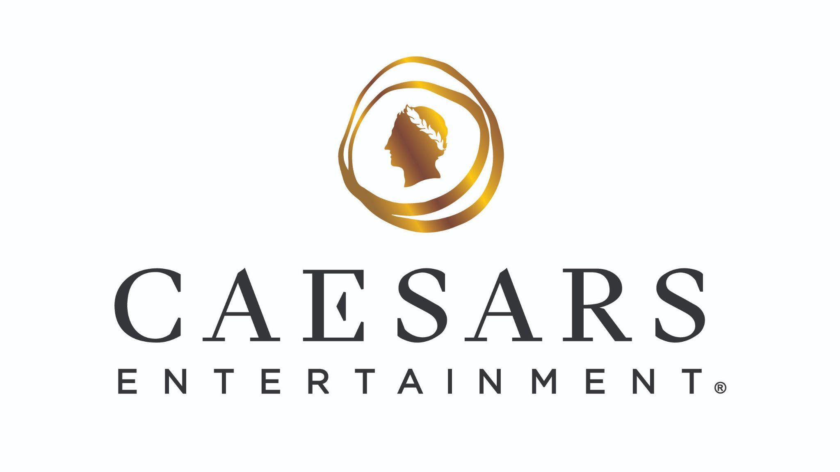

Hit the Jackpot of Relaxation with Caesars Entertainment’s Las Vegas Resorts

*For hi-res images, click here*

LAS VEGAS (Feb. 6, 2026) – Wellness on the Las Vegas Strip is getting a glow up as Caesars Entertainment introduces innovative spa offerings across its resorts.

Anchoring this evolution is the launch of Aescape, The Strip’s first AI-powered robotic massage, at Qua Baths & Spa at Caesars Palace. The fully automated experience allows guests to personalize pressure and focus areas for a precision-driven massage. Guests can now book a 15-minute session for $44 or a 30-minute session for $88.

Qua Baths & Spa Enhancements at Caesars Palace
Following enhancements to its facilities, Qua Baths & Spa features new programming and treatments designed to support physical, mental and emotional well-being.

Expanded offerings include:

- Physical wellness classes ($40) - yoga, sound healing, personal training, qi gong, Pilates mat and HIIT circuit training
- Caesars Run Club every Friday morning (free)
- Touchless wellness experiences - Reiki energy treatments and mindfulness coaching
- Signature 100-minute immersive journeys:
  - Breathe ($100) - Mojave sound ritual with breathwork, sound bowl attunement and restorative bodywork
  - Thrive ($100) - Sculpting body techniques and traditional lymphatic drainage with a Cryo Sculpt Facial
  - Glow ($100) - Acu Energy Diamond Facial, LED light therapy, custom masking and collagen hand and foot treatments

For additional details on Qua Baths & Spa, a full menu of wellness and spa offerings and to book a reservation, guests can visit caesars.com/caesars-palace/things-to-do/qua.

All-You-Can-Spa Experiences at The LINQ and Harrah’s Las Vegas
Guests seeking an all-day wellness escape can indulge in the all-you-can-spa experience at The Spa at Harrah’s Las Vegas and the Spa at The LINQ Hotel, offering a customizable approach to relaxation.

All-You-Can-Spa
For $475 at Harrah’s and $500 at The LINQ, guests can enjoy up to four hours of treatments, including signature facials, massages, body scrubs and mud wraps.

For additional details on The Spa at The LINQ, a full menu of wellness and spa offerings and to book a reservation, guests can visit caesars.com/linq/things-to-do/spa-and-fitness-center/

For additional details on The Spa at Harrah’s, a full menu of wellness and spa offerings and to book a reservation, guests can visit caesars.com/harrahs-las-vegas/things-to-do/spa-and-health-club.

