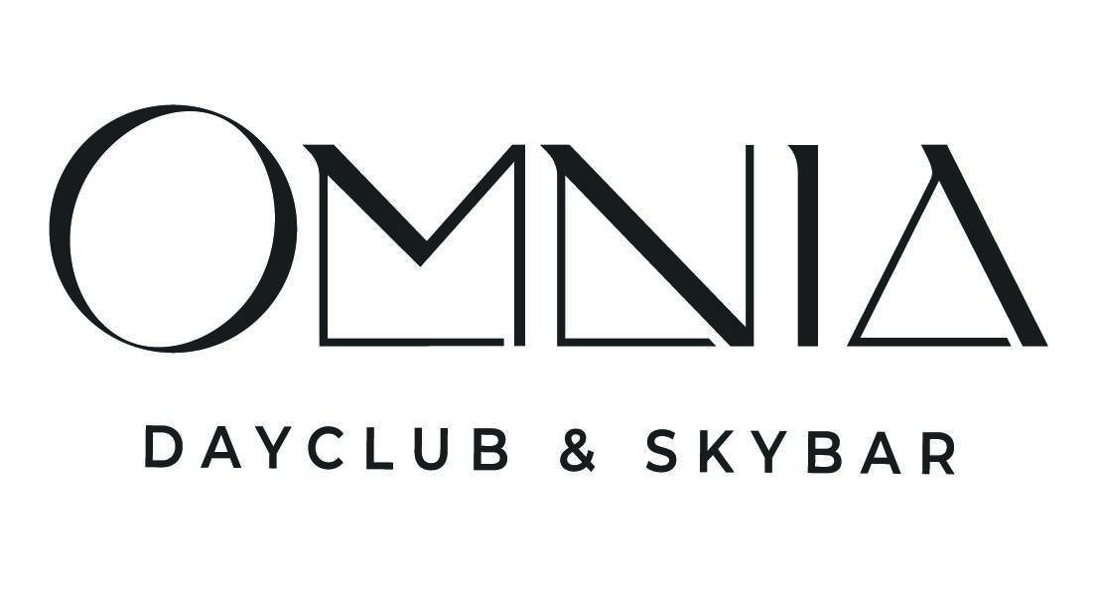

OMNIA DAYCLUB & SKYBAR TO OPEN AT CAESARS PALACE FOR THE 2026 POOL SEASON
Tao Group Hospitality Expands Famed Entertainment Complex on Las Vegas Strip

High-Resolution Renderings Linked HERE

LAS VEGAS, NV (February 1, 2026) - Tao Group Hospitality will debut OMNIA Dayclub & Skybar, a new entertainment complex built from ground up at Caesars Palace in 2026. Spanning 46,000 square-feet directly on Las Vegas Boulevard, the venue will usher in a new era of entertainment, merging European-inspired design, world-class talent, next-generation production technology and elevated culinary offerings, all backed by Tao Group’s signature gracious hospitality. OMNIA Dayclub & Skybar will be connected to the iconic OMNIA Nightclub by a dedicated bridge creating a seamless day-to-night experience spanning a combined 121,000 square-feet.

“With OMNIA Dayclub & Skybar, we’re defining what’s next for Las Vegas at the scale, energy, and ambition the city demands,” said Tao Group Hospitality Co-CEO Noah Tepperberg. “This project underscores our long-term commitment to Las Vegas as a global entertainment capital,” added Co-CEO Jason Strauss.

Designed in collaboration with Rockwell Group, OMNIA Dayclub draws from the elegance of the beach clubs from Mykonos to St. Tropez and Ibiza to craft a sun-soaked, multi-level social environment with an unmistakably modern edge. Guests arrive directly through OMNIA Nightclub’s main entrance or via a dramatic grand staircase from The Strip, greeted by sweeping sightlines of the entire venue.
On the main level, two organically shaped central pools anchor the club, surrounded by custom daybeds and banquettes. Along the perimeter, private cabanas and exclusive VIP plunge pools offer a refined retreat reminiscent of seaside European villas. Materials including teak wood, stacked stone, woven hyacinth and rich emerald accents, create a polished yet relaxed atmosphere.
The deck above features shaded seating, a dedicated bar, and tiered banquettes beneath cream-and-jade umbrellas, providing an elevated vantage point of the entire space. This level transforms into OMNIA Skybar, which will operate year-round as an alfresco destination for food, drink and Las Vegas Strip views.
Purpose built for Tao Group Hospitality’s roster of top-tier global residents as well as high production events, OMNIA Dayclub features systems engineered to deliver festival-level production in a dayclub setting. This includes a DJ booth with a custom 8K LED main stage screen built for broad-daylight performances, live visuals and generative effects, with a multi-camera system capturing performers and crowd vibes in real time. The L-Acoustics L2 sound system provides unparalleled clarity, spatial accuracy and energy across the venue.
True to Tao Group Hospitality’s culinary roots, the food and beverage offerings extend beyond typical pool fare. OMNIA Dayclub & Skybar will feature an American Bistro–style menu and craft cocktails, blending elevated, fresh and approachable flavors designed for daytime indulging.
Visit OMNIA Dayclub & Skybar for additional information and @omniadayclub to follow the progress as the venue comes to life.
About Tao Group Hospitality
Tao Group Hospitality delivers distinctive culinary and premium entertainment experiences through its portfolio of restaurants, nightclubs, lounges, and daylife venues, including TAO, OMNIA, Marquee, LAVO, Beauty & Essex, Cathédrale, Little Sister, The Highlight Room, Sake No Hana, KOMA, Avenue, Fleur Room, JEWEL, and more. Led by Co-CEOs Noah Tepperberg and Jason Strauss, the company combines over 25 years of industry experience with innovation and creativity to set the standard for guest experiences. Tao Group Hospitality is part of Mohari Hospitality, an investment firm focused on the luxury lifestyle and hospitality sectors.

