FOR IMMEDIATE RELEASE



Tropicana Atlantic City Opens Solana Tower

Guests can now book stays at the newly reimagined 598‑room Solana Tower, featuring tropical décor, coastal views and modern comforts

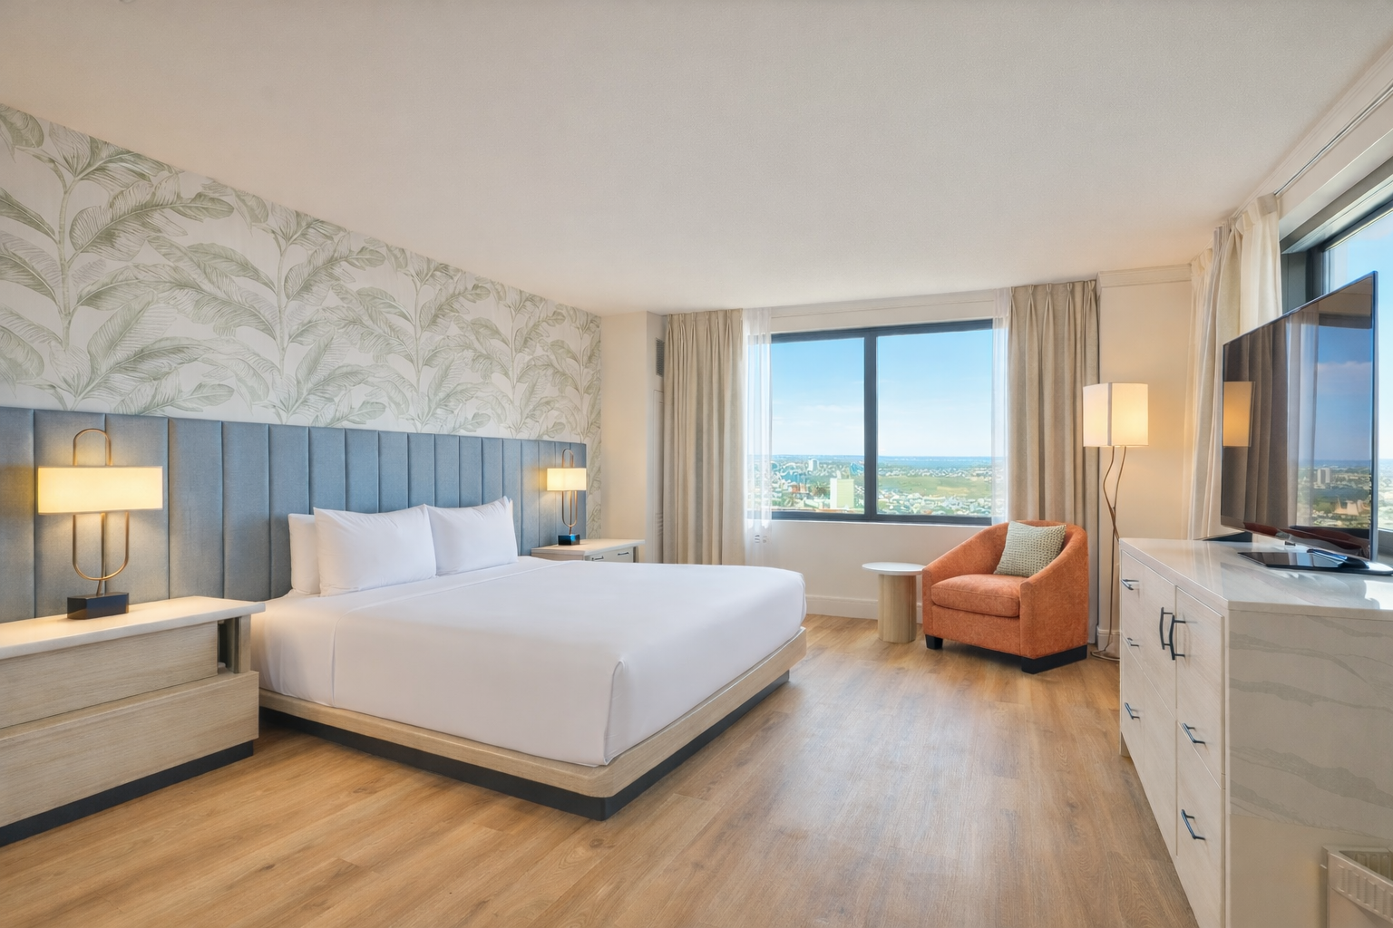

For hi-res photos and b-roll, click HERE

ATLANTIC CITY, N.J. (Feb. 2, 2026) – Tropicana Atlantic City officially welcomes guests to the all-new Solana Tower. After a complete transformation, the west wing of the resort now features 598 redesigned rooms and suites, offering a modern, coastal-inspired retreat. The opening marks a significant milestone in the resort’s ongoing evolution and commitment to providing elevated accommodations in the heart of Atlantic City.

Drawing inspiration from Tropicana’s iconic Palm Walk, the Solana Tower evokes a sense of destination within the resort. The redesign blends classic Atlantic City charm with contemporary touches, including soft wood finishes, tropical accents, curated artwork and thoughtful details that create a warm, inviting atmosphere for every traveler.

“It’s incredibly rewarding to finally welcome guests to the new Solana Tower,” said Gregg Klein, senior vice president and general manager, Tropicana Atlantic City. “After reimagining every detail, we’re thrilled to share a space where guests can relax, explore and enjoy a fresh, modern Atlantic City experience.”

Guests can now book their stay and experience the new Solana Tower. Whether visiting for leisure or a night on the town, Tropicana’s latest offering provides a refreshed home base in the heart of Atlantic City.

For reservations and more information, visit caesars.com/tropicana-ac.

###

About Caesars Entertainment Atlantic City
Caesars Entertainment owns and operates three Las Vegas-style resort destinations in the Atlantic City region, Caesars Atlantic City, Harrah’s Resort Atlantic City, and Tropicana Atlantic City. From Atlantic City’s world-famous beach and Boardwalk to the Marina District bay, Caesars Entertainment’s world-class casinos and hotels offer guests unparalleled amenities and experiences, including celebrity chef restaurants, nightlife, shopping, and entertainment, delivered with impeccable service. Home to the country’s premier loyalty card program of its kind, Caesars Rewards, customers have more ways to play, earn, and redeem rewards at over 50 Caesars Rewards destinations across the country in cities such as Las Vegas, New Orleans, Lake Tahoe and more. To learn more about Caesars Entertainment Atlantic City, visit caesars.com/atlantic-city.

Media Contact
Heather Costabile
hcostabile@caesars.com

Noel Stevenson
nstevenson@harrahs.com

Allied Global Marketing
caesarsac@alliedglobalmarketing.com

