FOR IMMEDIATE RELEASE

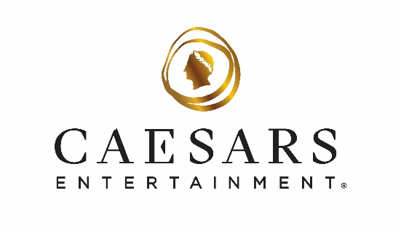

Caesars Entertainment Celebrates Nevada Residents with Exclusive Dining and Parking Perks
From Sept. 21 to Oct. 30, locals receive a 25% food and beverage discount and complimentary self-parking across Caesars Entertainment’s Las Vegas resorts Sunday through Thursday

**For high-res photos and b-roll of Caesars Entertainment’s Las Vegas resorts, click here**

LAS VEGAS (Sept. 19, 2025) – Now is the perfect time for Las Vegas locals to experience their favorite restaurants and lounges in the heart of The Strip. Caesars Entertainment is launching a 25% food and beverage discount and complimentary self-parking across its eight Las Vegas resorts, including the Miracle Mile Shops/Planet Hollywood garage, for Nevada residents Sunday through Thursday from Sunday, Sept. 21, to Thursday, Oct. 30.

Locals can enjoy the 25% discount at more than 100 restaurants, bars and lounges across Caesars Entertainment’s eight Las Vegas resorts. Options include the iconic Bacchanal Buffet at Caesars Palace, Ramsay’s Kitchen by Gordon Ramsay at Harrah’s Las Vegas or The Bedford by Martha Stewart at Paris Las Vegas, where her cherished recipes are brought to life in a setting inspired by her New York farmhouse. Visitors can also get a taste of vintage glam with a signature cocktail at Pinky’s by Vanderpump at Flamingo Las Vegas from television personality and restaurateur Lisa Vanderpump or indulge in Italian favorites and dine al fresco overlooking The Strip at Caramella at Planet Hollywood Resort & Casino. Sports fans can enjoy gameday bites and catch all the action at Guy Fieri’s Flavortown Sports Kitchen at Horseshoe Las Vegas. The Celebrity Food Hall at Caesars Palace and Fulton Street Food Hall at Harrah’s Las Vegas offer quick and convenient options as well. Additionally, the discount is valid at Caesars Entertainment’s pool venues, where locals can dine poolside during the final days of warm weather.

Guests must show a valid Nevada ID to receive the food and beverage discount and complimentary self-parking. Locals who book a staycation by March 31, 2026, can also receive an additional 15% off for stays through March 31, 2026, with a valid Nevada ID at hotel check-in. To make a reservation or for more information on these offers, including participating venues, blackout dates and exclusions, guests can visit caesars.com/las-vegas/hotels/deals/locals.

About Caesars Entertainment, Inc.
Caesars Entertainment, Inc. (NASDAQ: CZR) is the largest casino entertainment company in the U.S. and one of the world's most diversified casino entertainment providers. Since its beginning in Reno, NV, in 1937, Caesars Entertainment, Inc. has grown through the development of new resorts, expansions and acquisitions. Caesars Entertainment, Inc.'s resorts operate primarily under the Caesars®, Harrah's®, Horseshoe® and Eldorado® brand names. Caesars Entertainment, Inc. offers diversified gaming, entertainment and hospitality amenities, one-of-a-kind destinations, and a full suite of mobile and online gaming and sports betting experiences. All tied to its industry-leading Caesars Rewards® loyalty program, the company focuses on building value with its guests through a unique combination of impeccable service, operational excellence and technology leadership. Caesars is committed to its Team Members, suppliers, communities and the environment through its PEOPLE PLANET PLAY framework. Know When To Stop Before You Start.® Gambling Problem? Call 1-800-522-4700. For more information, please visit www.caesars.com/corporate. If you think you or someone you care about may have a gambling problem, call 1-877-770-STOP (1-877-770-7867).

###

Media Contact:
Kristin Soo Hoo
Ksoohoo@caesars.com

