FOR IMMEDIATE RELEASE

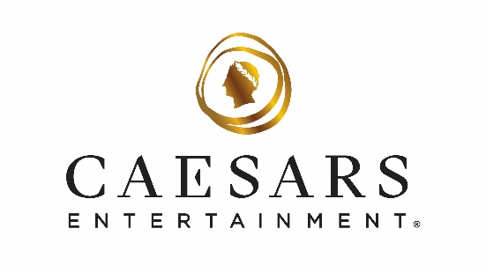
Caesars Entertainment Launches $300 Escape to Harrah’s Las Vegas, The LINQ Hotel and Flamingo Las Vegas
The two-night package includes $200 food and beverage credit,
taxes and resort fees

**For high-res photos of Harrah’s Las Vegas, The LINQ Hotel and
Flamingo Las Vegas, click here**

LAS VEGAS (Sept. 2, 2025) – Caesars Entertainment is introducing a new getaway package, making the Las Vegas Strip more accessible than ever. For $300, guests can enjoy a two-night stay at Harrah’s Las Vegas, The LINQ Hotel or Flamingo Las Vegas and receive a $200 food and beverage credit valid at a wide selection of lounges and restaurants across Caesars Entertainment’s Las Vegas resorts. The package price includes taxes and resort fees.

Dine, Lounge and Explore Across Eight Resorts
From world-class restaurants helmed by celebrated chefs and restaurateurs to casual food hall outlets and grab-and-go coffee shops, guests can experience more than 100 dining and lounge venues across Caesars Entertainment’s Las Vegas resorts.

“There’s no better time to visit Vegas, and this package is an incredible value in the heart of The Strip,” said Dan Walsh, SVP and General Manager of the three resorts. “From upscale dining to convenient, fast-casual meals, this offer gives guests the opportunity to try a wide range of options across all our Las Vegas resorts.”

Additional Offer: All You Can Spa at The LINQ Hotel and Harrah’s Las Vegas
Visitors looking to treat themselves to an ultimate day of indulgence can take advantage of the All You Can Spa package at Harrah’s Las Vegas or The LINQ Hotel. For $475 at Harrah’s and $500 at The LINQ, spa enthusiasts can enjoy up to four hours of treatments from a curated menu, including signature facials, massages, body scrubs and mud wraps. For more details and to book, guests can visit The Spa at Harrah’s website and Spa at The LINQ website.
Booking Information
Reservations are bookable now for immediate stays through Dec. 31, 2025. To book or for more information, including participating venues, blackout dates and exclusions, guests can visit caesars.com/las-vegas/hotels/deals/the-caesars-300.

About Caesars Entertainment, Inc.
Caesars Entertainment, Inc. (NASDAQ: CZR) is the largest casino entertainment company in the U.S. and one of the world's most diversified casino entertainment providers. Since its beginning in Reno, NV, in 1937, Caesars Entertainment, Inc. has grown through the development of new resorts, expansions and acquisitions. Caesars Entertainment, Inc.'s resorts operate primarily under the Caesars®, Harrah's®, Horseshoe® and Eldorado® brand names. Caesars Entertainment, Inc. offers diversified gaming, entertainment and hospitality amenities, one-of-a-kind destinations, and a full suite of mobile and online gaming and sports betting experiences. All tied to its industry-leading Caesars Rewards® loyalty program, the company focuses on building value with its guests through a unique combination of impeccable service, operational excellence and technology leadership. Caesars is committed to its Team Members, suppliers, communities and the environment through its PEOPLE PLANET PLAY framework. Know When To Stop Before You Start.® Gambling Problem? Call 1-800-522-4700. For more information, please visit www.caesars.com/corporate. If you think you or someone you care about may have a gambling problem, call 1-877-770-STOP (1-877-770-7867).

###

Media Contact:
Brooke Kaplan
bkaplan@caesars.com

