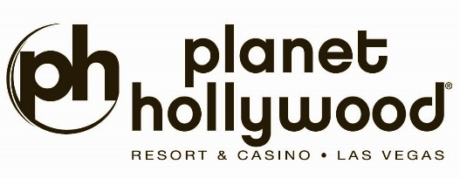
Alice Cooper & Criss Angel ANNOUNCE
“Welcome To Our Nightmare”
AT PLANET HOLLYWOOD RESORT & CASINO
limited engagement to premiere
Friday, March 6 & Saturday, March 7, 2026

EXCLUSIVE BACKSTAGE ULTIMATE VIP NIGHTMARE EXPERIENCES AND A NIGHTMARE COLLECTABLE PACKAGE ALSO AVAILABLE!

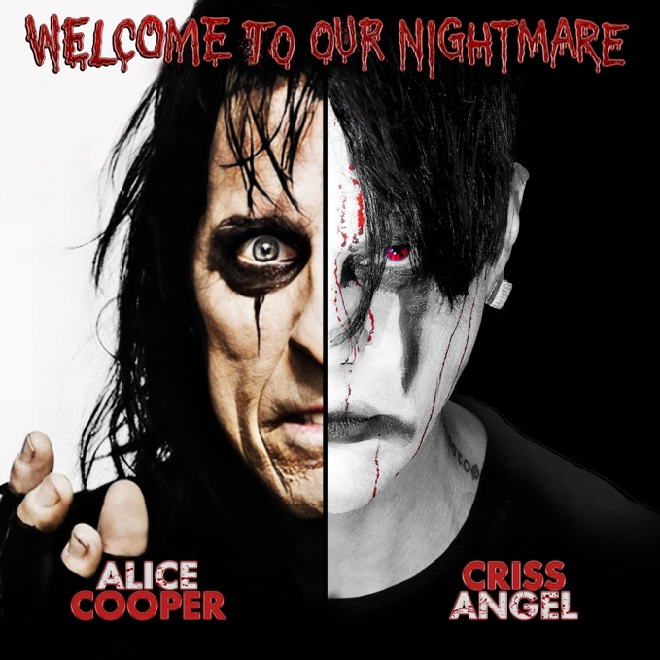
For photos and b-roll of Welcome To Our Nightmare, click here

LAS VEGAS (Oct. 30, 2025) – For the first time ever, music icon Alice Cooper and magic GOAT Criss Angel - father and son - unite to create the Shock Rock Magic experience of a lifetime, WELCOME TO OUR NIGHTMARE!, with all the smash hits in a theatrical visual feast that will destroy your MIND! Immerse your senses; run for your lives. History will be made again in The Criss Angel Theater at Planet Hollywood Resort & Casino with this exclusive limited engagement partnership.

Welcome To OUR Nightmare! Are You Ready?
Alice and Angel bring the smash hits to life: “Poison,” “I’m 18,” “School’s Out,” “You and Me” and more in an unprecedented ninety-minute revolutionary concert spectacle of magic, music, and mayhem.

Additionally, fans can take advantage of exclusive ticket add-ons, including a limited number of Ultimate VIP Nightmare Experiences with an up close and personal backstage meet & greet with Alice and Criss, and a Nightmare Collectible Package.

Welcome To Our Nightmare premieres in the Criss Angel Theater at Planet Hollywood Resort & Casino on Friday, March 6 and Saturday, March 7, 2026 at 7 p.m. Tickets will be on sale Thursday, November 6 at 10 a.m. (PT), with an exclusive presale starting Tuesday, November 4 at 10 a.m. (PT). Tickets can be purchased via Ticketmaster.com/crissangel, or by calling (855) 234-7469. For more information on Nightmare VIP experiences and packages, visit Ticketmaster.com/crissangel.

About Alice Cooper
Alice Cooper pioneered a grandly theatrical brand of hard rock that was designed to shock. Drawing equally from horror movies, vaudeville, and garage rock, the group created a stage show that featured electric chairs, guillotines, fake blood and boa constrictors. Known as the architect of shock-rock, Cooper (in both the original Alice Cooper band and as a solo artist) has rattled the cages and undermined the authority of generations of guardians of the status quo, continuing to surprise fans and exude danger at every turn, like a great horror movie, even in an era where CNN can present real life shocking images. Few performers in the history of rock and roll have blended music, theater, and pure shock the way Alice Cooper has. For more than five decades, the godfather of shock rock has terrified, thrilled, and captivated audiences around the globe with a stage show unlike anything else in music. From the guillotines and snakes to unforgettable anthems like “School’s Out” and “Poison”, Alice Cooper turned concerts into experiences that blurred the line between rock and horror.

For more information, visit AliceCooper.com or follow him on Facebook, Instagram, and X @AliceCooper.
About Criss Angel
For more than a decade, Criss Angel has dominated the world of magic as the biggest name on the planet. From his role as star, creator, executive producer, and director of the most successful magic television series of all time, Criss Angel MINDFREAK on A&E Network, to his #1 best-selling Las Vegas stage show Criss Angel MINDFREAK, to countless critically acclaimed television specials and series, best-selling books, top-grossing retail products, music CDs and more, Angel is the most influential and imitated magician of the modern era. Hailing spectacular reviews from outlets such as Bloomberg Businessweek - who called him “the biggest name in Las Vegas magic” - Angel brings “an estimated $150 million a year into the local economy” (Newsweek) and generates a whopping “$70 million a year” personally (Businessweek), proving time and again that he is the most successful magician ever.

For more information, visit CrissAngel.com or follow him on Facebook, Instagram, and X @CrissAngel.

About Planet Hollywood Resort & Casino
Planet Hollywood Resort & Casino is the centerpiece of the famed Las Vegas Strip, with 2,500 beautifully redesigned guest rooms and suites showcasing some of the best views in town, along with endless options of unparalleled shopping, distinguished dining, popular entertainment and a bustling nightlife. A bright, bold addition to the resort’s portfolio, the Ultra Hip Rooms feature contemporary elegance and luxury bedding. Known as the place to play for its roster of A-list celebrity guests, Planet Hollywood’s 231 restyled suites feature stunning views of the glittering skyline and daring décor elements such as suspended sofas, lounge-style living spaces and oversized modern artwork. The resort encompasses more than 100,000 square feet of gaming, Caesars Sportsbook at Planet Hollywood, The Scene Pool Deck, several lounges, an intimate wedding chapel and Reflections the Spa at Planet Hollywood. Impressive restaurants include Gordon Ramsay Burger, Strip House, Caramella – a new Italian restaurant and lounge in partnership with Tao Group Hospitality – and more. PH Live is one of the largest and most celebrated theaters on The Strip and showcases a variety of resident headliners, tour stops and limited engagements from music’s top artists. Magician Criss Angel performs an over-the-top visual spectacular with “Criss Angel MINDFREAK®” in the Criss Angel Theater. The world-famous male revue Chippendales bring high-energy performances, irresistible charm, live music and dazzling dance moves to the Chippendales Theater. The property is encircled by Miracle Mile Shops with more than 150 specialty stores and restaurants. Planet Hollywood Resort & Casino is operated by a subsidiary of Caesars Entertainment, Inc. (NASDAQ: CZR). For more information, please visit planethollywoodresort.com or the Caesars Entertainment media room. Find Planet Hollywood Resort & Casino on Facebook and follow on X and Instagram. Must be 21 or older to gamble. Know When To Stop Before You Start.® If you or someone you know has a gambling problem, crisis counseling and referral services can be accessed by calling or texting 1- 522-4700, Caesars License Company, LLC.

###

Media Contacts:
Robert Jarrett / Brooke Kaplan
RJarrett@caesars.com / BKaplan@caesars.com

