FOR IMMEDIATE RELEASE

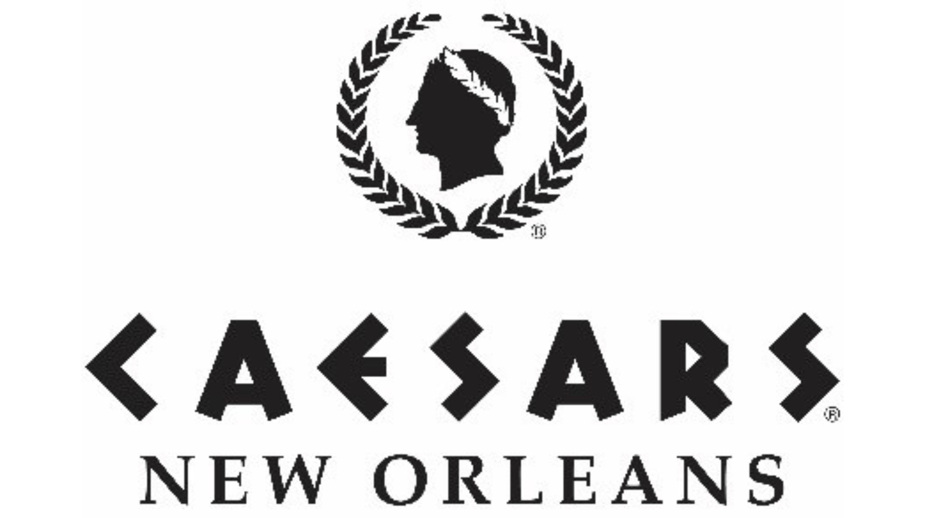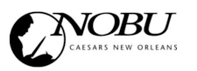

Caesars New Orleans Celebrates First Anniversary with $10,000 Donation to The Roots of Music, Food and Beverage Specials
and More
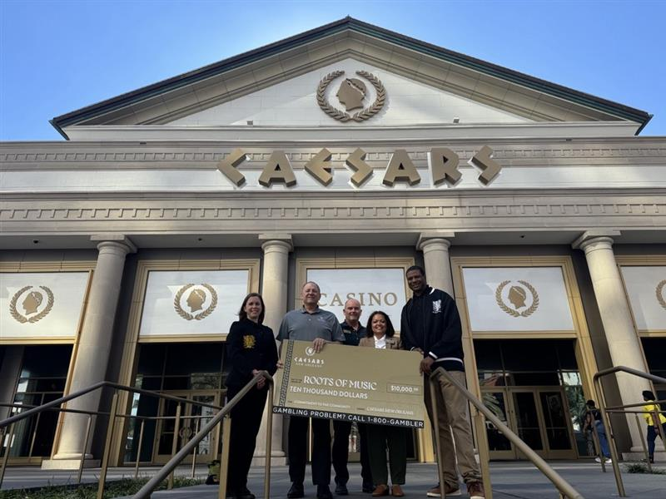

NEW ORLEANS [Oct. 27, 2025] – Caesars New Orleans is thrilled to celebrate its first anniversary, marking a remarkable year of growth, success and unforgettable guest experiences. Since officially opening its doors in October 2024, the property has redefined hospitality and entertainment in the Crescent City, combining the world-class energy of Caesars with the vibrant culture of New Orleans.

“Caesars New Orleans was built on a vision of blending the iconic Caesars brand with the unique character of New Orleans,” said Samir Mowad, senior vice president and general manager of Caesars New Orleans. “As we celebrate our first anniversary, we’re not only recognizing a year of incredible milestones but also reaffirming our commitment to the community that makes this city so special. Supporting our community reflects the heart of who we are, and we’re looking forward to building on the Caesars legacy here in New Orleans for years to come.”

As part of its first anniversary celebration, Caesars New Orleans awarded local nonprofit The Roots of Music—an organization dedicated to empowering the city’s youth through music education, academic support and mentorship—a $10,000 grant to support its continued efforts in preserving and promoting New Orleans’ rich musical and cultural heritage. After helping to commemorate Caesars New Orleans’ grand opening in 2024 as part of its grand opening parade, The Roots of Music will once again share in the celebration of the destination’s anniversary. Caesars New Orleans executives presented the $10,000 donation yesterday, underscoring the property’s commitment to supporting the community that has embraced it and supported its success.

“We are profoundly grateful to Caesars New Orleans for this generous grant,” said Derrick Tabb, Founder and Executive Director of The Roots of Music. “This support gives our students the resources to create, learn and grow, removing barriers like cost, transportation and access to instruments. With this support from Caesars New Orleans, together we can amplify the promise of youth in New Orleans through the transformative power of music.”

But the celebration doesn’t stop there. To honor the occasion, Caesars New Orleans is also inviting locals to join the celebration with an exclusive “1 on Us” dining experience running now through Nov. 22. Locals and guests alike can enjoy a special perk just for being part of the Caesars Rewards® family: when Rewards cardholders purchase dinner at Emeril’s or Nobu, they’ll receive a complimentary after-dinner drink at Octavia. Each guest will be presented with a drink card valued at $21 per person—the perfect way to toast to an unforgettable evening in the Big Easy.

In just 12 months, Caesars New Orleans has achieved standout milestones that showcase its impact and momentum in the heart of the city—welcoming remarkable growth, setting new benchmarks and establishing itself as a premier destination.

Key milestones include:
- 165,724 overnight guests welcomed at the new Caesars New Orleans
- Welcomed visitors from all 50 states + Washington D.C.
- 179,383 total jackpots celebrated in the casino at table games, slot machines and video poker
- The introduction of brand-new food & beverage options -- from classic fine dining at Nobu and Emeril’s Brasserie, to opulent craft cocktails at Octavia and 1931 Lounge, and uniquely delicious quick service options at the Food Hall, like Bobby’s Burgers, PizzaCake by Buddy V. and Nina’s Creole Cottage
  - Over 2.1 million cocktails mixed, muddled, and enjoyed across our venues
  - Dished out 798,006 unforgettable dining experiences across our restaurants
- 790 of 790 SOLD OUT guest rooms during Super Bowl weekend
- 11,337 bets placed at the Caesars Sportsbook for Super Bowl LIX

As Caesars New Orleans looks to the future, the property remains committed to delivering best-in-class experiences, raising the bar on luxury hospitality and continuing to redefine what it means to stay, play and dine in the heart of New Orleans.

###

About Caesars New Orleans
Caesars New Orleans, originally opened as Harrah's New Orleans Casino in October 1999, is located on Canal Street in the heart of downtown New Orleans, steps away from The French Quarter. As the area's only land-based casino, it offers an extensive gaming experience with over 151,400 square feet of gaming and dining space. The casino features more than 1,300 slot machines, 120 table games, a 20-table World Series of Poker Room and three outdoor gaming courtyards. In addition, the resort offers a 5,700-square-foot Caesars Sportsbook, a celebrity chef food hall, Emeril's Brasserie, and Nobu.
The destination also includes a luxury hotel component. In 2006, the original 450-room hotel opened on Poydras Street adjacent to the casino. Following a $435 million renovation, Caesars New Orleans now boasts a new 340-room hotel tower, a two-floor, 54-room Nobu Hotel, and a 13,500 sq. ft. bar and lounge named Octavia, connecting the hotel tower and the casino. Caesars New Orleans is part of Caesars Entertainment, Inc. For more information, please visit https://www.caesars.com/caesars-new-orleans. Know When To Stop Before You Start.® Gambling Problem? Call 1-800-GAMBLER. If you think you or someone you care about may have a gambling problem, call 1-800-GAMBLER (1-800-426-5372).

Media Contact:
Berk Communications
berknola@berkcommunications.com

