FOR IMMEDIATE RELEASE

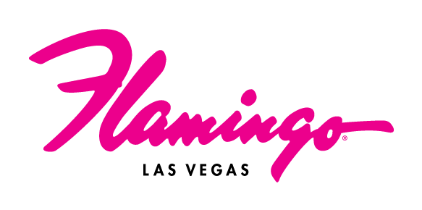

Flamingo Las Vegas Unveils Fabulous Renovations
Ahead of Its 80th Anniversary

Updates include an all-new lobby bar and an elevated hotel check-in experience

*For high-res renderings (credit: Allard & Conversano Design), click here*

LAS VEGAS (Nov. 24, 2025) – As Flamingo Las Vegas approaches its 80th anniversary in 2026, the center-Strip resort is turning up the glam with fresh enhancements while honoring its legendary spirit and welcoming a new generation of guests.

The renovations will introduce a completely redesigned lobby, featuring an all-new bar and an upgraded VIP check-in area. The resort will also debut refreshed public spaces and a full revamp of Bugsy’s Bar on the casino floor.
Designed by Allard & Conversano Design, the new spaces will feel elevated with modern elements to make the guest experience more convenient. The tropical design incorporates images of the resort's namesake bird throughout the property, reinforcing the Flamingo’s rich history while adding a bit of playfulness.

The new lobby will welcome guests with a pod-style front desk and eye-catching decor, including bronze flamingo statues and custom murals. The lobby bar will serve as the centerpiece of the resort’s arrival experience, offering guests an inviting atmosphere for both gaming and lounging. The 20-seat venue will offer tabletop gaming and TVs that circle the entire bar.

At the heart of the casino floor, Bugsy’s Bar will undergo a full reimagination with a bold new design and an inventive cocktail menu, serving drinks around the clock.

“We’re introducing fresh designs that complement the recent additions to the property, creating spaces that feel modern yet unmistakably Flamingo,” said Dan Walsh, SVP and General Manager of the resort. “The resort has always been an icon on The Strip, and these renovations ensure it remains a vibrant, must-visit destination for years to come."

This redesign contributes to the ongoing transformation at Flamingo Las Vegas, which recently debuted Pinky’s by Vanderpump, Gordon Ramsay Burger, Havana 1957 and the all-new Go Pool. The resort will welcome Salt & Straw ice cream shop and Category 10, a Luke Combs-inspired entertainment experience by Opry Entertainment Group, next year. For more information and to book, visit caesars.com/flamingo-las-vegas.

###

About Flamingo Las Vegas
Located in the heart of the Las Vegas Strip, Flamingo Las Vegas is a true desert oasis. The center-Strip resort features more than 3,500 guest rooms and suites, including the renovated Flamingo Rooms and Suites, as well as unique Bunk Bed Rooms and Suites. The iconic hotel-casino is home to a sprawling 15-acre pool complex and wildlife habitat, featuring waterfalls, mature island vegetation, tropical wildlife, the all-new Go Pool for guests 21 and older, the Family Pool and several outdoor wedding gardens. Flamingo Las Vegas offers a variety of dining options, such as vintage-inspired Bugsy & Meyer’s Steakhouse, Lisa Vanderpump’s third Las Vegas venue Pinky’s by Vanderpump, the second Gordon Ramsay Burger on The Strip, Miami’s iconic Havana 1957 and Cortadito Coffee House. The resort also hosts an all-star line-up of entertainers, including Piff The Magic Dragon, the late-night adult revue X Burlesque, RuPaul’s Drag Race LIVE! Las Vegas, as well as Mr. Las Vegas, Wayne Newton. In 2026, Flamingo Las Vegas will welcome Salt & Straw and Category 10, a Luke Combs-inspired entertainment experience by Opry Entertainment Group. Flamingo Las Vegas features more than 93,000 square feet of casino space, including Caesars Sportsbook kiosks and a live betting window. Flamingo Las Vegas is operated by a subsidiary of Caesars Entertainment, Inc. (NASDAQ: CZR). For more information, please visit flamingolasvegas.com or the Caesars Entertainment media room. Find Flamingo Las Vegas on Facebook and follow on X and Instagram. Must be 21 or older to gamble. Know When To Stop Before You Start.® If you or someone you know has a gambling problem, crisis counseling and referral services can be accessed by calling or texting 1-800- 522-4700, Caesars License Company, LLC.

Media Contact:
Brooke Kaplan
bkaplan@caesars.com

