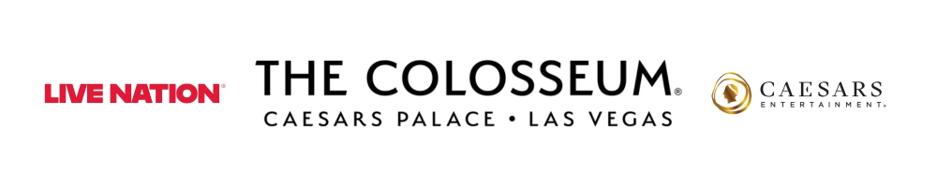
KELLY CLARKSON ANNOUNCES
NEW 2026 DATES FOR LAS VEGAS RESIDENCY AT
THE COLOSSEUM AT CAESARS PALACE

Kelly Clarkson: Studio Sessions - The Las Vegas Residency
July 17 – August 15, 2026

Presales begin Tuesday, Nov. 4
Public on sale begins Friday, Nov. 7

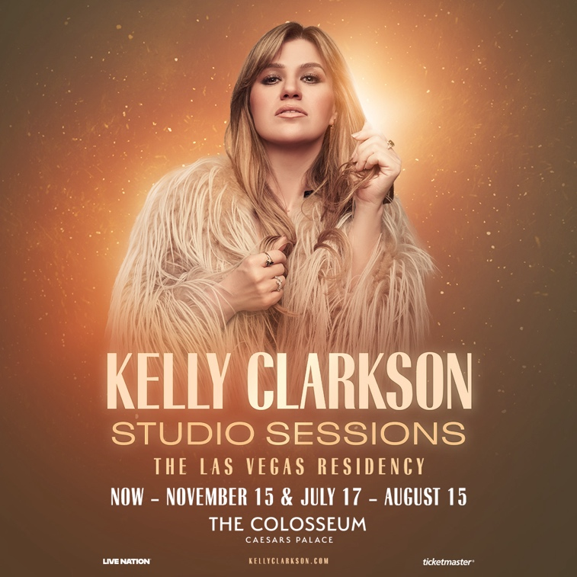

Click HERE for admat, photos and b-roll
LAS VEGAS, NV (Nov. 3, 2025) – GRAMMY Award-winning global superstar Kelly Clarkson has announced additional 2026 performances of Kelly Clarkson: Studio Sessions - The Las Vegas Residency at The Colosseum at Caesars Palace.

Studio Sessions delivers a powerful showcase of Kelly Clarkson’s unmatched talent. Backed by her brilliant band and longtime collaborators, Clarkson lit up the stage and brought the audiences to their feet with songs that span her legendary career—from chart-toppers like “Stronger,” “Since U Been Gone” and “Breakaway” to raw, emotional new tracks like “Mine” and “Where Have You Been.”

Citi is the official card of Kelly Clarkson at The Colosseum at Caesars Palace. Citi cardmembers will have access to presale tickets beginning Tuesday, Nov. 4 at 10 a.m. PT until Thursday, Nov. 6 at 10 p.m. PT through the Citi Entertainment program. For complete presale details visit www.citientertainment.com.

Fan club presale tickets will be available starting Wednesday, Nov. 5 at 10 a.m. PT. Caesars Rewards members, Caesars Entertainment’s loyalty program, and Live Nation and Ticketmaster customers will have access to a presale starting Thursday, Nov. 6 at 10 a.m. PT. All presales will end Thursday, Nov. 6 at 10 p.m. PT.

Tickets for the following newly added performances go on sale starting Nov. 7 at 10 a.m. PT:

August 2026: 7, 8, 14, 15

A limited number of tickets for the following previously announced performances are on sale now:

November 2025: 7, 8, 14, 15
July 2026: 17, 18, 24, 25, 31
August 2026: 1

Shows begin at 8 p.m. For more information and to purchase tickets, please visit ticketmaster.com/KellyVegas.

About Kelly Clarkson
Kelly Clarkson is a multi-talented artist with over 25 million albums and 50 million singles sold worldwide. Her award-winning daytime talk show, “The Kelly Clarkson Show,” now in its sixth season, has earned her multiple Emmy Awards, including wins for Outstanding Entertainment Talk Show Host and Outstanding Daytime Talk Series. Additionally, Kelly coached winning teams on “The Voice” in seasons 14, 15, 17, and 21.

Born in Texas, Kelly gained fame in 2002 as the winner of “American Idol.” She quickly became one of pop's top artists, and has topped each of Billboard’s pop, adult contemporary, country and dance charts.

Kelly Clarkson's latest single, "Where Have You Been," debuted globally on May 2, 2025, on her newly formed label, High Road Records. “Where Have You Been” is a sexy, sultry ballad that crosses various genres including rock, pop and R&B. Clarkson kicked off the release of “Where Have You Been” with a LIVE concert at Rockefeller Plaza for The Today Show’s 2025 Citi Concert Series and also showcased the song during the finale of “The Voice.” The celebration will continue into the summer with Kelly Clarkson: Studio Sessions; Kelly’s new Las Vegas residency at The Colosseum at Caesars Palace. The show launches on Friday, July 4 with 18 performances scheduled through November 15, 2025.

In 2024, Clarkson teamed up with internationally renowned artists/producers Mark Ronson & Andrew Wyatt for brand-new original holiday single You For Christmas which can be heard on her deluxe re-release, When Christmas Comes Around…Again. The re-release also included a new cover of Sleigh Ride.

In 2023, she released chemistry which earned a Grammy nomination for Best Pop Vocal Album and was celebrated with an exclusive, sold-out Las Vegas residency, chemistry… An Intimate Night with Kelly Clarkson, where she and her longtime band captivated audiences with a musical journey through her extensive catalog of hits. Clarkson previously released nine studio albums (Thankful, Breakaway, My December, All I Ever Wanted, Stronger, Wrapped in Red, Piece By Piece, Meaning of Life, When Christmas Comes Around…), one EP, Kellyoke, one greatest hits album and two children’s books (New York Times Top 10 bestseller River Rose and the Magical Lullaby and River Rose and the Magical Christmas).

Her extensive list of music accolades includes three Grammy Awards, four American Music Awards, three MTV Video Music Awards, one MTV Movie & TV Award, two Academy of Country Music Awards, two American Country Awards, and one Country Music Association Award.

About Live Nation Las Vegas
Live Nation Entertainment (NYSE: LYV) is the world’s leading live entertainment company comprised of global market leaders: Ticketmaster, Live Nation Concerts, and Live Nation Sponsorship. Live Nation Las Vegas produces residency shows from Cyndi Lauper, Blake Shelton, Def Leppard, Dolly Parton, Jennifer Lopez, Alanis Morissette, Kelly Clarkson and Rod Stewart at The Colosseum at Caesars Palace; ZAYN, Mariah Carey, Sammy Hagar, New Kids On The Block and Bruno Mars at Dolby Live at Park MGM; The B-52s, Earth, Wind & Fire, FOREIGNER, STYX and Chicago at The Venetian Theatre at The Venetian Resort Las Vegas; John Fogerty at PH Live at Planet Hollywood Resort & Casino; and Santana at House of Blues. Live Nation Las Vegas also brings other world-famous artists to many of the city’s other premier concert venues including Allegiant Stadium, T-Mobile Arena, MGM Grand Garden Arena, Michelob ULTRA Arena, the Pearl at Palms Casino Resort, Downtown Las Vegas Events Center and more. For additional information, visit www.livenationentertainment.com. Find Live Nation Las Vegas on Facebook and Instagram.

About Caesars Palace
Caesars Palace, the iconic Las Vegas Strip resort where every guest is treated like a Caesar, features 3,980 hotel guest rooms and suites, including the redesigned 182-room Nobu Hotel Caesars Palace, the renovated Colosseum Tower and THE VILLAS Caesars Palace, which has earned the prestigious AAA Five Diamond rating. Both Caesars Palace and Nobu Hotel Caesars Palace have also received AAA Four Diamond designations. The 85-acre resort offers diverse dining options from the award-winning Bacchanal Buffet to celebrity chef-branded restaurants, including Gordon Ramsay HELL’S KITCHEN, Pronto by Giada, Amalfi by Bobby Flay, Vanderpump Cocktail Garden by restaurateur and television star Lisa Vanderpump, one of Nobu Matsuhisa’s largest Nobu restaurants, Restaurant Guy Savoy, award-winning pastry chef Dominique Ansel’s first Las Vegas bakery, Stanton Social Prime – a dining concept in partnership with Tao Group Hospitality, legendary New York Steak House Peter Luger and Brasserie B Parisian Steakhouse by Bobby Flay. The Celebrity Food Hall features Guy Fieri’s Chicken Guy!, Bobby’s Burgers by Bobby Flay, Tortazo by Rick Bayless, Buddy V’s Pizzeria and Mokbar by Esther Choi. For the best in cocktails, destination lounges include Montecristo Cigar Bar, VISTA Cocktail Lounge, Stadia Bar and Caspian’s – a cocktail and caviar bar with Clique Hospitality. The resort also features nearly 130,000 square feet of casino space, the Caesars Race & Sportsbook at Caesars Palace with a 143-foot HD LED screen and state-of-the-art sound, a five-acre Garden of the Gods Pool Oasis, the luxurious Qua Baths & Spa, Hairdreams by Michael Boychuck, five wedding chapels and gardens, and the 75,000-square-foot OMNIA Nightclub with top DJs. The 4,300-seat Colosseum is the most celebrated venue in Las Vegas with an impressive legacy of superstar talent featured in an intimate, once-in-a-lifetime setting. The Colosseum currently spotlights world-class entertainers, including Kelly Clarkson, Jennifer Lopez, Dolly Parton, Alanis Morissette, Blake Shelton, Nikki Glaser and David Spade, Def Leppard, Cyndi Lauper, Jerry Seinfeld and Rod Stewart. Also, the Green Fairy Garden in front of Caesars Palace hosts ABSINTHE by Spiegelworld, an adults-only circus variety show featuring a cocktail of wild and outlandish acts. The Forum Shops at Caesars Palace showcases more than 160 boutiques and restaurants. Caesars Palace is operated by a subsidiary of Caesars Entertainment, Inc. (NASDAQ: CZR). For more information, please visit caesarspalace.com or the Caesars Entertainment media room. Find Caesars Palace on Facebook and follow on X and Instagram. Know When To Stop Before You Start.® If you or someone you know has a gambling problem, crisis counseling and referral services can be accessed by calling or texting 1-800- 522-4700, Caesars License Company, LLC.

# # #

MEDIA CONTACTS:
For Live Nation Las Vegas:
Kelly Frey
Kelly@KFPublicity.com

For Caesars Entertainment:
Robert Jarrett
RJarrett@caesars.com

For Kelly Clarkson:
Melissa Kates
melissa.kates@viewpointla.com

