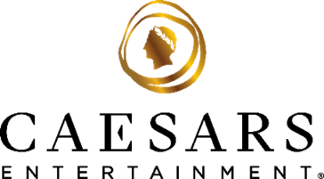

**FOR IMMEDIATE RELEASE**

**Caesars Entertainment Becomes First Online Casino Operator to Launch Branded Version of Pixiu Gaming’s Keno Title, Lucky Bonus Draw Keno**Caesars Palace Bonus Draw Keno, the first branded version of the popular Keno title, is now live exclusively on Caesars’ marquee online casino platforms in New Jersey and Ontario

**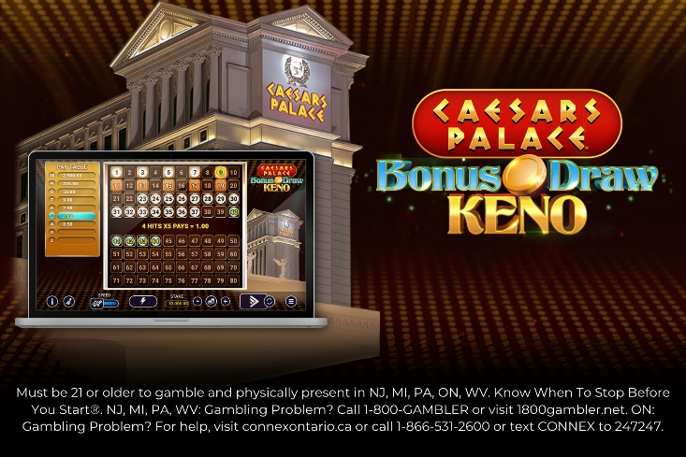***\*\*For downloadable high-res assets, click* [*here*](https://drive.google.com/drive/folders/1rrYQ7f8bGv2fBDRr7khumvwv_nscWHdu?usp=sharing)*\*\**

**LAS VEGAS (March 6, 2025)** – **Caesars Entertainment, Inc.** (NASDAQ: CZR) (“Caesars”) today announced its marquee iGaming platforms are the first in the online casino industry to launch a branded version of Pixiu Gaming’s beloved Keno title, Lucky Bonus Draw Keno. Online casino players on Caesars Palace Online Casino, Horseshoe Online Casino, and Caesars Sportsbook & Casino in New Jersey and Ontario can now enjoy exclusive access to a fully Caesars-branded installment of Pixiu’s fan-favorite Keno title, entitled Caesars Palace Bonus Draw Keno.

“The widespread appeal of Lucky Bonus Draw Keno is undeniable, and we couldn’t be happier to infuse this classic game with a distinctive Caesars flair for our digital platforms,” said Matthew Sunderland, Senior Vice President and Chief iGaming Officer at Caesars Digital. “The launch of Caesars Palace Lucky Draw Keno underscores our dedication to offering tailored content that embodies our brand's core values for our online casino players.”

Keno has been a celebrated favorite game in brick-and-mortar casinos. Its lasting appeal continues to enchant players from Las Vegas to Atlantic City and now extends to online casino platforms. Caesars Palace Lucky Draw Keno features a unique gameplay aesthetic that brings the Las Vegas Strip’s most iconic casino, Caesars Palace, directly into focus. Players aged 21 and older can enjoy a classic Lucky Bonus Draw Keno experience, enhanced by the regal aesthetic of the Caesars brand, with Caesars Palace prominently featured in the gameplay.

Caesars Palace Online Casino, Horseshoe Online Casino, and Caesars Sportsbook & Casino are available on iOS, Android, and desktop for those 21 and older in New Jersey, Pennsylvania, Michigan, Ontario, and West Virginia. Each platform offers a dynamic online casino experience with a range of unique Caesars-branded games alongside hundreds of classic land-based casino favorites and core casino game mechanics, including high-limit slots, private live dealer tables, linked progressive jackpots, variations of poker and roulette, and more.

Caesars’ easy-to-navigate online casino apps and desktop platforms also tie online gaming to The Company’s industry-leading customer loyalty program, [Caesars Rewards](https://www.caesars.com/myrewards)®. Players in the United States earn Caesars Rewards Credits through their online and in-person casino play that can be redeemed for unforgettable Caesars Rewards experiences at one of Caesars' more than 50 world-class destinations across North America. Accruing Caesars Rewards credits is currently unavailable in Ontario when using Caesars’ online casino platforms.

Caesars Entertainment is an industry leader in Responsible Gaming, known for pioneering Responsible Gaming awareness and education. In 1989, Caesars became the first commercial casino company to address problem gambling by launching the industry’s first Responsible Gaming program, Project 21. Today, the Company’s commitment to ensuring all players are aware of Responsible Gaming resources remains steadfast and spans all of Caesars’ digital platforms and world-class destinations in which it operates. Caesars Entertainment proudly enforces an enhanced 21+ gaming policy that prevents individuals under the age of 21 from using Caesars Rewards and restricts access to its gaming products for individuals under the age of 21.

In March 2024, Caesars Sportsbook received the prestigious [RG Check accreditation](https://newsroom.caesars.com/press-releases/press-release-details/2024/Caesars-Sportsbook-Recognized-for-Responsible-Gaming-Practices-with-Top-Accreditation-by-Responsible-Gambling-Councils-RG-Check-Program/default.aspx) from the Responsible Gambling Council in Ontario, Canada, which recognizes companies that achieve the highest standards for their Responsible Gaming practices. Just a few months later, the Company was awarded the National Council on Problem Gambling’s award for Corporate Social Responsibility. For more information about Caesars Entertainment's Responsible Gaming program, please visit <https://www.caesars.com/corporate>.

# # # 

**About Caesars Entertainment, Inc.**   
Caesars Entertainment, Inc. (NASDAQ: CZR) is the largest casino-entertainment Company in the U.S. and one of the world’s most diversified casino-entertainment providers. Since its beginning in Reno, NV, in 1937, Caesars Entertainment, Inc. has grown through development of new resorts, expansions and acquisitions. Caesars Entertainment, Inc.’s resorts operate primarily under the Caesars®, Harrah’s®, Horseshoe®, and Eldorado® brand names. Caesars Entertainment, Inc. offers diversified gaming, entertainment and hospitality amenities, one-of-a-kind destinations, and a full suite of mobile and online gaming and sports betting experiences. All tied to its industry-leading Caesars Rewards loyalty program, the Company focuses on building value with its guests through a unique combination of impeccable service, operational excellence and technology leadership. Caesars is committed to its employees, suppliers, communities and the environment through its PEOPLE PLANET PLAY framework. Know When To Stop Before You Start.® Gambling Problem? Call or text 1-800-GAMBLER. For more information, please visit [www.caesars.com/corporate](http://www.caesars.com/corporate).

**About Pixiu Gaming**

[Pixiu Gaming](http://www.pixiugaming.com) is a boutique, high-quality, game studio in the regulated Canadian, US and European markets. We create beautiful, player-centric, authentic games with a focus on fun and innovation. We pride ourselves on working closely with our partners, including Canadian Provincial governments and the Dan Marino Foundation, to help charitable and community-focused good causes.

Pixiu specialises in entertaining kenos, establishing itself as the market leader in Canada. Alongside slots, Pixiu is also heavily focused on bringing unique Multiplayer games to the market where multiple players play the same iCasino game, at the same time.

We pride ourselves on collaboration, mutual benefit, and delivering fun, responsible gaming.

**Responsible Gaming**

Casino app & website available in MI, NJ, PA, WV and ON only.

Must be 21+ and physically present in MI, NJ, PA, WV an ON only. See CaesarsPalaceOnline.com for full terms. Void where prohibited. Know When To Stop Before You Start®. Gambling Problem? MI, NJ, WV, PA (Affiliated with Harrah's Philadelphia): If you or someone you know has a gambling problem, crisis counseling and referral services can be accessed by calling 1-800-GAMBLER (1-800-426-2537) or WV: Visit 1800gambler.net; ON: Visit connexontario.ca or call 1-866-531-2600 or text CONNEX to 247247. Accruing Caesars Rewards credits is currently not available in Ontario when using Caesars Palace Online Casino and Caesars Sportsbook & Casino. ©2025, Caesars Entertainment

**Media Contacts:**

Brad Harwood, [bharwood@caesars.com](mailto:bharwood@caesars.com)

Dominic Holden, [dholden@caesars.com](mailto:dholden@caesars.com)

Jenny Lu,[jenny@pixiugaming.com](mailto:jenny@pixiugaming.com)