
FOR IMMEDIATE RELEASE
Caesars Entertainment Launches Signature Blackjack Surrender
Across Online Casino Platforms in New Jersey
Singlehand blackjack title becomes the second proprietary game
developed by Caesars’ in-house games studio, Empire Creative™

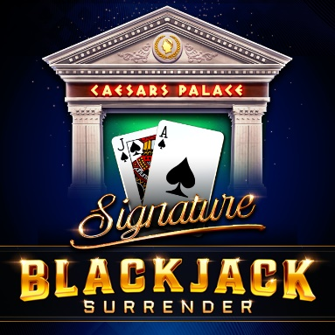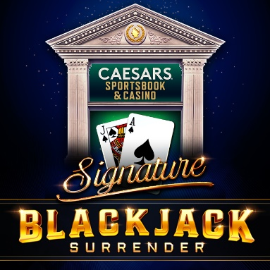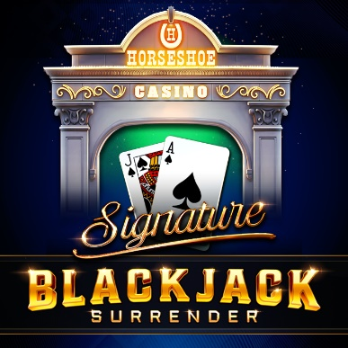
**For downloadable high-res assets, click here**
LAS VEGAS (June 30, 2025) – Caesars Entertainment, Inc. (NASDAQ: CZR) (“Caesars”) today announced the launch of its second proprietary online casino table game, Signature Blackjack Surrender, which is now live across Caesars’ marquee online casino platforms, Caesars Palace Online Casino, Caesars Sportsbook & Casino and Horseshoe Online Casino in New Jersey. Developed by Empire Creative™, Caesars’ in-house games studio, this release follows last month’s successful debut of Caesars Palace Signature Multihand Blackjack Surrender and continues the Company’s momentum in delivering brand-led, best-in-class digital casino experiences.
This latest release further strengthens Caesars' development and distribution of exclusive in-house iGaming content that reflects the sophistication of its legendary brands. Signature Blackjack Surrender is designed to offer a highly intuitive experience for players who prefer traditional singlehand gameplay, wrapped in the luxurious aesthetic of the various Caesars Palace iconic online gaming brands.
“Signature Blackjack Surrender marks the latest triumph of our in-house developed content, which is becoming a core piece of our online casino foundation,” said Matt Sunderland, Senior Vice President and Chief iGaming Officer at Caesars Digital. “Signature Blackjack Surrender is the perfect complement to Caesars Palace Signature Multihand Blackjack Surrender, which successfully debuted last month.”
“Every detail in Signature Blackjack Surrender has been carefully crafted to deliver the look, feel, and energy of a live blackjack table,” said Scott Krell, Senior Director of Game Products & Head of Studio at Caesars Digital. “We’re proud to follow up our multihand product with a singlehand version that’s equally refined, intuitive, and brand aligned. This is the next step in building a robust library of Caesars-exclusive games that players can’t find anywhere else.”
Signature Blackjack Surrender retains the same exciting and innovative features found in Empire Creative’s first release, Caesars Palace Signature Multihand Blackjack Surrender, including:
- Ambidextrous Game Modes – Left and right-handed modes where all players can enjoy a comfortable and ergonomic gaming experience regardless of their dominant hand.
- Brand-Aligned Design – Player-selectable table felts combined with the iconic Caesars Palace laurel wreath.
- Comprehensive Wagering Options – Advanced betting options such as surrender, even money, and insurance, allowing players more choice over their gameplay strategies.
- Customizable Audio Experience – Immersive gaming mechanics tailored to each player’s preferences through eight player-selectable proprietary audio tracks.
- Safety Net – Designed to prevent accidental bets, reducing the risk of making unintended selections during gameplay.
- Voiceover Flexibility – For a personalized experience with a choice between male and female voiceovers for game audio.
Coming soon: Caesars’ first slot title developed in collaboration with Bragg Gaming, Triple Golden Shields, is set to debut later this summer, marking the next evolution in Caesars’ exclusive content roadmap.
Those 21 and older in New Jersey can download the Caesars Palace Online Casino app on iOS or Android, or access the platform on desktop to be the first to enjoy Signature Blackjack Surrender. Caesars Palace Online Casino, Horseshoe Online Casino, and Caesars Sportsbook & Casino are available for players 21 and older in New Jersey, Pennsylvania, Michigan, Ontario, and West Virginia. Each platform offers a dynamic online casino experience with a range of unique games from top providers, Caesars-branded games, and timeless casino classics. Additionally, these platforms seamlessly integrate with Caesars Rewards®, the Company's industry-leading loyalty program, allowing players in the United States to earn Caesars Rewards Credits redeemable for unforgettable experiences at over 50 world-class Caesars destinations across North America.
Caesars Entertainment is an industry leader in Responsible Gaming, known for pioneering Responsible Gaming awareness and education. In 1989, Caesars became the first commercial casino company to address problem gambling by launching the industry’s first Responsible Gaming program, Project 21. Today, the Company’s commitment to ensuring all players are aware of Responsible Gaming resources remains steadfast and spans all of Caesars’ digital platforms and world-class destinations in which it operates. Caesars Entertainment proudly enforces an enhanced 21+ gaming policy that prevents individuals under the age of 21 from using Caesars Rewards and restricts access to its gaming products for individuals under the age of 21.
In March 2024, Caesars Sportsbook received the prestigious RG Check accreditation from the Responsible Gambling Council in Ontario, Canada, which recognizes companies that achieve the highest standards for their Responsible Gaming practices. Just a few months later, the Company was awarded the National Council on Problem Gambling’s award for Corporate Social Responsibility. For more information about Caesars Entertainment's Responsible Gaming program, please visit https://www.caesars.com/corporate.
# # #
About Caesars Entertainment, Inc.
Caesars Entertainment, Inc. (NASDAQ: CZR) is the largest casino-entertainment Company in the U.S. and one of the world’s most diversified casino-entertainment providers. Since its beginning in Reno, NV, in 1937, Caesars Entertainment, Inc. has grown through development of new resorts, expansions and acquisitions. Caesars Entertainment, Inc.’s resorts operate primarily under the Caesars®, Harrah’s®, Horseshoe®, and Eldorado® brand names. Caesars Entertainment, Inc. offers diversified gaming, entertainment and hospitality amenities, one-of-a-kind destinations, and a full suite of mobile and online gaming and sports betting experiences. All tied to its industry-leading Caesars Rewards loyalty program, the Company focuses on building value with its guests through a unique combination of impeccable service, operational excellence and technology leadership. Caesars is committed to its employees, suppliers, communities and the environment through its PEOPLE PLANET PLAY framework. Know When To Stop Before You Start.® Gambling Problem? Call or text 1-800-GAMBLER. For more information, please visit www.caesars.com/corporate.
Responsible Gaming
Online Casino apps & websites available in MI, NJ, PA, WV and ON only.
Must be 21+. See Caesars.com/sportsbook-and-casino, CaesarsPalaceOnline.com, or HorseshoeOnlineCasino.com for full terms. Void where prohibited.
Know When To Stop Before You Start®. Gambling Problem? MI, NJ, WV, PA (Affiliated with Harrah's Philadelphia): If you or someone you know has a gambling problem, crisis counseling and referral services can be accessed by calling 1-800-GAMBLER (1-800-426-2537) or WV: Visit 1800gambler.net; ON: Visit connexontario.ca or call 1-866-531-2600 or text CONNEX to 247247. Accruing Caesars Rewards credits is currently not available in Ontario when using Caesars Sportsbook & Casino, Caesars Palace Online Casino, and Horseshoe Online Casino. ©2025, Caesars Entertainment
Media Contacts:
Brad Harwood, bharwood@caesars.com
Dominic Holden, dholden@caesars.com
Source: Caesars Entertainment Inc.; CZR

