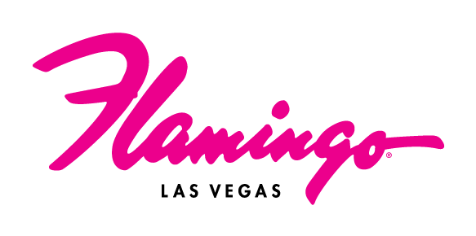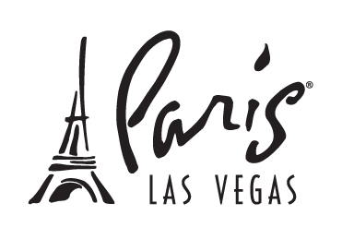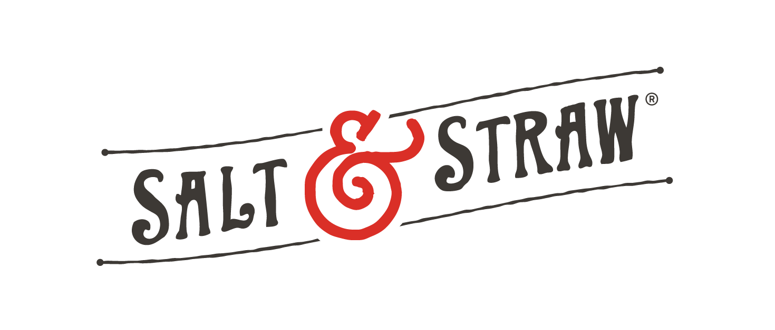
Salt & Straw Rings in the New Year with New Scoop Shops at Paris Las Vegas and Flamingo Las Vegas

For high-res photos, click here

LAS VEGAS, NV – (December 30, 2025) – Salt & Straw, the beloved, artisan ice cream brand, makes its debut on the Las Vegas Strip – opening new shops on Wednesday, Dec. 31 at Paris Las Vegas (within the foot of the legendary Eiffel Tower) and Flamingo Las Vegas, two of the most iconic resorts on The Strip. To celebrate these openings, both shops will launch with a special menu – The Icons Series – highlighting a standout variety of Salt & Straw’s most iconic flavors created by co-founder and head ice cream maker Tyler Malek. Guests can ring in the new year by indulging in this flavor series, which has been curated for The Strip’s new scoop shops.

Founded by cousins Kim and Tyler Malek, Salt & Straw has redefined what ice cream can be, transforming each scoop into a storytelling experience. From fan-favorite classics like Sea Salt with Caramel Ribbons and Double Fold Vanilla to wildly inventive originals like Strawberry Honey Balsamic with Black Pepper, every flavor is crafted to ignite curiosity and spark joy. In addition to its core menu, Salt & Straw is known for its monthly rotating flavors, each built around an original theme – whether it’s spotlighting local farmers and artisans, honoring cultural traditions or exploring big ideas through unexpected ingredients. In Las Vegas, guests can expect the full Salt & Straw experience: thoughtful flavors, boundless creativity and a chance to connect over a one-of-a-kind culinary experience.

“Bringing Salt & Straw to the Las Vegas Strip is a dream realized,” says Co-Founder and CEO Kim Malek. “We started this company to build places where people could come together, connect and celebrate life over a scoop of unforgettable ice cream. To now open beneath the Eiffel Tower replica at Paris Las Vegas and the neon lights at Flamingo Las Vegas – it’s hard to imagine two better locations to debut on The Strip. This is where people from around the world gather for iconic, once-in-a-lifetime moments, and we’re honored to be part of that.”

“Salt & Straw brings a creative, fresh take on ice cream that fits perfectly with our culinary collection at Caesars Entertainment,” said Sean McBurney, Chief Commercial Officer and Regional President of Caesars Entertainment. “They’re a destination in their own right, and we’re excited for locals and visitors to enjoy their inventive flavors at our two new locations on The Strip.”

THE MENU
Head ice cream maker and co-founder Tyler Malek has created a menu of 13 classic, always-available flavors, including Sea Salt with Caramel Ribbons, Honey Lavender, Arbequina Olive Oil and Chocolate Gooey Brownie. Salt & Straw also offers monthly rotating menus that tell the stories of artisans, farmers and seasonal food moments.

To mark Salt & Straw’s debut on the Las Vegas Strip, Tyler has crafted The Icons Series – curating a selection of his most beloved and iconic flavors that are fit for celebrations of all kinds. The series includes:
- Pots of Gold & Rainbows – Hand-sorted rainbow marshmallows tossed into a cereal-steeped ice cream
- Birthday Cakes & Blackberries – Hunks of rainbow-sprinkled birthday crumble studded throughout double-vanilla ice cream and ribboned with blackberry jam
- Almond Brittle with Salted Ganache – Pieces of almond brittle and hunks of creamy chocolate ganache swirled in vanilla ice cream
- Chocolate Chili Crisp Peanut Butter Cups – Milk chocolate ice cream with bite-sized, housemade chili crisp peanut butter cups, swirled with peanut butter marshmallow fluff
- Death by Chocolate Chocolate Cake (v) – Chocolate barley oat milk swirled with chocolate caramel fudge and hunks of chocolate cake, finished with a chocolate ganache

MORE INFORMATION:
Both Salt & Straw scoop shops offer convenient sidewalk access along Las Vegas Boulevard.
The Paris Las Vegas shop [3655 South Las Vegas Blvd.], located within the foot of the legendary Eiffel Tower near Arc Bar, is open daily from 11 a.m. to 11 p.m. The Flamingo Las Vegas shop [3555 South Las Vegas Blvd.], adjacent to Gordon Ramsay Burger, is open from 11 a.m. to midnight.

For more information, visit www.saltandstraw.com and follow @saltandstraw.

ABOUT SALT & STRAW:
Salt & Straw is more than an ice cream company – it’s a celebration of creativity, community, and connection. Founded by cousins Kim and Tyler Malek, the brand has redefined what ice cream can be, transforming each scoop into a storytelling experience. From fan-favorite classics like Sea Salt with Caramel Ribbons and Double Fold Vanilla to wildly inventive originals like Strawberry Honey Balsamic with Black Pepper, every flavor is crafted to ignite curiosity and spark joy. In addition to their core menu, Salt & Straw is known for its monthly rotating flavors, each built around an original theme – whether it’s spotlighting local farmers and artisans, honoring cultural traditions, or exploring big ideas through unexpected ingredients.
About Flamingo Las Vegas:
Located in the heart of the Las Vegas Strip, Flamingo Las Vegas is a true desert oasis. The center-Strip resort features more than 3,500 guest rooms and suites, including the renovated Flamingo Rooms and Suites, as well as unique Bunk Bed Rooms and Suites. The iconic hotel-casino is home to a sprawling 15-acre pool complex and wildlife habitat, featuring waterfalls, mature island vegetation, tropical wildlife, the all-new Go Pool for guests 21 and older, the Family Pool and several outdoor wedding gardens. Flamingo Las Vegas offers a variety of dining options, such as vintage-inspired Bugsy & Meyer’s Steakhouse, Lisa Vanderpump’s third Las Vegas venue Pinky’s by Vanderpump, the second Gordon Ramsay Burger on The Strip, Miami’s iconic Havana 1957 and Cortadito Coffee House and a Salt & Straw scoop shop. The resort also hosts an all-star line-up of entertainers, including Piff The Magic Dragon, the late-night adult revue X Burlesque, RuPaul’s Drag Race LIVE! Las Vegas, as well as Mr. Las Vegas, Wayne Newton. In 2026, Flamingo Las Vegas will welcome Category 10, a Luke Combs-inspired entertainment experience by Opry Entertainment Group. Flamingo Las Vegas features more than 93,000 square feet of casino space, including Caesars Sportsbook kiosks and a live betting window. Flamingo Las Vegas is operated by a subsidiary of Caesars Entertainment, Inc. (NASDAQ: CZR). For more information, please visit flamingolasvegas.com or the Caesars Entertainment media room. Find Flamingo Las Vegas on Facebook and follow on X and Instagram. Must be 21 or older to gamble. Know When To Stop Before You Start.® If you or someone you know has a gambling problem, crisis counseling and referral services can be accessed by calling or texting 1-800- 522-4700, Caesars License Company, LLC.

About Paris Las Vegas:
Paris Las Vegas brings the passion and sophistication of the City of Light to the heart of the Las Vegas Strip, transporting guests to Europe's most romantic city. Distinctive for its dramatic 46-story replica Eiffel Tower with a free, nightly light show and authentic architectural reproductions, the resort features more than 2,900 rooms and suites, including Burgundy Rooms. The newly renovated Versailles Tower adds 756 redesigned luxury guestrooms to the hotel, with select rooms featuring balconies. The resort offers an 85,000-square-foot casino; the renovated Caesars Race & Sportsbook at Paris Las Vegas; the two-acre Pool à Paris; the rooftop bar and grill BEER PARK; Voie Spa & Salon; two wedding chapels; unique French retail shopping located along the resort’s Le Boulevard District and the Parisian-themed restaurant and lounge, Chéri Rooftop. Restaurants include a distinctive array of fine cuisine, such as Chef Joho's acclaimed Eiffel Tower Restaurant, French-bistro Mon Ami Gabi and internationally renowned Gordon Ramsay Steak. Paris Las Vegas also offers quick service options like Brioche by Guy Savoy and Bobby’s Burgers by Bobby Flay. Additionally, the resort is home to Lisa Vanderpump’s second Las Vegas venue, Vanderpump à Paris, Nobu restaurant, The Bedford by Martha Stewart, Montecristo Cigar Bar, Dominique Ansel Marché and a Salt & Straw scoop shop. Featuring one of the largest ballrooms in Las Vegas, Paris offers 140,000 square feet of pillarless function space. Paris Las Vegas is operated by a subsidiary of Caesars Entertainment, Inc. (NASDAQ: CZR). For more information, please visit parislasvegas.com. Find Paris Las Vegas on Facebook and follow on X and Instagram. Must be 21 or older to gamble. Know When To Stop Before You Start.® If you or someone you know has a gambling problem, crisis counseling and referral services can be accessed by calling 1-800-522-4700, Caesars License Company, LLC.

