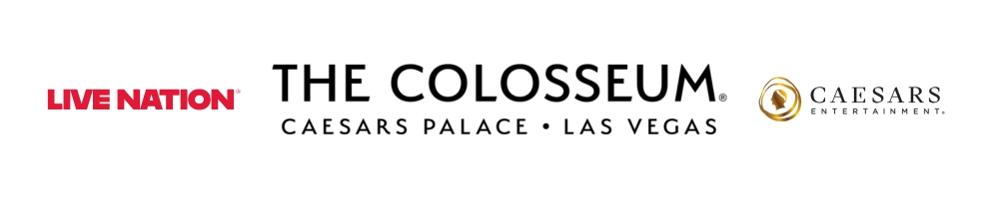
The Colosseum at Caesars Palace Earns No. 1 Spot on Billboard Magazine’s Year-End Top Venue List

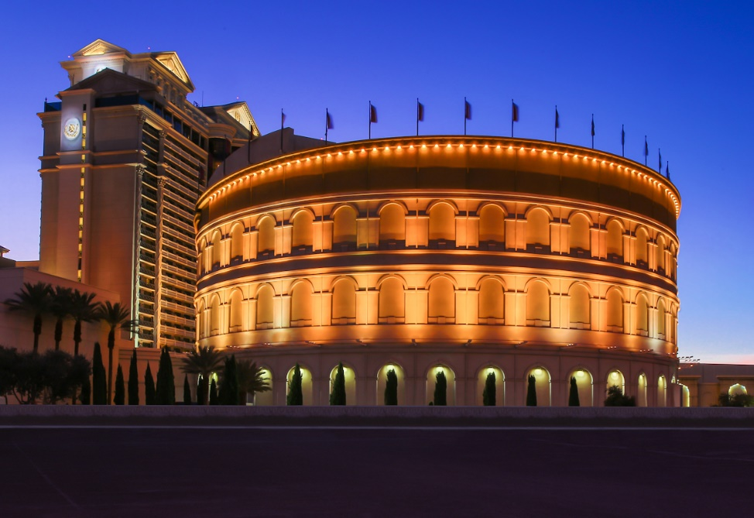

Las Vegas, NV (Dec. 12, 2025) – The Colosseum at Caesars Palace has been named Top Venue (2,501-5,000 capacity) in Billboard Magazine’s 2025 Year-End Chart. This is the venue’s 17th time atop a version of this list which was introduced in 2005. With more than $66 million in grosses over 64 shows with 239,000 fans within the 2025 reporting window, this prestigious recognition underscores The Colosseum’s reputation as one of the most iconic and popular entertainment destinations in Las Vegas and beyond.

"We are incredibly proud that The Colosseum at Caesars Palace has earned the top spot on Billboard’s list this year,” said Amy Graca, Senior Vice President of Entertainment for Caesars Entertainment. “This honor reflects not only the iconic artists that grace our stage, but also the dedication of our team to delivering world-class experiences for every guest. The Colosseum is more than a venue, it’s a symbol of Las Vegas entertainment, and we are thrilled to see it recognized among the very best."

“This recognition from Billboard underscores the power of Live Nation's partnership with Caesars Entertainment and the enduring legacy of The Colosseum. From groundbreaking residencies to unforgettable one-night-only performances, this stage continues to set the standard and define live entertainment in Las Vegas,” said Kurt Melien, President of Live Nation Las Vegas.

Since opening its doors in 2003, The Colosseum has hosted legendary residencies and unforgettable performances from the world’s biggest superstar talent, cementing its place as a premier stage for live entertainment. With state-of-the-art production capabilities and an intimate yet grand atmosphere, the venue continues to set the standard for excellence in live performance.

The Colosseum will end 2025 with the debut of “Jennifer Lopez: Up All Night Live in Las Vegas.” The powerhouse lineup continues in 2026 with shows from Blake Shelton, Nikki Glaser and David Spade, Def Leppard, Jerry Seinfeld, David Byrne, Cyndi Lauper, Rod Stewart and Kelly Clarkson. For more information on performance schedule and to purchase tickets, please visit www.caesars.com/caesars-palace.

About Caesars Palace
Caesars Palace, the iconic Las Vegas Strip resort where every guest is treated like a Caesar, features 3,980 hotel guest rooms and suites, including the redesigned 182-room Nobu Hotel Caesars Palace, the renovated Colosseum Tower and THE VILLAS Caesars Palace, which has earned the prestigious AAA Five Diamond rating. Both Caesars Palace and Nobu Hotel Caesars Palace have also received AAA Four Diamond designations. The 85-acre resort offers diverse dining options from the award-winning Bacchanal Buffet to celebrity chef-branded restaurants, including Gordon Ramsay HELL’S KITCHEN, Pronto by Giada, Amalfi by Bobby Flay, Vanderpump Cocktail Garden by restaurateur and television star Lisa Vanderpump, one of Nobu Matsuhisa’s largest Nobu restaurants, Restaurant Guy Savoy, award-winning pastry chef Dominique Ansel’s first Las Vegas bakery, Stanton Social Italian – a dining concept in partnership with Tao Group Hospitality, legendary New York Steak House Peter Luger and Brasserie B Parisian Steakhouse by Bobby Flay. The Celebrity Food Hall features Guy Fieri’s Chicken Guy!, Bobby’s Burgers by Bobby Flay, Tortazo by Rick Bayless, Buddy V’s Pizzeria and Mokbar by Esther Choi. For the best in cocktails, destination lounges include Montecristo Cigar Bar, VISTA Cocktail Lounge, Stadia Bar and Caspian’s – a cocktail and caviar bar with Clique Hospitality The resort also features nearly 130,000 square feet of casino space, the Caesars Race & Sportsbook at Caesars Palace with a 143-foot HD LED screen and state-of-the-art sound, a five-acre Garden of the Gods Pool Oasis, the luxurious Qua Baths & Spa, Hairdreams by Michael Boychuck, five wedding chapels and gardens, the 75,000-square-foot OMNIA Nightclub and OMNIA Dayclub on Las Vegas Boulevard (coming summer 2026). The 4,300-seat Colosseum is the most celebrated venue in Las Vegas with an impressive legacy of superstar talent featured in an intimate, once-in-a-lifetime setting. The Colosseum currently spotlights world-class entertainers, including Kelly Clarkson, Jennifer Lopez, Dolly Parton, Blake Shelton, Nikki Glaser and David Spade, Def Leppard, Cyndi Lauper, Jerry Seinfeld and Rod Stewart. Also, the Green Fairy Garden in front of Caesars Palace hosts ABSINTHE by Spiegelworld, an adults-only circus variety show featuring a cocktail of wild and outlandish acts. The Forum Shops at Caesars Palace showcases more than 160 boutiques and restaurants. Caesars Palace is operated by a subsidiary of Caesars Entertainment, Inc. (NASDAQ: CZR). For more information, please visit caesarspalace.com or the Caesars Entertainment media room. Find Caesars Palace on Facebook and follow on X and Instagram. Know When To Stop Before You Start.® If you or someone you know has a gambling problem, crisis counseling and referral services can be accessed by calling or texting 1-800- 522-4700, Caesars License Company, LLC.

About Live Nation Las Vegas
Live Nation Entertainment (NYSE: LYV) is the world’s leading live entertainment company comprised of global market leaders: Ticketmaster, Live Nation Concerts, and Live Nation Sponsorship. Live Nation Las Vegas produces residency shows from Cyndi Lauper, Blake Shelton, Def Leppard, Dolly Parton, Jennifer Lopez, Alanis Morissette, Kelly Clarkson and Rod Stewart at The Colosseum at Caesars Palace; ZAYN, Mariah Carey, Sammy Hagar, New Kids On The Block and Bruno Mars at Dolby Live at Park MGM; The B-52s, Earth, Wind & Fire, FOREIGNER, STYX and Chicago at The Venetian Theatre at The Venetian Resort Las Vegas; John Fogerty at PH Live at Planet Hollywood Resort & Casino; and Santana at House of Blues. Live Nation Las Vegas also brings other world-famous artists to many of the city’s other premier concert venues including Allegiant Stadium, T-Mobile Arena, MGM Grand Garden Arena, Michelob ULTRA Arena, the Pearl at Palms Casino Resort, Downtown Las Vegas Events Center and more. For additional information, visit www.livenationentertainment.com. Find Live Nation Las Vegas on Facebook and Instagram.

###

Media Contact:
Robert Jarrett
Caesars Entertainment
RJarrett@caesars.com

Kelly Frey
Live Nation Las Vegas
Kelly@KFPublicity.com

