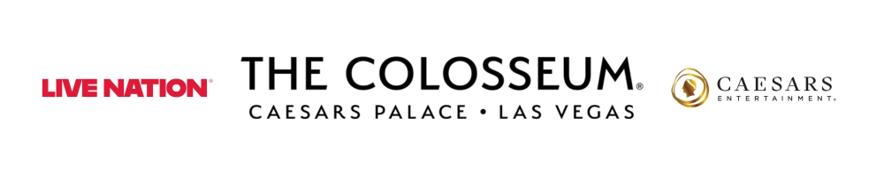
DAVID BYRNE
BRINGING SPRING 2026 NORTH AMERICAN TOUR TO
THE COLOSSEUM AT CAESARS PALACE
APRIL 20, 2026

NEW ALBUM WHO IS THE SKY?
OUT NOW VIA MATADOR
LISTEN HERE

Presales begin Tuesday, Dec. 9
Public on sale begins Friday, Dec. 12

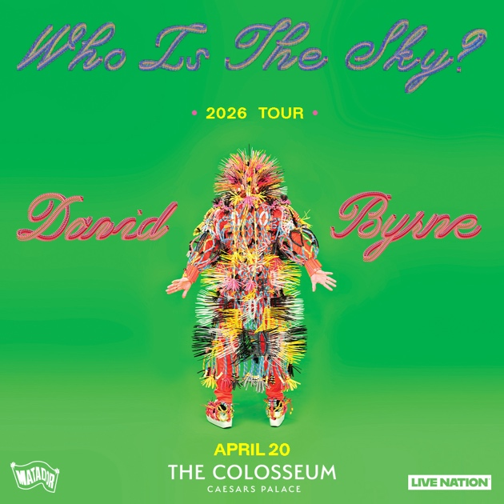

Click HERE for admat and photo
LAS VEGAS, NV (Dec. 8, 2025) – Last week, David Byrne wrapped up the first leg of his widely celebrated and acclaimed “Who Is The Sky” tour, celebrating the release of his new album of the same name. Today, he announces another run of North American dates which will make a Las Vegas stop at The Colosseum at Caesars Palace on Monday, April 20, 2026 at 8 p.m.

Presales will run throughout the week ahead of the general on sale beginning
Friday, Dec. 12 at 10 a.m. PT at ticketmaster.com.

The tour will also offer a variety of different VIP packages and experiences for fans to take their concert experience to the next level. Packages vary but include premium tickets, tour of the stage and an on stage photo op, signed copy of David Byrne’s photo book, early entry and more. VIP package contents vary based on the offer selected. For more information, visit vipnation.com.

Last month saw the release of the timely new single, “T Shirt.” Co-produced by Byrne’s longtime friend and collaborator Brian Eno, the song is a classic piece of electro-pop wrapped in lightly humorous, but always earnest, political commentary. The track has become a notable moment and quick fan favorite on Byrne’s latest tour.

LISTEN TO “T SHIRT” HERE

David Byrne and his band recently brought his live performance energy to the NPR offices for an epic Tiny Desk Concert, with Exclaim! saying, "Everything he does is pure magic." Watch below. WATCH HERE.

Who Is the Sky?, released via Matador Records, is Byrne’s first album since releasing the acclaimed 2018 American Utopia, which was later adapted into a hit Broadway musical and HBO film. It was produced by the Grammy-winning Kid Harpoon (Harry Styles, Miley Cyrus), while its 12 songs were arranged by the members of New York-based chamber ensemble Ghost Train Orchestra. Guests include Paramore’s Hayley Williams, St. Vincent and The Smile drummer Tom Skinner.

The album was introduced by the infectious first single “Everybody Laughs,” directed by multimedia artist Gabriel Barcia-Colombo. The video set the tone for Who Is the Sky? with its universal themes of human connection and the potential for societal unity against the chaotic backdrop of the world. WATCH HERE.

“At my age, at least for me, there's a ‘don't give a shit about what people think’ attitude that kicks in,” Byrne says about the spirit behind Who Is the Sky? “I can step outside my comfort zone with the knowledge that I kind of know who I am by now and sort of know what I'm doing. That said, every new set of songs, every song even, is a new adventure. There's always a bit of, ‘how do I work this?’ I've found that not every collaboration works, but often when they do, it's because I'm able to clearly impart what it is I'm trying to do. They hopefully get that, and as a result, we're now joined together heading to the same unknown place.”

About Live Nation Las Vegas
Live Nation Entertainment (NYSE: LYV) is the world’s leading live entertainment company comprised of global market leaders: Ticketmaster, Live Nation Concerts, and Live Nation Sponsorship. Live Nation Las Vegas produces residency shows from Cyndi Lauper, Blake Shelton, Def Leppard, Dolly Parton, Jennifer Lopez, Alanis Morissette, Kelly Clarkson and Rod Stewart at The Colosseum at Caesars Palace; ZAYN, Mariah Carey, Sammy Hagar, New Kids On The Block and Bruno Mars at Dolby Live at Park MGM; The B-52s, Earth, Wind & Fire, FOREIGNER, STYX and Chicago at The Venetian Theatre at The Venetian Resort Las Vegas; John Fogerty at PH Live at Planet Hollywood Resort & Casino; and Santana at House of Blues. Live Nation Las Vegas also brings other world-famous artists to many of the city’s other premier concert venues including Allegiant Stadium, T-Mobile Arena, MGM Grand Garden Arena, Michelob ULTRA Arena, the Pearl at Palms Casino Resort, Downtown Las Vegas Events Center and more. For additional information, visit www.livenationentertainment.com. Find Live Nation Las Vegas on Facebook and Instagram.

About Caesars Palace
About Caesars Palace
Caesars Palace, the iconic Las Vegas Strip resort where every guest is treated like a Caesar, features 3,980 hotel guest rooms and suites, including the redesigned 182-room Nobu Hotel Caesars Palace, the renovated Colosseum Tower and THE VILLAS Caesars Palace, which has earned the prestigious AAA Five Diamond rating. Both Caesars Palace and Nobu Hotel Caesars Palace have also received AAA Four Diamond designations. The 85-acre resort offers diverse dining options from the award-winning Bacchanal Buffet to celebrity chef-branded restaurants, including Gordon Ramsay HELL’S KITCHEN, Pronto by Giada, Amalfi by Bobby Flay, Vanderpump Cocktail Garden by restaurateur and television star Lisa Vanderpump, one of Nobu Matsuhisa’s largest Nobu restaurants, Restaurant Guy Savoy, award-winning pastry chef Dominique Ansel’s first Las Vegas bakery, Stanton Social Italian – a dining concept in partnership with Tao Group Hospitality, legendary New York Steak House Peter Luger and Brasserie B Parisian Steakhouse by Bobby Flay. The Celebrity Food Hall features Guy Fieri’s Chicken Guy!, Bobby’s Burgers by Bobby Flay, Tortazo by Rick Bayless, Buddy V’s Pizzeria and Mokbar by Esther Choi. For the best in cocktails, destination lounges include Montecristo Cigar Bar, VISTA Cocktail Lounge, Stadia Bar and Caspian’s – a cocktail and caviar bar with Clique Hospitality The resort also features nearly 130,000 square feet of casino space, the Caesars Race & Sportsbook at Caesars Palace with a 143-foot HD LED screen and state-of-the-art sound, a five-acre Garden of the Gods Pool Oasis, the luxurious Qua Baths & Spa, Hairdreams by Michael Boychuck, five wedding chapels and gardens, the 75,000-square-foot OMNIA Nightclub and OMNIA Dayclub on Las Vegas Boulevard (coming summer 2026). The 4,300-seat Colosseum is the most celebrated venue in Las Vegas with an impressive legacy of superstar talent featured in an intimate, once-in-a-lifetime setting. The Colosseum currently spotlights world-class entertainers, including Kelly Clarkson, Jennifer Lopez, Dolly Parton, Blake Shelton, Nikki Glaser and David Spade, Def Leppard, Cyndi Lauper, Jerry Seinfeld and Rod Stewart. Also, the Green Fairy Garden in front of Caesars Palace hosts ABSINTHE by Spiegelworld, an adults-only circus variety show featuring a cocktail of wild and outlandish acts. The Forum Shops at Caesars Palace showcases more than 160 boutiques and restaurants. Caesars Palace is operated by a subsidiary of Caesars Entertainment, Inc. (NASDAQ: CZR). For more information, please visit caesarspalace.com or the Caesars Entertainment media room. Find Caesars Palace on Facebook and follow on X and Instagram. Know When To Stop Before You Start.® If you or someone you know has a gambling problem, crisis counseling and referral services can be accessed by calling or texting 1-800- 522-4700, Caesars License Company, LLC.

# # #

MEDIA CONTACTS:
For Live Nation Las Vegas:
Kelly Frey
Kelly@KFPublicity.com

For Caesars Entertainment:
Robert Jarrett
RJarrett@caesars.com

