FOR IMMEDIATE RELEASE
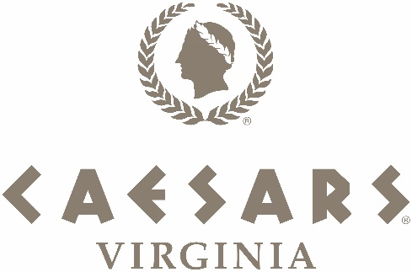

Caesars Virginia To Open Dec. 17, 2024

For assets, please click here

DANVILLE, VA. (Dec. 6, 2024) – Caesars Virginia will now be welcoming its first guests on Tuesday, Dec. 17 at noon when doors officially open.

Grand opening festivities will begin at 10:15 a.m. with an exciting parade of race cars and supercars supplied by Virginia International Raceway, Kaizen Autosport and Foreign Cars Italia. The parade route will weave through Danville’s streets, starting at the corner of Main and Craghead Street and ending at Caesars Virginia. The parade’s master of ceremonies is five-time NBA Champion and the league’s “best rebounding forward in NBA history,” Dennis Rodman, who will also make the ceremonial first bet in Caesars Sportsbook.

Beginning at 11 a.m. in the resort’s main entrance, Caesars Entertainment and Eastern Band of Cherokee Indian executives will offer remarks alongside community leaders with doors officially opening at noon. Guests will enjoy a firework and drone show at 8 p.m., lighting the sky above the resort and historic “Three Sisters” smokestacks.

“We know that there is tremendous excitement for our grand opening, and we appreciate everyone’s patience with this short delay,” said Chris Albrecht, Senior Vice President and General Manager of Caesars Virginia. “The Team has been working around the clock to officially open the doors of Caesars Virginia, and we cannot wait to begin welcoming guests on Dec. 17.”

Guests can continue playing at Danville Casino, the temporary facility located in the resort’s parking lot. Since the temporary facility’s opening in May 2023, it has paid more than $66 million to the City of Danville and The Commonwealth in gaming taxes. Caesars Virginia is owned by Caesars Entertainment and venture partners EBCI Holdings and Eastern Band of Cherokee Indians.

About Caesars Virginia
Roman Luxury Meets Southern Charm – Located in historic Danville, Virginia, the all-new destination resort brings the iconic Caesars brand to the heart of Southern Virginia in style. Set to open in late 2024, Caesars Virginia will provide a luxurious casino resort experience, complete with a full-service spa, pool, world-class dining, including Ramsay’s Kitchen by Multi-Michelin-starred chef Gordon Ramsay and the 500 Block Food Hall, upscale bars and lounges, endless gaming action and non-stop entertainment. The 320-room hotel tower will provide stunning floor-to-ceiling panoramic views of the Southern Virginia skyline and the historic “Three Sisters” smokestacks. The resort will also feature more than 90,000 square feet of gaming space, including nearly 1,500 of the newest, most exciting slots, 79 live-action table games, 48 electronic table games, a WSOP™ poker room and Caesars Sportsbook. With 50,000 square feet of flexible meeting and convention space that will also serve as a 2,500-seat live entertainment venue, Caesars Virginia can accommodate a variety of meeting and event needs. Caesars Virginia is owned in partnership between Caesars Entertainment (NASDAQ: CZR) and the Eastern Band of Cherokee Indians. For more information and to follow progress, please visit www.caesars.com/caesars-virgina or find Caesars Virginia on Facebook, Twitter and Instagram. Know When To Stop Before You Start.® If you or someone you know has a gambling problem, crisis counseling and referral services can be accessed by calling or texting 1-800-GAMBLER.

###

Media Contact:
For Caesars Virginia:
French I West I Vaughn / Fatima Osborne
CaesarsVA@fwv-us.com
fosborne@caesars.com

For Caesars Entertainment:
Robert Jarrett
rjarrett@caesars.com

