

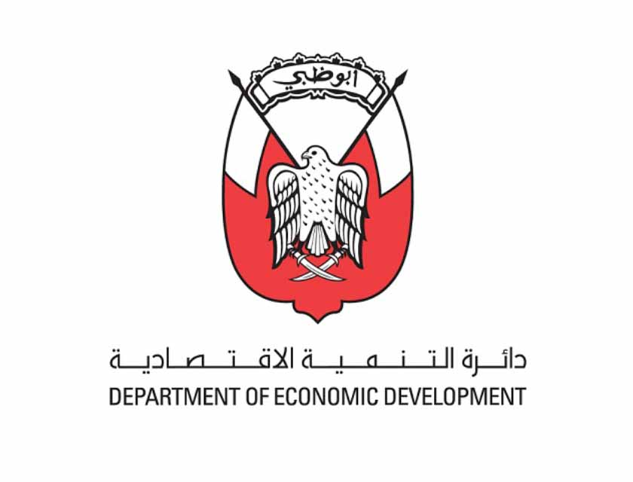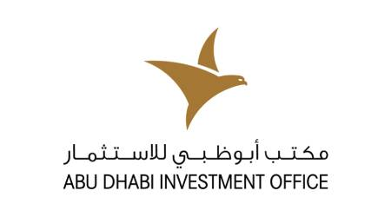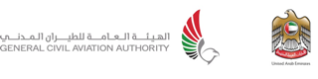

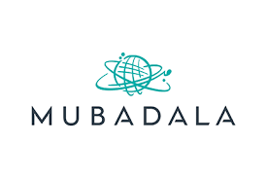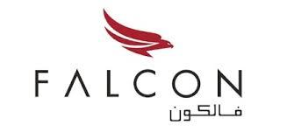

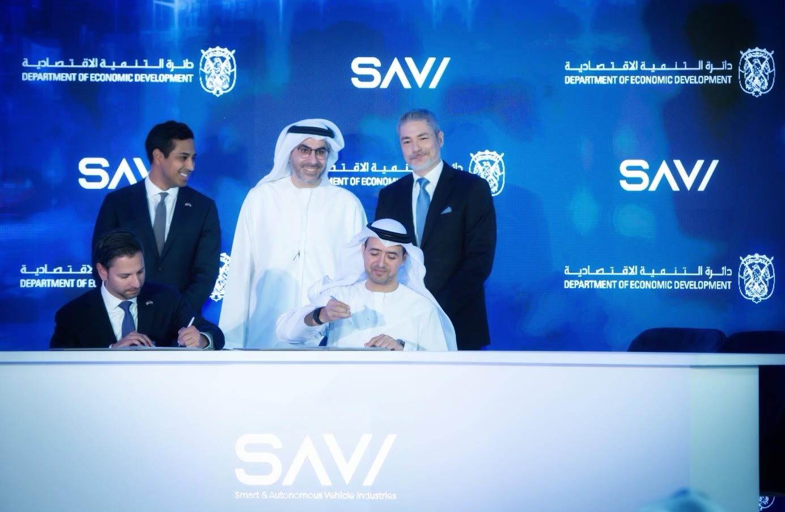

*His Excellence Badr Salim Al-Olama, Archer CEO Adam Goldstein and CCO Nikhil Goel During Signing Ceremony Announcing Archer’s Plans To Make the UAE Its First International Launch Partner*

**Archer & Abu Dhabi Investment Office Announce Plan to Launch Archer’s All-Electric Air Taxi Service Across the UAE**

* Abu Dhabi Investment Office (ADIO) and Archer held a signing ceremony at which they, along with other aviation industry leaders from across the region, including Falcon Aviation and GAL-AMMROC, will support the launch of Archer’s all-electric air taxi service across the UAE.
* Archer and Abu Dhabi Investment Office (ADIO) entered today into a memorandum of understanding (MOU) that sets forth their plans to accomplish the following initiatives:
  + Archer launching an all-electric air taxi service across the UAE with the goal of starting service in 2026.
  + ADIO to support Archer’s plans to launch in the UAE, through incentives
  + Archer building an engineering Center of Excellence to support the growing advanced air mobility industry in the UAE and across the Middle East and to collaborate with local manufacturing companies and Maintenance, Repair, and Overhaul (MRO) providers in Abu Dhabi to spearhead the production of eVTOL aircraft, furthering Abu Dhabi’s efforts to grow its Smart and Autonomous Vehicle Industry (SAVI) cluster.
* In celebration of this strategic initiative to bring Archer to the UAE, Archer, which counts Mubadala Capital, the asset management subsidiary of Abu Dhabi sovereign wealth fund Mubadala Investment Company as one of its investors, will showcase their Midnight aircraft to the region for the first time at the Dubai Airshow, as well as the Conference on Aviation and Alternative Fuels (CAAF) hosted by the General Civil Aviation Authority (GCAA) the following week in Dubai.

**ABU DHABI, United Arab Emirates Oct. 16, 2023** - [Archer Aviation Inc.](https://archer.com/) (NYSE: ACHR), a leader in electric vertical takeoff and landing (eVTOL) aircraft, announced today that it has entered into an agreement with ADIO pursuant to which the parties intend to work together to make Abu Dhabi its first international launch partner, with plans to commence air taxi operations in Abu Dhabi in 2026. As part of this strategic initiative, ADIO plans to support Archer with incentives for establishing its first international headquarters and manufacturing facilities in the Smart and Autonomous Vehicle Industry (SAVI) Cluster in Abu Dhabi.

ADIO and Archer held a signing ceremony at which they, along with several other aviation industry participants from across the region, including Falcon Aviation and GAL-AMMROC, committed to support this strategic initiative. Archer is still in discussions with numerous other industry participants that it plans to announce MOUs with when the company is in the region to showcase its Midnight aircraft at the Dubai Air Show from November 13-17, as well as the ​ Conference on Aviation and Alternative Fuels (CAAF) hosted by ICAO and the General Civil Aviation Authority (GCAA) the following week in Dubai​.

Archer is seeking to work with its global manufacturing partner Stellantis, as well as local partners in the UAE, to build out its aircraft manufacturing capabilities and its Center of Excellence in Abu Dhabi. Archer’s Center of Excellence will be focused on the development and implementation of next-generation aviation technologies.

His Excellency Saif Mohammed Al Suwaidi, Director General of the General Civil Aviation Authority, said: “The GCAA recently visited Archer Aviation’s global headquarters in California to inspect its Midnight aircraft and learn about their certification progress with the Federal Aviation Administration. Our goal is to approve Archer’s air taxi to fly in the UAE as soon as it is certified by the FAA, and we are very excited to collaborate with them to bring electric air taxis to the country.”

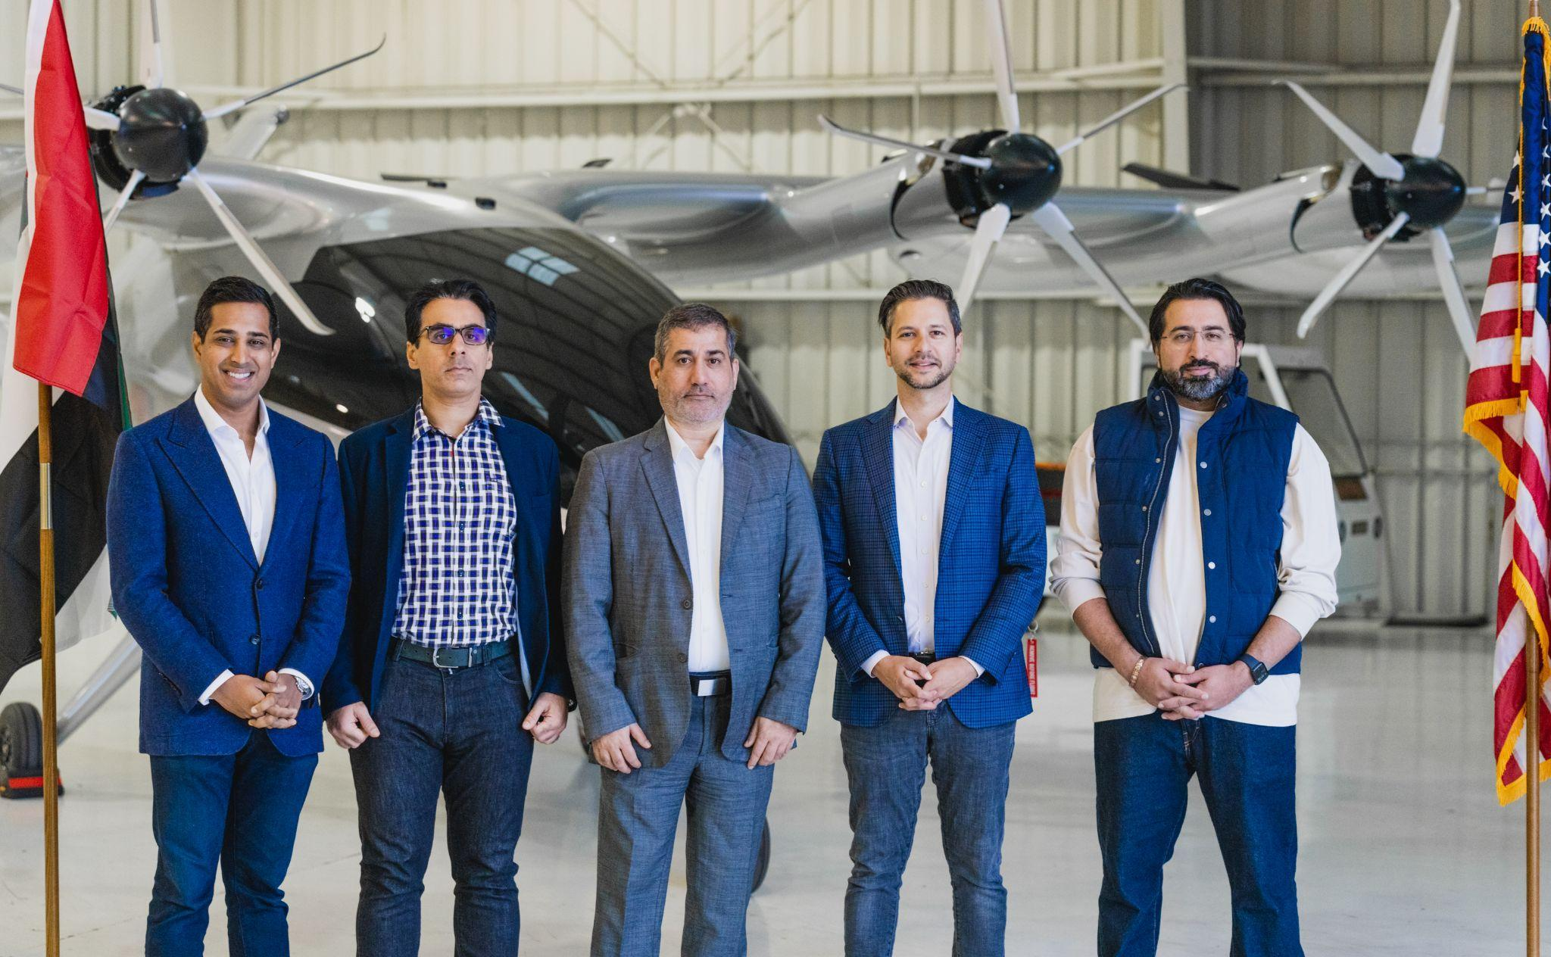

***Pictured: GCAA Leadership Visits Archer’s Flight Test Facility***

His Excellency Badr Al-Olama, Acting Director General of the Abu Dhabi Investment Office, said: “We are thrilled to work with Archer to host their first international operations in Abu Dhabi. Bringing electric aviation to the UAE will help unlock congestion with zero emissions and, in turn, bring millions in foreign direct investment and thousands of jobs to the region over the next decade.”

Archer has raised over $1.1 billion of funding to date, including investments from Mubadala Capital, United Airlines, Stellantis, and Boeing.

Archer Aviation’s Founder and CEO, Adam Goldstein, said, “We are excited to announce this joint collaboration for the United Arab Emirates to become our first international market outside of the United States. Archer plans to partner closely with ADIO and the Department of Economic Development to bring manufacturing and operations for our air taxis to the region. Together, we are positioned to be a driving force in making all-electric air taxis a reality in the skies of the UAE and beyond in the coming years.”

Meera Al Suwaidi, Head of Value Creation at Mubadala Investment Company, said: “Through our asset management subsidiary Mubadala Capital, we have been an investor in Archer for several years. We are looking forward to working alongside them for the debut of their Midnight aircraft at the Dubai Air Show later this year, and to continue discussions on further expanding our collaboration.”

Carlos Tavares, CEO of Stellantis, said, “We are excited to be working with Archer to begin establishing a high-volume manufacturing facility for the Midnight aircraft in the United States over the last couple of years. We hope this first production site will be a blueprint for future Archer manufacturing facilities as it expands operations to serve new regions, starting with the Middle East, where we see extraordinary potential for urban air mobility.”

Archer is working with numerous industry partners across the UAE to support its plans to commercialize operations in the UAE by 2026. Archer signed MOUs with Falcon Aviation who will operate its air taxis across Dubai and Abu Dhabi, as well as GAL-AMMROC who will provide MRO support for Archer’s eVTOL aircraft.

Falcon Aviation Vice Chairman, Sheikh Mohammed Bin Sultan Bin Khalifa, said, “Falcon Aviation has built an unparalleled reputation for flying passengers in helicopters across the UAE for nearly two decades. With this agreement with Archer, we look forward to continuing to provide world-class passenger transport in all-electric air taxis across Dubai and Abu Dhabi in the next decades to come.”

Mahmood Alhay Alhameli, CEO of GAL & AMMROC, commented: “Based on Archer’s eVTOL technology, their plans to launch and manufacture in the UAE, coupled with our trusted experience in providing maintenance, repair, and overhaul services for our wide range of industry-leading clients, GAL & AMMROC is proud to have been chosen as the ideal launch partner for Archer.”

Archer’s goal is to transform urban travel, replacing 60–90-minute commutes by car with estimated 10-20 minute electric air taxi flights that are safe, sustainable, low noise, and cost-competitive with ground transportation. Archer’s Midnight is a piloted, four-passenger aircraft designed to perform rapid back-to-back flights with minimal charge time between flights.

# # #

**About Archer**

Archer is designing and developing electric vertical takeoff and landing aircraft for use in urban air mobility networks. Archer’s mission is to unlock the skies, freeing everyone to reimagine how they move and spend time. Archer's team is based in Santa Clara, CA.

To learn more, visit[www.archer.com](http://www.archer.com).

**Archer Media Contacts**

The Brand Amp - Archer@TheBrandAmp.com

**Archer Forward Looking Statements**

This press release contains forward looking statements regarding Archer’s future business plans, including statements regarding the timing of Archer’s development, commercialization, and certification of its eVTOL aircraft, business opportunities, government incentives, potential investments by third parties in Archer, expansion of Archer’s business internationally, and the building of Archer’s international headquarters and international manufacturing facilities. In addition, this press release refers to MOUs that are conditioned on the future execution by the parties of binding definitive agreements incorporating the terms outlined in the MOUs, which definitive agreements may not be completed or may contain different terms than those set forth in the MOUs. These forward-looking statements are only predictions and may differ materially from actual results due to a variety of factors. The risks and uncertainties that could cause actual results to differ from the results predicted are more fully detailed in Archer’s filings with the Securities and Exchange Commission, including its most recent Annual Report on Form 10-K and Quarterly Report on Form 10-Q, available at www.sec.gov. In addition, please note that any forward-looking statements contained herein are based on assumptions that Archer believes to be reasonable as of the date of this press release. Archer undertakes no obligation to update these statements as a result of new information or future events.

Source: Archer

Text: ArcherIR